Appendix 1 - Framework Elaboration
- Review of Current Landscape
By its very nature the commitment of food fraud is a secretive process and research underpinned the concern expressed by Professor Elliott (quoted below) that limited intelligence is currently available. It was also clear from both the literature study and more particularly from a project survey together with industry and regulator interviews that many questions remain unanswered regarding the full nature and extent of food fraud and the mechanisms by which it is perpetrated.
“Limited intelligence has been collected and it is not possible to gauge whether we are dealing mainly with systematic criminality perpetrated by individuals and groups operating exclusively in the food chain, or whether organized criminal networks (i.e. those already established in activities such as trafficking drugs, cigarettes, fuel, firearms or humans) have moved into food crime” (Elliott, 2013)
Nevertheless the project team was able to identify useful research including a number of reference databases and alternative attempts to “model” types of fraudulent activity all of which informed the development process of our own model.
- Key information
The key information that was identified as part of our initial research and literature study is summarized and discussed here under the following broad headings:
- Definitions of fraud
- Alternative or relevant modeling of fraud mechanisms
- Reference databases of known incidents
- Evaluation of known incidents as potential indicators for fraud
- Existing and potential control mechanisms
- Standards
- The role of governance and business maturity
- Testing
- Fraud risk management best practice
- Governance and internal control
- Food fraud frameworks
- The role of organised crime
- Supply chain management
- Intelligence
- Forensic testing
- Collaboration and data sharing
- Food fraud tools

- Definitions of Food Fraud
Regulators and academics have made attempts to define food fraud. Additional terms commonly used to describe food fraud include economically motivated adulteration, food fraud, food crime and food counterfeiting.
These are discussed below:
Statutory/Regulatory
Two main trading blocks that can be said to have attempted to define food fraud or economically motivated adulteration within a statutory framework are the European Union and the Unites States of America.
Other definitions arise from various academic papers and of course more recently the interim Elliott report which uses the term Food Crime although Elliott is not the first to use this term to help convey the criminal nature of much fraud since the UK Co Operative movement first coined the term in its Report “Food Crimes A consumer perspective on ethics of modern food production” first published in 2000.
The EU
Whilst the EU has no generally acknowledged or regulatory definition of food fraud, the current EU legislative framework being largely focused on food safety a general guideline can be found in Regulation 178/2002 on general principles and requirements of food law, which states that the labelling, advertising, presentation and packaging ‘shall not mislead consumers’, although in practical terms, the application of this provision varies largely among Member States and the number of controls in this area is extremely limited (EU, 2013).
The U.S.
The US Federal Food, Drug, and Cosmetic Act (FDA, 2010) declares a food adulterated ‘if any valuable constituent been in whole or in part omitted or if any substance has been substituted wholly or in part or if damage or inferiority has been concealed or if any substance has been added thereto so as to increase its bulk or weight, or reduce its quality or strength, or make it appear better or of greater value than it is’.
Food fraud was recently defined in a report commissioned by the Department of Homeland Security and funded by the National Centre for Food Protection and Defence (University of Minnesota) as a collective term that encompasses the deliberate substitution, addition, tampering, or misrepresentation of food, food ingredients, or food packaging, or false or misleading statements made about a product for economic gain (Spink, 2011).

Academic/Other definitions
Addressing a more specific type of fraud, the USP Expert Panel on Food Ingredient Intentional Adulterants, which operates under the aegis of the Food Ingredients Expert Committee in the Council of Experts, defined the intentional or economically motivated adulteration of food ingredients as “the fraudulent addition of non-authentic substances or removal or replacement of authentic substances without the purchaser's knowledge for economic gain of the seller” (DeVries, 2009).
A number of commentators refer to economically motivated adulteration (EMA). EMA incidents are usually defined as intentional acts with unintentional harm and are designed specifically not to be detected and circumvent existing regulatory systems or QA testing methodologies.
A comprehensive review of EMA has recently been published (Everstine et al., 2013) which sets out to provide an overview of documented EMA incidents in various categories of food products, to describe the common characteristics that allowed the incident to happen or allowed detection of the adulteration, and to discuss these characteristics in the context of the increasingly globalised food supply.
It is important to note that risk assessment & proactive prevention strategies cannot rely on traditional food safety strategies.

Our team found the definitions used by Spink or DeVries adequate for the purposes of this project.
- Alternative or relevant Fraud Modelling
A range of fraud models was identified from the literature study of which the most relevant of which was felt to be a modified version of the classic fraud triangle (The fraud diamond).
The Fraud Triangle was compiled in the 1950s by Donald Cressey which explains the factors leading to occupational fraud by an individual.is the triangle is composed of 1) Pressure (Incentive/Profit), 2) Opportunity & 3) Rationalisation (1).
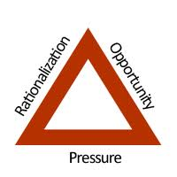
Diagram 1. Fraud Triangle
The fraud triangle as it relates to food has been variously described:

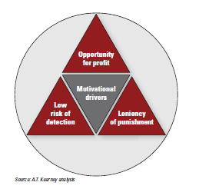

Diagram 2. Food Fraud Triangle - (GMA & A.T.Kearney, 2010)
Breaking the Fraud triangle is the key to food fraud deterrence, and implies that if an organization removes one of the elements in the Fraud Triangle, the likelihood of fraudulent activities is highly reduced.
'Profit' and avoidance of QA systems 'Opportunity' are at the core of food fraud. (Moore et al., 2012; Everstine et al., 2013
The classic fraud triangle model has also been extended as a fraud diamond model to include organized crime. A different interpretation to pressure and rationalization is needed, as the original model is designed for employee fraud against the organization. In terms of food fraud, this includes individuals or organizations whose intentions are clearly to commit fraud for financial gain or to money launder rather than those organizations or individuals for whom the principal motivation might simply be to meet customer or commercial market demands when supply volumes of legitimate product cannot be met for some reason. For example, where there are commodity shortages following crop failure.
Thus, this type of extended version of the fraud triangle includes The Predator/ Criminal Crime as far more deliberate and focused than the opportunistic fraudsters for which the original Cressey fraud triangle was designed to reflect; they are better organized, have better concealment schemes, and are better prepared to deal with auditors and other oversight mechanisms. All the predator seeks is opportunity; his pressures and rationalizations are different. Thus, one version of the fraud diamond replaces the latter two points with the terms arrogance and a criminal mind-set.

http://www.fraud-magazine.com/article.aspx?id=4294970127.

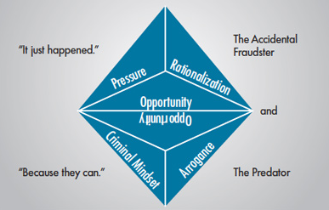
Diagram 3: The Fraud Diamond

Of some interest is a game-theoretic approach, which has been developed for reconstructing economic temptations, and applies criminal behaviour to the risk continuum (Hirschauer & Zwoll, 2008).
This paper provides an interesting insight into the behavioural aspects contributing to food fraud in the context of EMA with the 'Opportunities' of stakeholders/game-players within the poultry sector as the example.
Game theory has been used by some authors to analyze economic temptations and criminal behaviour. Hirschauer & Zwoll (2008), for example, show that breaches of production standards in the poultry industry, which they term a crime against the consumer, are economically motivated and are a response to an economic environment which puts pressure on businesses and creates opportunities for criminal responses. However, the use of game theory to understand food fraud is as yet underdeveloped.
- Reference Databases of known fraud
A number of articles have identified the first step against fraud is to create a perpetual repository of information that consolidates all relevant historical information to include ingredient, adulterant, source, date of incidence, cost to the firm and actions taken. This can be useful in performing a risk assessment to identify key criteria to identify targeted products and develop scorecards for prioritised action (Morehouse, 2010; GMA, 2010; Spink & Moyer, 2011b).

Two of the most relevant databases identified are described below:
US Pharmacopeial (USP) Food Fraud Database
The (USP ) have developed a food fraud database as a repository for ingredient fraud reports, from previously disparate information, in an effort to identify problematic food ingredients and catalogue detection methods (Moore et al., 2012).
This report describes the development and application of a database of food ingredient fraud issues from publicly available references in scholarly journals and general media. The database provides baseline information and data useful to governments, agencies, and individual companies assessing the risks of specific ingredients produced in specific regions as well as products distributed and sold in other regions. In addition, the report describes current analytical technologies for detecting food fraud and identifies trends and developments. It includes 1305 records, including 1000 records with analytical methods collected from 677 references from 1980 to 2010.
Each record in the database is a publically reported unique combination of food ingredient, adulterant, and literature reference. Individual entries in the database should not be interpreted as unique adulteration incidents because this was not the intention of the database.
Trends into high risk ingredients and insights are reported.
The database is available at http://www.foodfraud.org/
National Center for Food Protection and Defence (NCFPD)
The NCFPD database is described by Everstine et al., (2013b)
It catalogues and details a wide range of unique incidents of EMA in 16 different product categories and is searchable by incident characteristics such as food adulterant, production location, morbidity/mortality, and date.

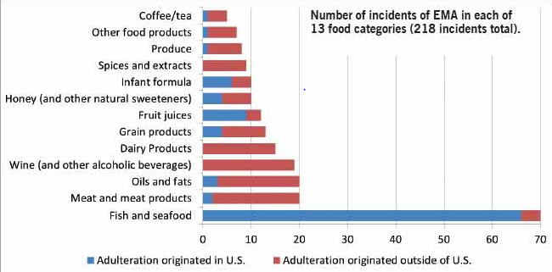

Existing research from numerous U.S. and international databases has been identified and assessed since 1980. Those projects deemed of value have been added to the data base totalling over 300 entries to date while more than 1000 have been reviewed. The project entries contain incidents addressing the intentional contamination of the food protection, animal, and water supply. This includes methods of contamination, detection, persistence, risk assessment/communication, and decontamination.
Access to the database is available at: https://www.foodshield.org/member/register/index.cfm
- Fraud Database Review
The US Pharamacopoeia (USP), NCFPD (See Section 5.2.2.3) and RASFF databases were evaluated ( all have free access and are in English) to inform development of the model criteria and select categories across the risk spectrum for evaluation of the validity of the model. (Appendix 4 Fraud Database Review)
- USP
The database provides a useful repository of reports to identify the nature of adulteration in ingredients and appropriate methods of detection. This information is particularly useful in providing visibility of previous incidents & preventing repeat adulteration in the same ingredient (Gray, 2012).
Limitations:
A number of limitations for the purpose of the “NSF Fraud Protection Model” project were identified.
These include:
- Ingredients only (Notably beef substitution with horsemeat is not included)
- Individual data entries as opposed to incidents precludes a reliable mechanism for quantifying risks.
- Excludes the nature of the incident.
- No information on the countries implicated.
- Trend analysis requires separate analysis on an XL spreadsheet.
Security was not robust: Registration with required an e-mail address (private e-mail address was accepted) and password. Access to the database was also possible without being logged in.
- NCFPD
This database is more encompassing, with a focus on products and incidents (as opposed to just ingredients).
There is good functionality within the database to allow ease of analysis of trends. Search criteria are product category (which provides a list of relevant incidents), food product, adulterant, type of adulteration and produced location.
Incident summaries provided include the reasoning ( to inform profit and likelihood of detection) , level and nature of adulteration , which allows determination of what was done, by who, countries impacted, how it was detected (analysis & intelligence) and the public health impact hence has provided an invaluable repository to inform development of the “NSF Fraud Protection Model”.
Limitations:
  - No links to source material
Security: This was extremely tight with a more demanding approval process (access initially denied - accepted on strength of involvement with the “NSF Fraud Protection Model” project) additional security questions and account expiry/ renewal.
- USP v NCFPD Content
The USP database was used as the source of data within an EU draft report on food fraud in published response to the Horse meat crisis (EU, 2013). It was commented at the time that it was surprising that meat products were not identified in the top 10 risks (Scott-Thomas, 2013).
Interrogation of the NCFPD database allowed distinction of incidents for product categories (not just ingredient entries) and the ability to isolate European incidents from the rest.
A comparison of the top 10 carried out provides a very different landscape for the EU:
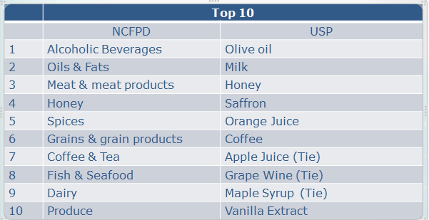
A detailed comparison of these databases is included in a review of food fraud published by the US Congressional Research Service after the project database was carried out (Johnson, 2014)
- RASFF Database
A report was generated using the following filter selection:
Hazard category - adulteration/fraud
Product type - food
Notified from- 1/1/1980
Notified till – 23/10/2013
The date 1/1/1980 was selected to allow a comparison with the NCFPD database and notified till was the same date as the NCFPD database review.
The report identified 741 notifications, which were automatically categorised by product type. The subject column described the nature of the notifications, which were in the main relating to illegal import and fraud in respect of fraudulent documentation and very few indications of food fraud relevant to the scope of this project. Where relevant evidence of fraud was provided, no insight into the nature of the incident was provided.
Of particular note were three notifications relating to horsemeat in January & February 2013, a year prior to the beginning of the EU Horse meat crisis. These were discussed during the FSA interview

Date | Reference | Product type | Notification type | Notification basis | Notified by | Origin | Subject | Distribution | Action taken | Distribution status
01/02/2012 | 2012.0162 | Food | Information for follow-up | Official control on the market | Denmark | From Denmark | Suspicion of fraud in relation to horse carcasses from Denmark, processed in Italy | Belgium, Germany, Denmark | Informing recipients | Distribution to other member countries
 |  |  |  |  |  | Processed in Italy
15/02/2012 | 2012.0241 | Food | Information for attention | Official control on the market | Italy | From Hungary | Suspicion of fraud in relation to horse carcasses from Hungary | Italy | Re-dispatch | No distribution
07/03/2012 | 2012.0358 | Food | Information for follow-up | Official control on the market | Italy | From Hungary | Suspicion of fraud in relation to horse meat from Hungary | Italy |  | No distribution

- Evaluation of known Incidents
An EU draft report on food fraud in response to the Horse meat crisis (EU, 2013) underlines the risk of food fraud is greatest when potential economic gains are large and chances of getting caught are slim which supports two of the key parameters of the proposed model. Most of the at risk foods can easily be mixed with products that are difficult to detect, or powders, pastes or liquids bulked out with fraudulent products.
A comprehensive literature search on incidents from 1980 identifying 137 incidents, across 11 food product categories has been carried out (Everstine et al., 2013): fish & seafood, dairy, fruit juices, oils & fats, grain products, honey & natural sweeteners, spices & extracts, wine & alcohol & other.
Common characteristics were identified that may help better evaluate and reduce the risk of EMA. These reflect current inadequacies in existing regulatory systems or testing methodologies and how novel detection methods and other deterrence strategies can be deployed.
Those providing common themes & diagnostic clues for development of the “NSF Fraud Protection Model” model are included and highlighted in bold here:
- Dairy - The 2008 melamine adulteration of milk by dairy producers was well organised; reportedly there was a protocol for creating a melamine solution used by multiple dairy companies.
Melamine had been previously used to dupe the nitrogen testing for protein. However, the addition of melamine to dairy products in China was widespread and dated back at least 3 years. Since 2008, dairy products containing melamine have repeatedly been discovered for sale in China.
- Fruit juices - The case of the Beech-Nut Vitrition Corporation makes interesting reading: They were knowingly buying apple concentrate for 20-15% below market price and were found to be complicit in the fraud.
The case study described for pomegranate juice also identified juice concentrate being purchased (in the Middle East) at prices far below the market rate.
Pomegranate juice has enjoyed increased consumer demand in recent years due to potential health claims has made it an attractive target for adulteration.
- Oils & fats - Olive oil is an attractive target because of high demand & potential profit margin, with widespread adulteration of olive oil with less expensive oils reported
In one case, products were targeted that were least likely to be tested and imports of low-grade olive oil were re-packaged as locally produced
- Grain products - Basmati rice adulterated with up to 20% non-Basmati and organic false certification were identified.
- Honey & natural sweeteners - Numerous cases of honey adulteration are provided with adulteration with other cheaper syrups. High-fructose corn syrup developed in the 1970s was less detectable than before, until new tests were introduced in the 1980s.
Adulteration has continued to evolve to evade testing methods, including filtration of honey to remove pollen or soil that could be used to trace it back to its origin.
Perks (2007) describes honey as the fraudsters dream since bee propolis can be more or less any colour from green to red, and is expensive- 25ml of a solution of unspecified concentration costs about £19.
Many countries appear to be exporting more honey than their domestic bees produced (i.e. Demand exceeds supply). A recent media article which describes Manuka Honey Fraud supports this. As with pomegranate, there are is a growing health (& beauty) claims market driving the temptation for fraud. Tests have identified that UK consumption alone is greater than the quantity produced globally.
(http://www.foodnavigator-asia.com/Markets/Fake-honey-UK-manuka-sales-alone-outstrip-entire-global-production/?utm_source=newsletter_daily&utm_medium=email&utm_campaign=Newsletter%2BDaily&c=lOCN1Fg0FrFd4nHvAkQ64Q%3D%3D )
- Spices & extracts - The Sudan1 incident of adulteration of chilli powder is described: The chilli powder was originally imported from India and passed through the hands of at least seven companies in India and the UK prior to purchase by the manufacturers of the Worcestershire sauce that triggered the incident.
Spices are particularly susceptible to adulteration because they are typically sold in powdered form and they have long & complicated supply chains which present many challenges for EMA detection & prevention since they are often sold and transported in bulk processed form, which makes them easier to adulterate.
Reliable & effective testing methodologies are challenging to develop, and performance losses in final food products can be difficult to detect due to low concentration. Sudan dyes are commonly detected in chilli, curry & paprika powders, palm oil & various sauces
Saffron was also identified as an attractive target because of its high production costs and potential profit margin: In 2000, a Spanish producer was priced out of the British market due to the competition selling adulterated product.
- Claims - The trend in product innovation for health & beauty claims is set to increase the temptation for fraud. Fraudsters have capitalised on the variety and popularity of health products ( Schultz, 2013) including Aloe Vera (Perks ,2007).
- Other - Wine & alcohol, Infant formula, plant-based proteins (Animal feed & pet-food) & other incidents are reported with similar themes.
Multiple incidents of fraud involving claims such as 'natural', 'free range' and 'organic' have been uncovered. Development of novel detection methods uncovered bulking agents injected into chicken, previously undetected with traditional DNA testing.
The Temptation for the fraudster also adds cost of the adulterant to the list of indicators (Food Adulteration in the Spotlight: 'Science Gone Astray'. September 2011 Available at: http://www.foodnavigator-usa.com/Markets/Food-adulteration-in-the-spotlight-Science-gone-astray
In summary components from previous fraud incidents that proved useful to include or consider within the framework scoring matrices for our “NSF Fraud Protection Model” were:
Factors contributing to Food Fraud. Source:NSF Literature Study

- Knowingly buying below market price
- Presence of added value claims (organic, Healthy, free range)
- High profit margins
- Less likely to be detected
- Less detectable due to low concentration
- Evadable testing
- Demand exceeding supply
- Passed through many hands
- Cost of adulterant
- Physical form(powdered)eased adulteration process

Various fraud indicators were described at the Leatherhead/FERA launch of the Horizon scan Tool (April 2013) which has been incorporated into the risk assessment model and data sources for “NSF Fraud Protection Model” development as appropriate. These are as follows:

Factors contributing to Food Fraud. Source: Leatherhead/FERA launch 2013

- Raw material quality, cost, and availability
- Adulterant material cost and availability
- Profit associated with delivery of goods
- Loss and consequences associated with a failure to deliver goods.
- Perception of associated risk and consequences
- Likelihood of being caught
- Consequences of being caught
- Ease of adulteration particularly in comminuted, liquid, powder and processed ingredients of products
- Scale, profit and consequences
- Supply chain demands
- Legislative changes
- Links between productivity & reward
- Ability to hide deception
- Corporate awareness
- Sampling and testing

- Existing or potential control mechanisms
Various articles support the view and it is clear that that traditional food safety strategies (e.g. Hazard Analysis and Critical Control Points, Good Manufacturing Practices, ISO 22000, the Global Food Safety Initiative, British Retail Consortium and similar food safety plans) cannot be relied on for detection & prevention of EMA (Lipp, 2012, Everstine et al., 2013).
Current systems are based on known and predictable threats and are distinctly different from management of unknowns through fraudulent activity.

The relationship between food safety systems is usefully represented in the diagram below:
Diagram 4: Relationships between Food Quality, Safety, Fraud & Defense

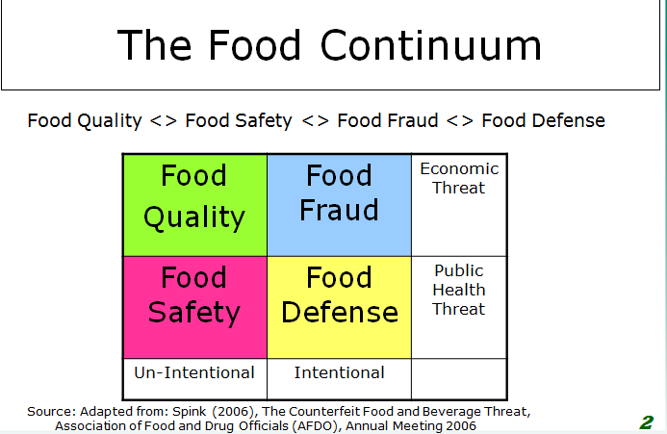

- Standards
Nationally and internationally agreed industry standards are one mechanism by which the potential for fraud might be addressed.
FoodQuest TQ has carried out a systematic review of standards. (http://www.youtube.com/watch?v=dfHnzFyxIpw&feature=youtu.be)
As part of their analysis of the existing food defence standards they looked at two global, seven U.S. federal and seven industry standards schemes and found over three thousand food related performance criteria.
Of these, they identified 1574 food defence related criteria mixed with food safety and other regulatory and best practice food standards.
From these 1574 food defence related criteria 433 requirements were identified that were related in one way or another to food fraud. All of the criteria were directed toward the actions of the opportunist fraudster and that organized crime was not addressed by any of the existing standards reviewed.
Each of the 433 food fraud related criteria were analysed and scored for their deterrence, detection, prevention, response and mitigation value.
Many of the standards had very little value. Many critical areas were not addressed at all, e.g. infiltration by organized crime.
An article published in May 2013 identifies that the GFSI (Global Food Safety Initiative) now recognises food fraud as a food safety issue and is currently focussing on embedding fraud controls into standards, advised by a food fraud think- tank (Spink 2013a).
BRC Food Safety Standard
Compliance to the BRC Food Safety Standard is an industry ‘ticket to trade’ within the UK and or provides a degree of legal Due Diligence for retailers. It has provided significant improvement in traditional food safety & quality standards but does not currently provide any requirements for fraud management & control, although this is currently under review
http://www.foodmanufacture.co.uk/Food-Safety/BRC-audit-not-designed-to-pick-up-food-fraud?utm_source=RSS_text_newsutm_medium=RSS%2Bfeedutm_campaign=RSS%2BText%2BNews&dm_i=116Q,1VAIP,5QIUKF,6P5R4,1
Industry commentators claim that reliance on BRC as a substitute for supplier risk management by manufacturers has left the industry exposed to food fraud (http://www.foodmanufacture.co.uk/Business-News/Supermarkets-have-underwear-around-ankles-on-horse-meat/?c=3eYffeo0PvqRtmGA8eIFsw%3D%3D&utm_source=newsletter_special_edition&utm_medium=email&utm_campaign=Newsletter%2BSpecial%2BEdition )
- Governance / Business Risk Maturity
A comprehensive review of business risk strategy provides a useful industry insight into Governance and risk management, with particular emphasis on the impact and lessons learnt from the Horse meat crisis (Cardno, 2013): Technology enablement/ maturity provide significant business benefit and differentiation.
Diagram 5: Business annual growth rates by maturity level (Cardno, 2013)

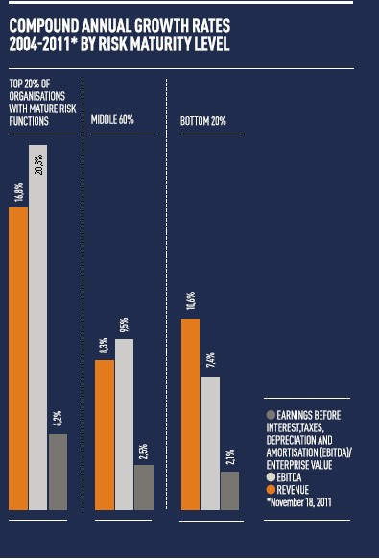

Indeed without such investment there may be a temptation for businesses to be regressive in their maturity & entertain/embrace fraudulent activity: In numerous situations non-compliance with food law has been shown to be more profitable than compliance (Hennessy et al., 2003; Hirschauer & Zwoll, 2008).
- Testing
Fraudsters have been smart enough to keep pace with developments in analytical techniques to avoid detection (Morehouse, 2010; Lipp, 2012; Everstine, 2013). Current inadequacies in existing testing methodologies are described by Everstine et al. (2013) and how novel detection methods are necessary as an integral part of the armoury to fight food fraud.
Warriner reports reactive investigations of a number of incidents, including: Investigating the adulteration of UHT milk in Brazil
Food adulteration with melamine on an international scale: field work and troubleshooting in Africa
Investigating cases of taste disturbance caused by pine nuts in Denmark
Development and application of molecular tools to investigate the mislabelling of cod sold in Sweden and testing for genetically modified organisms (GMOs) revealed the real source of rice imported to Norway.
Limitations of testing to counter food fraud are also described by Kennedy (2008), whereby the use of analytical methods is a trade - off between cost and effectiveness and requires a comprehensive understanding of the ingredient supply chain. Regular testing at critical points along the supply chain within routine QA regimes with targeted, specific testing methods is the first line of defence.
A wide variety of sophisticated technologies have been used to identify fraud after the fact. These are generally very sensitive but often prohibitively expensive for routine use. Developments of new technologies are also useful to smoke out previously undetected fraud.
Examples are provided below:
The FSA unveiled new technology, including DNA, trace element & isotope testing to clamp down of fraud, in 2008, which can be used to target specific problem areas such as claims on organic, GM-free, Halal & Kosher.
(http://www.foodmanufacture.co.uk/Business-News/Technology-helps-to-trace-food-fraud)
A presentation by Adrian Charlton of the Central Science Laboratory on food origin mapping at a FSA seminar on food fraud in 2008 gives an extremely useful overview of fraud detection methods (Available at:
http://www.food.gov.uk/multimedia/pdfs/fraudseminarprof.pdf)

Next generation DNA test method development by LGC was described in 2011, where several substances can be detected simultaneously, particularly useful in countering food fraud. (http://www.foodmanufacture.co.uk/Food-Safety/Government-boosts-DNA-testing-to-fight-rising-fraud)
Laser Ablation Inductively Coupled Plasma Mass Spectrometry (LAICPMS) to detect an elemental fingerprint which allows for the pinpointing of exactly where a food is sourced from was reported in use in Australia in 2011 (http://www.sciencewa.net.au/topics/agriculture/item/170-fingerprinting-fights-food-fraud.html). LAICPMS tests for five different isotopes and 50–60 trace elements contained in a single food sample. By comparing this to a database of samples sourced from around the globe the group is able to detect its origins.
Specific molecular fingerprinting techniques have been developed for high value commodities such as Manuka honey
(http://www.foodnavigator-asia.com/Formulation/New-way-to-fingerprint-manuka-honey-findings-may-combat-fraud;
http://www.foodproductiondaily.com/Safety-Regulation/Sweet-solution-to-honey-fraud)
Bioinformatics- Barcode of Life. Prof Janet Thornton Director of the European Molecular Biology Laboratory - European Bioinformatics Institute.
http://www.ebi.ac.uk/;http://www.barcodeoflife.org/content/about/what-dna-barcoding. This approach is focused upon a rapid diagnostics solution to identifying species 'in the field’, lending itself to food security. Application of hand-held instrumentation is in development with commercialisation about 1 - 2 years away.
In summary testing methodologies are clearly continually being improved and enhanced and any fraud anticipation model will have to be dynamic to take account of these technological changes since significant improvements to testing efficacy may force fraudsters to alter the products they target. There is in effect a testing and detection avoidance “arms race” that must be continually monitored.
- Fraud Risk Management Best Practice
A global survey on fraud risk management assessing the status of implementation of current best practice across a variety of business sectors was carried out between November 2011 & February 2012 (Ernst & Young, 2012.)
This was based on 1,700 interviews in 43 countries with chief financial officers and heads of legal, compliance and internal audit, to get their views of fraud, bribery & corruption risk and how their businesses are mitigating them.
It provides a useful outline as to what fraud risk management best practice looks like against which significant weaknesses were identified: Forensic data analysis and other technology-related tools were seldom adopted and robust risk-based compliance audits, including transaction testing not common practice.
- Governance/Internal Control
Governance and Risk Compliance (GRC) flips the focus of food fraud from detection by scientific means to Board room Governance to identify vulnerabilities as compared to recurring events.
Spink (2013b) advocates the adoption of Corporate Governance as a mechanism to prepare for a Black Swan event. [Black Swan events are the unknown unknowns and led to the evolution of Enterprise Risk Management (ERM; otherwise known as GRC)]. Spink & Moyer (2011a) also relate the classic fraud triangle model to food fraud showing that improved internal control systems are critical to reducing 'Opportunity' factors in a business. Internal controls involve checking and crosschecking inventory, purchase and sales as well as quality controls. Technology enabled system integration helps to reduce the number of gaps between systems, which can be exploited by fraudsters. (Cendrowski et al., 2006)

- Food Fraud Frameworks
A holistic systems-based approach appears to be needed to combat food fraud: such a system should make use of multiple disciplines & data sources (Everstine et al., 2013). Risk assessment is required to assess the highest level of vulnerability and involves a matrix of indicators. Lipp identifies potential profit as the key criterion with supply and demand as a useful indicator, physical state (Liquids, powders & pastes being most at risk) and feasibility (Difficulty):‘If it [the fraud] requires really specialist knowledge or specialist equipment then it may not happen.’ (Scott-Thomas, C. 23rd August 2013. Food Fraud: Which Ingredients most vulnerable? Food Quality News. Available at:
http://www.foodqualitynews.com/Public- Concerns/Food-fraud-Which-ingredients-are-most-vulnerable.)
Morehouse (2010) states that the first step against fraud is to create a perpetual repository of information that consolidates all relevant historical information to include ingredient, adulterant, source, date of incidence, cost to the firm and actions taken. This can be useful in performing a risk assessment to identify key criteria to identify targeted products and develop scorecards for prioritized action. 'Raising the Bar' over and above current standards to integrate fraud into existing systems is recommended as part of a holistic systems based approach by the
GMA published a report in 2010 following the melamine adulteration (GMA 2010) with the aim of broadening industry stakeholders understanding of economic adulteration, counterfeiting and the implications, provide strategic recommendations and tactical options to minimize associated risks and establish a basis for advancing partnerships to monitor and address the threats: Integration of fraud prevention strategies into existing programs is recommended, for which a 5-step approach is provided. Their first stage is to evaluate prior incidents, in line with the objectives of this project.
This advocates integration of buyers/procurement & supply chain management within the quality & safety framework to provide an ‘Anti-economic adulteration team.

Diagram 6: Value from an Anti-economic adulteration team and stakeholder support

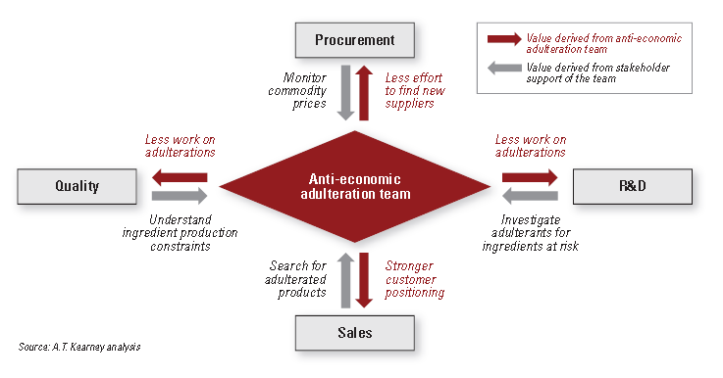

The report outlines the necessary cultural shift from individual businesses to Industry stakeholder collaboration, a framework for success and sound advice as to what is required to get there.
Key Recommendations include:
- Collaboration & Data Sharing for collective industry improvement
- Establishment of a clearinghouse to share intelligence is advocated
- Shared audits (c.f.SEDEX)
- Ingredient Standards
- Library of Ingredient Reference samples
- Horizon Scanning through Partnership with Academia
- Partnership with Authorities

- Organised crime
High-end premium brands have historically been perceived as the target in 2011, with the UK FSA perception at that time being that fraud was not a significant problem. http://www.foodproductiondaily.com/Safety-Regulation/Profile-of-food-fraud-needs-to-be-raised-says-consultant
Most food fraudsters are involved in other criminal activities, which might be easier to identify than through conventional testing regimes (Everstine et al., 2013). A number of examples where food fraud detection has or could have been made earlier through pursuit of tax and other financial data are identified. The use of non-traditional data sources for detection are described, such as tax records, below-market pricing, rapid increases in supplies and sales or known imbalances in quantities between primary production and final distribution. The potential for the use of import & trade data, economic production data and market pricing data to provide an early indication are also described.
Long supply chains are particularly highlighted since these can be designed or manipulated to specifically avoid tariffs benefit from subsidies, or subject to market price fluctuation, such as Chinese honey. A recent article in business Week identifies the 'Honey Trap' as to the mechanism for fraudulent honey imports from China into the US. (Berfield, 2013 ; Available at:
http://www.sciencedaily.com/releases/2012/04/120405144244.htm).
Diagram 7: The Honey Trap

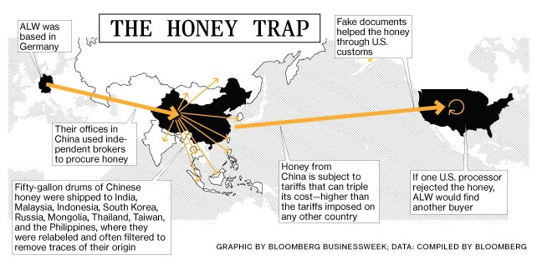

- Supply Chain Management
Food commodities with long or complicated supply chains present many challenges for EMA detection & prevention (Everstine et al., 2013), since they are often sold and transported in bulk processed form, which makes them easier to adulterate and further complicated since detection is difficult due to dilution.
Comprehensive and detailed knowledge of ingredient supply chains and vertical integration are important for prevention & detection of EMA in industrial commodity groups.
A four level model for supply chain risk & vulnerability is described by Peck (2005). This is a tool for explaining the scope and dynamic nature of supply chain risk. It emphasizes that a resilient network involves much more than the design and management of robust supply chain processes. It is important to recognize that by taking actions to reduce risk at one point within the four levels, at the same time the risk profile for the other levels is changed, including players and stakeholders not thought of in the initial risk assessment.
Supply chains are dynamic and constantly evolving, and so is supply chain risk. Achieving supply chain resilience is a constant battle and a never-ending process.
The EU Sigma project developed a Stakeholder guide for supply chain vulnerability in 2009 (Sigma, 2009) which demonstrates the benefits of collaborative working for the purpose of food safety management, as the challenges faced are similar in every country. The use of case studies permits people to learn from the mistakes of others. It advocates that development of a supply chain framework to identify and prioritise risks along the food chain is essential to target finite resources appropriately. It also includes useful examples of the assessments of potential vulnerabilities of the food safety system requiring more effective measures. The same principles apply equally with respect to food fraud.
Recommendations include harmonisation of standards, predictive ontology (Intelligence/horizon scanning) and development of early warnings and other signals.
The United Nations Global Compact Office has published useful guidance for mitigation of corruption in the supply chain (UN, 2010).
This provides a comprehensive reference describing types of supply chain corruption, notably procurement fraud, corruption & bribery involving governments & 3rd party auditors. It provides a useful reference point and practical advice (including useful scenarios) on best practice, tools & resources and integration of anti-corruption & fraud into a holistic supply chain management regime.
A comprehensive survey of supply chain risk management issues - perceptions of risk impacts and causes, mitigation methods & tools and the continuing challenges, was carried out by Deloitte in 2012, involving 600 executives at manufacturing and retail companies across a number of sectors, including food (Marchese & Paramasivam, 2013). This provides an extremely useful reference as to supply chain risks and their management from an industry perspective. The lack of adoption of appropriate technology in this area is highlighted.
- Intelligence
The requirement for intelligence to forecast food fraud risks overlaid on a risk assessment is described by Morehouse (2010). The outline of the industry framework described is detailed in a report published by the Grocery Manufacturers Association (2010) following the melamine crisis.
In the post- horsemeat review by Professor Pat Troop a failure in current intelligence in ‘joining the dots’ was identified.
http://www.meatinfo.co.uk/news/fullstory.php/aid/15704/Horsemeat:_FSA_must_improve_intelligence,_says_expert.html?utm_source=newsletter_weekly&utm_medium=email&utm_campaign=Newsletter%2BWeekly%2BIssue%2B241
Limitations on the FSAs Memex Patriarch system in its ability to predict future fraud events were reported in 2011.
http://www.foodmanufacture.co.uk/Food-Safety/Intelligent-software-won-t-predict-next-Sudan-1-experts-warn-FSA/?c=3eYffeo0PvoBLDnqPxwXug%3D%3D&utm_source=newsletter_daily&utm_medium=email&utm_campaign=Newsletter%2BDaily. Further details of the Memex system are available at:
http://www.itproportal.com/2007/04/19/memex-launches-new-intelligence-management-tools/
A cloud-based fraud framework for predictive fraud detection in the US Federal Subsidy arena gives a useful insight into what an intelligent fraud framework that ‘connects the dots’ looks like.
http://www.sas.com/resources/whitepaper/wp_41905.pdf
A new intelligence hub within the FSA Emerging Risks function has also been set up which will include fraud indicators such as commodity price as a recommendation following the Horse meat crisis.
- Forensic Testing & Standards
Food fraud has been described as the perfect crime since product is likely to taste similar, probably look similar and will cost about the same, and will not necessarily do the consumer any harm ( Perks, B. 2007). A forensic approach to food fraud detection is described, including the methods and their basis. The development of food mapping procedures is also described, recently used to identify ‘rogue’ pork chops:
http://www.thegrocer.co.uk/opinion/the-grocer-blog-daily-bread/pork-chop-shock/349569.blog; http://www.meatinfo.co.uk/news/fullstory.php/aid/16145/Industry_plays_down_rogue_pork.html?utm_source=newsletter_weekly&utm_medium=email&utm_campaign=Newsletter%2BWeekly%2BIssue%2B307)
Kennedy (2008) proposes the highly selective use of low-cost, less sensitive (than for food safety) but very low false-positive rate assays for food defence. Points of detection must also be selected with a detailed understanding of the supply chain to ensure that public health is protected in an economically sustainable way.
A compendial strategy of testing for authenticity is advocated rather than testing for the absence of specific adulterants in order to potentially detect those that are expected and unexpected (Moore et al., 2012): Compendial testing for the identity, authenticity and purity of a food ingredient (i.e., what should be present and in what quantity instead of what should not be present). While this testing may not always be capable of detecting adulterants at trace levels, it is capable of detecting both known and unknown adulterants.
Well-designed compendial testing approaches can be a very powerful tool for guarding against food fraud, their potential to detect both unknown and known adulterants is a significant benefit in an environment where no one knows and is worried about what harmful adulterant criminals will use to create the next generation of fake food ingredients
(http://www.sciencedaily.com/releases/2012/04/120405144244.htm).
The important role of standards and specifically USP in the fight against food fraud was described by (Everstine et al., 2013): USP provides a compendium of monographs ( full product descriptions and standard analytical profiles) for food-grade chemicals, processing aids, foods, flavouring agents, vitamins and functional food ingredients widely used in specifications, crucial to detect and deter future EMA incidents. (Available at: http://www.usp.org/food-ingredients/food-chemicals-codex)
The importance of global harmonised standards and the role for Governments as facilitators of establishing them are described by Moore et al., (2012). Models in the pharmaceutical and dietary supplement industries are included.
- Collaboration and Data Sharing
This is a recurring theme in many publications and articles (GMA, 2010; Everstine, 2013; Media – Various).
The FDA recognised the need for a global collaborative & intelligent approach in 2011, to effect a paradigm shift in food safety & quality management (FDA ,2011): ‘Global supply chains, international trade, foreign sourcing, and terrorism remind us daily that the rest of the world will not stop and wait for regulators to catch up. It is incumbent upon FDA to engage its international counterparts, industry, and stakeholders worldwide to blaze the Pathway to Global Product Safety and Quality.’
Food fraud has more recently been added to that agenda (Spink, 2013a): FDA reaffirmed their commitment to collaborate to develop a proactive collaborative approach in the fight against food fraud, at a conference from National to Global; Component View to System Perspective; Adversarial to Collaborative; Reactive to Proactive; Compliance to Oversight. All of which underscore the prevention focus and partnership with industry.
There are numerous examples of collaboration in other industries as a model to draw on: STEADES for IATA; SMIS for the UK Rail Sector and NRLS for the UK NHS Health Sector.

Indeed, collaboration within the pharmaceutical industry was given as a model for collaboration and secure data sharing following the melamine crisis ( GMA, 2010) and the aviation industry is given as an example in a recent article as a way forward in light of the Horse meat crisis (Cardno, 2013)
- Food Fraud Tools
Rapid Alert System for Food and Feed (RASFF)
The Rapid Alert System for Food and Feed (RASFF) was put in place to provide food and feed control authorities with an effective tool to exchange information about measures taken responding to serious risks detected in relation to food or feed, which includes farud. This exchange of information helps EU Member States to act more rapidly and in a coordinated manner in response to a health threat caused by food or feed.
The RASFF database is available at:
https://webgate.ec.europa.eu/rasff-window/portal/?event=SearchForm&cleanSearch=1
HorizonScan
HorizonScan is marketed as an innovative and strategic alliance between FERA (Food and Environment Research Agency) and Leatherhead Food Research (http://services.leatherheadfood.com/foodline/horizonscan.aspx)
It aims to source recalls, alerts and food safety information at a global level, on a daily basis; it categorises this information by commodity, exporting country, issue and risk.
Emerging threats are identified by scanning issues over the last 14 or 31 days, allows review of previous issues and can assist in planning monitoring programmes and analytical suites to ensure you do not get caught out by unexpected residue or contaminant issues
Complementing HorizonScan is a software ‘bundle’, comprised of Contaminants On-Line, FoodLineScience and FoodLineNews, providing a comprehensive guide to European food contaminant legislation and residue limits; information on food science and technology; and the latest news and historical news feedback over the last 30 years, respectively. Access to Horizon Scan for the purpose of an evaluation for this project was been denied.
Pricing is aimed at large organisations, price puts out of the reach of small to medium manufacturers
The tool is reactive following an issue rather than predictive.
http://services.leatherheadfood.com/foodline/pricing.aspx
FoodQuestTQ
FoodQuestTQ LLC, where the TQ stands for “Threat Quotient,” is a risk management company specializing in the protection of the food supply. The company’s patented technology allows users to manage risk by: providing a “real time” picture of the food risk and threat environment across the globe; alerting of changes in the threat environment including the indicators and warnings of food fraud and other food anomalies, and; delivers quantitative values on the most effective risk reduction criteria to put into place.
Access to the tools is through the National Food Protection Collaboratory (NFPC) portal. Membership of the portal is free, and the tools are priced to reflect encouragement and participation of SMEs.
http://www.nfpcportal.com/Home/tabid/82/Default.aspx
POISON and FoodFraudster tools are described here:
POISON http://www.nfpcportal.com/FQTools/POISON/tabid/197/Default.aspx):
POISON serves as the “brain” for Food Protection TQ because it provides the structured data that is used to produce threat quotients for both intentional and unintentional events, ranging from antiquity to present day and cover all segments of the food supply chain from producers, processors, transporters, and distributors to retail sales.
Before an event can be placed into the knowledge base it is “reverse engineered” with the results validated by independent scientific peer review. Events in the database are subjected to scientific analysis to produce data that is subjected to computer analytics to produce threat quotients. A threat quotient is the statistical probability that a specific type of event will occur. Threat quotients are used to benchmark the performance of food defence and food safety programs.
The content is continually updated using computer automated harvesting of event data.
FoodFraudster
Food Fraudster was launched on October 1st 2013 and is marketed as the first intelligent collaborative platform specific to identifying and mitigating food fraud concerns within the food industry
http://www.foodqualitynews.com/Public-Concerns/Software-bids-to-tackle-time-consuming-and-expensive-food-fraud?goback=.gde_4318042_member_5791887303081218049#; http://www.nfpcportal.com/FQTools/FoodFraudster/tabid/329/Default.aspx; http://www.businessballa.com/2013/10/112468/foodquesttq-releases-food-fraudster?goback=.gde_4318042_member_278406844#full_story
The categories currently included are fish, beef, olive oil, honey, cocoa and rice. The next scheduled release of FoodFraudster will include additional categories as well as forensic accounting to determine a price range that a particular product should be sold at. Looking at factors, like weather, environment political unrest, etc. that can affect the yield of a product, FoodQuestTQ will issue an alert if a price of a commodity is too good to be true.
Zhichuchuangwai (ZZCW) Website
A private food safety website in China was initiated in 2011 to collate and spreads knowledge about food safety issues in the country. The website features a colour-coded map of China highlighting worst offending regions from 2004 onwards. This is reported in the following article:
http://www.foodqualitynews.com/Public-Concerns/China-officials-back-throw-out-the-window-food-safety-site/?utm_source=newsletter_daily&utm_medium=email&utm_campaign=Newsletter%2BDaily&c=lOCN1Fg0FrFVfs9OVYsRwA%3D%3D
Chinese 'Throw out the window' Food Safety Site is available at: http://www.zccw.info/ but is only available in Chinese.
Diagram 8: ZZCW Website Map

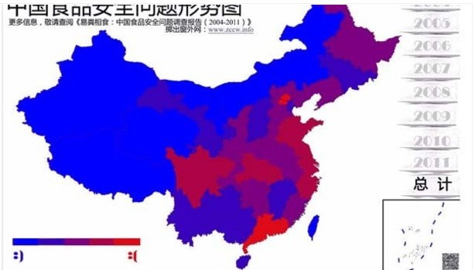

End of appendix 1

