Consultation response template
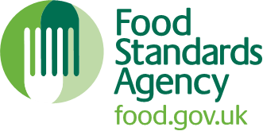

Name: Click or tap here to enter text.
Organisation: Click or tap here to enter text.
Email: Click or tap here to enter text.

Question 1. Does the layout / presentation of the proposed revisions to the Code facilitate consistent interpretation? If not, how could they be improved?
Click or tap here to enter text.

Question 2. Do you agree that the proposed changes to the food standards intervention rating scheme provide LAs with the ability to deploy current resources more effectively by improving the way in which the levels of risk and compliance associated with a business are assessed? If not, why not? (Please specify any aspects of the new model which require further consideration, and why).
Click or tap here to enter text.

Question 3. Do you agree that the proposed frequencies for official controls, specified in the decision matrix, within the new food standards intervention rating scheme are appropriate based on the levels of risk and compliance associated with the business? If not, please identify any concerns you have with the proposed frequencies.
Click or tap here to enter text.

Question 4. Do you foresee any problems with the proposals under consultation? If yes, please outline what these problems are and what, if any, solutions we should consider?
Click or tap here to enter text.

Question 5. Do you agree with our assessment of the impacts on LAs and our assumptions on familiarisation resulting from the proposed changes to the Code? If not, why not?
Click or tap here to enter text.

Question 6. Do you foresee any other impacts from the implementation of the main proposals detailed beyond those we have identified? Where possible, please explain your views and provide quantifiable evidence (for example, costs associated with updating your administration systems, existing procedures, the benefits of greater flexibility to allocate staff to activities).
Click or tap here to enter text.

