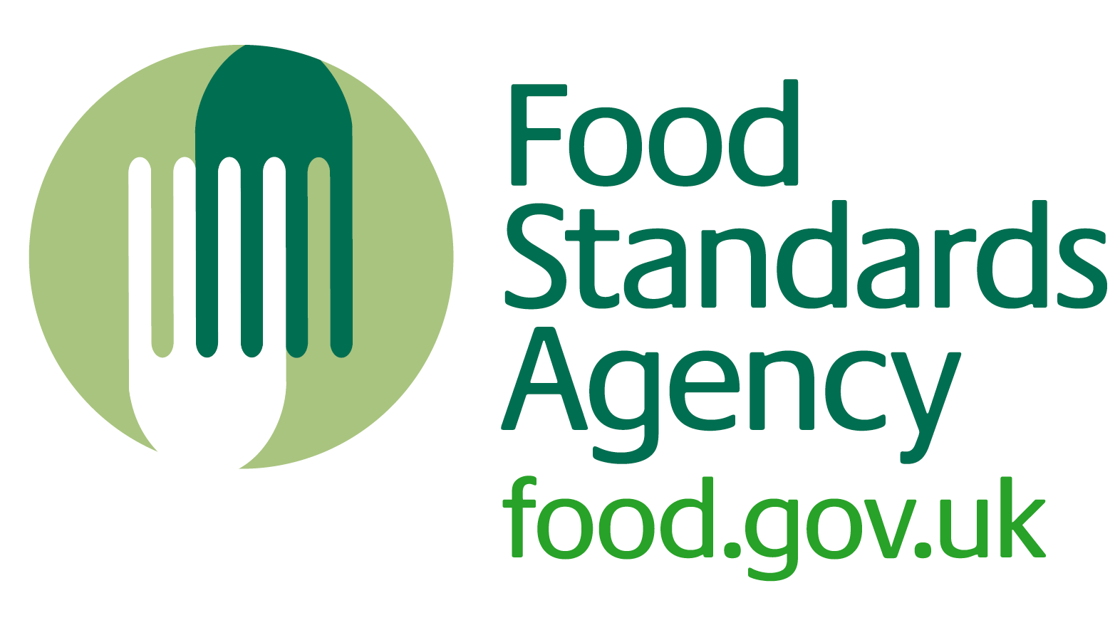
HO1

Opening and closing checks for Roberts Restaurant (kitchen)

Opening checks
You should do these checks at the beginning of the day:
- All fridges, chilled equipment and freezers are working properly.
- All other equipment (for example, oven) is working properly.
- Staff are fit for work and wearing clean work clothes.
- Food preparation areas are clean (work surfaces, equipment, utensils etc.)
- There are plenty of handwashing and cleaning materials (soap, paper towels, cloths etc.)
- Cleaning has been carried out according to the cleaning schedule

Closing checks
You should do these checks at the end of the day:
- No food is left out.
- Food past its ‘use by’ date has been thrown away.
- Dirty cloths have been removed for cleaning and replaced with clean ones.
- Waste has been removed and new bags put into the bins.
- The SFBB diary has been completed (reporting by exception) and signed and dated.
- Cleaning has been carried out according to the cleaning schedule

