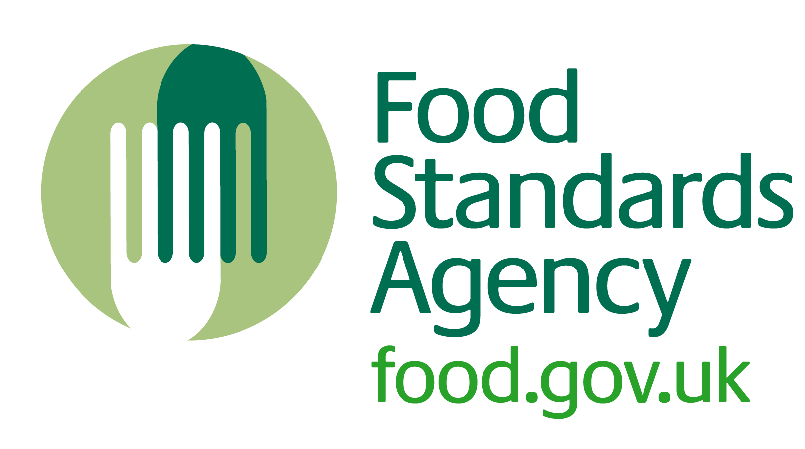
HO3

Opening and closing checks for Roberts Restaurant
(front-of-house areas)

Opening checks
You should do these checks at the beginning of the day:
- The dessert trolley, cold counters, ice machine and fridges are working properly.
- Staff are fit for work and wearing clean work clothes.
- There are plenty of handwashing and cleaning materials (soap, paper towels, cloths etc.)
- Surfaces are clean (counter tops, floors, equipment etc.)
- The restaurant and bar areas are ‘fit to trade’ i.e. clean and tidy, shelves stocked up etc.
- Other equipment (for example, glass washer, chafing dishes) are working correctly.
- Cleaning has been carried out according to the cleaning schedule

Closing checks
You should do these checks at the end of the day:
- Food and drink garnishes that have passed their ‘use by’ date, or any damaged or unfit (for example, mouldy) foods, have been removed from sale.
- Foods removed from sale have been disposed of correctly.
- No unwrapped food is left out.
- Waste has been removed and new bags put into the bins where required.
- The SFBB diary has been completed (reporting by exception) and signed and dated.
- Cleaning has been carried out according to the cleaning schedule

