
HO4

SFBB diary
Attached is a sample diary to show how a completed diary might look.
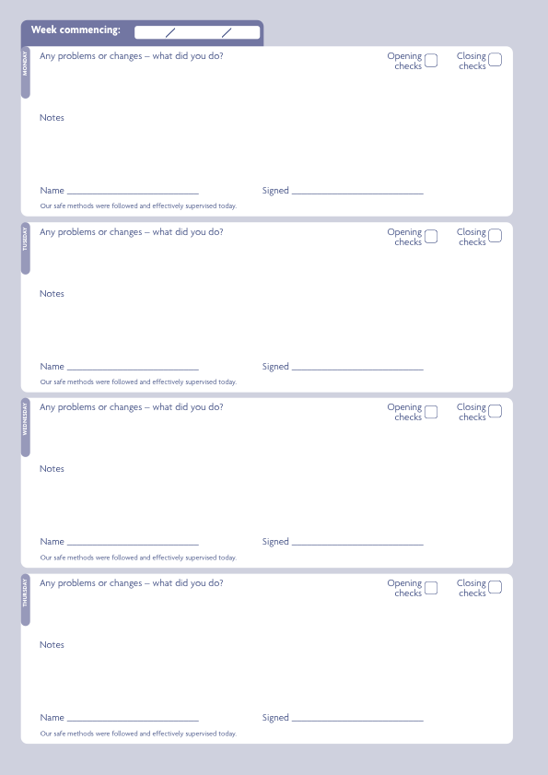
5 01 2009

Closed today
Pork dish under cooked.
Returned to oven and checked again to make sure no pink or red in centre

New Special on the menu – haddock and chips.

Safe methods checked for this dish.
Sophie Wells induction training completed.
Fish supplier has suddenly closed – gone out of business.

Changed supplier to ‘Fish4Us’.
Paul Wells started as a kitchen porter – completed his induction.
Jane JacksonJJackson
Jane JacksonJJackson
Jane JacksonJJackson
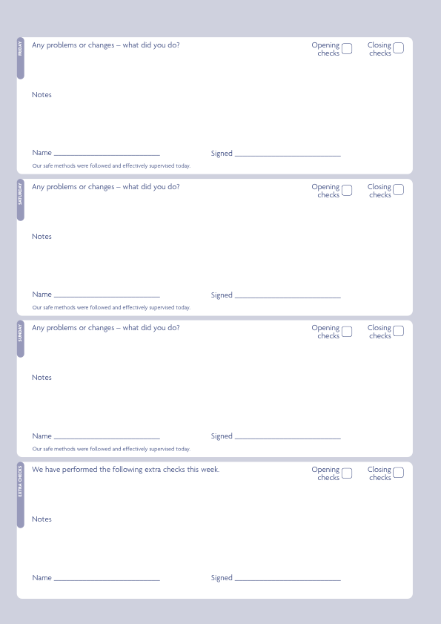
Microwave broke down today.
Put up ‘out of order’ sign.
No hand wash soap available at the sink – Jo refilled it today.
Microwave fixed by Mr Fix Shop.

New special on the menu – Prawn stir fry
Safe methods checked.
No problems or changes today

High level cleaning

Jane JacksonJJackson
Jane JacksonJJackson
Jane JacksonJJackson
Jane JacksonJJackson
12 01 2009

Closed today
Microwave broke down again.
Reported it to Mr Fix Shop
Completed SFBB training with Paul Wells.
Microwave back in kitchen
Reported it to Mr Fix Shop
Completed SFBB training with Paul Wells.

Customer complained that they found a hair in her food.

Manager dealt with the customer.
Jo – kitchen – retrained in wearing hairnet correctly
√√

√√

√√

Jane JacksonJJackson
Jane JacksonJJackson
Jane JacksonJJackson
Microwave broke again!
New microwave purchased, the old one thrown out.
Staff trained on new microwave.

No problems or changes today.

No problems or changes today.

Jane JacksonJJackson
Jane JacksonJJackson
Jane JacksonJJackson
19 01 2009
Closed
Closed

Paul Wells rang in sick with vomiting – advised him to stay off work till he has no symptoms for 48 hours.

No problems or changes today.

√√

√√

Jane JacksonJJackson
Jane JacksonJJackson
New dessert special – strawberry and fresh cream cakes.

Safe methods checked for this dish.
Mixing bowl cracked – threw it away.
No problems or changes today.

Deep cleaning – kitchen.
Checked by J. Jackson.
Jane JacksonJJackson
Jane JacksonJJackson
Jane JacksonJJackson
Jane JacksonJJackson
26 01 2009

Closed today
No problems or changes today.

Left hand oven not working correctly.
Reported to supplier.
Out of order sign put on oven.
No problems or changes today.

√√

√√

√√

Jane JacksonJJackson
Jane JacksonJJackson
Jane Jackson JJackson
Mouse droppings seen in dry store.
Pest controller called – full clean completed.
The damaged food thrown away.

No problems or changes today.

Dead mouse found in the dry store.
Area fully cleaned – mouse disposed of.
Extra pest control checks.
Re-trained staff on aspects of pest control.
Jane JacksonJJackson
Jane JacksonJJackson
Jane JacksonJJackson
Jane JacksonJJackson

