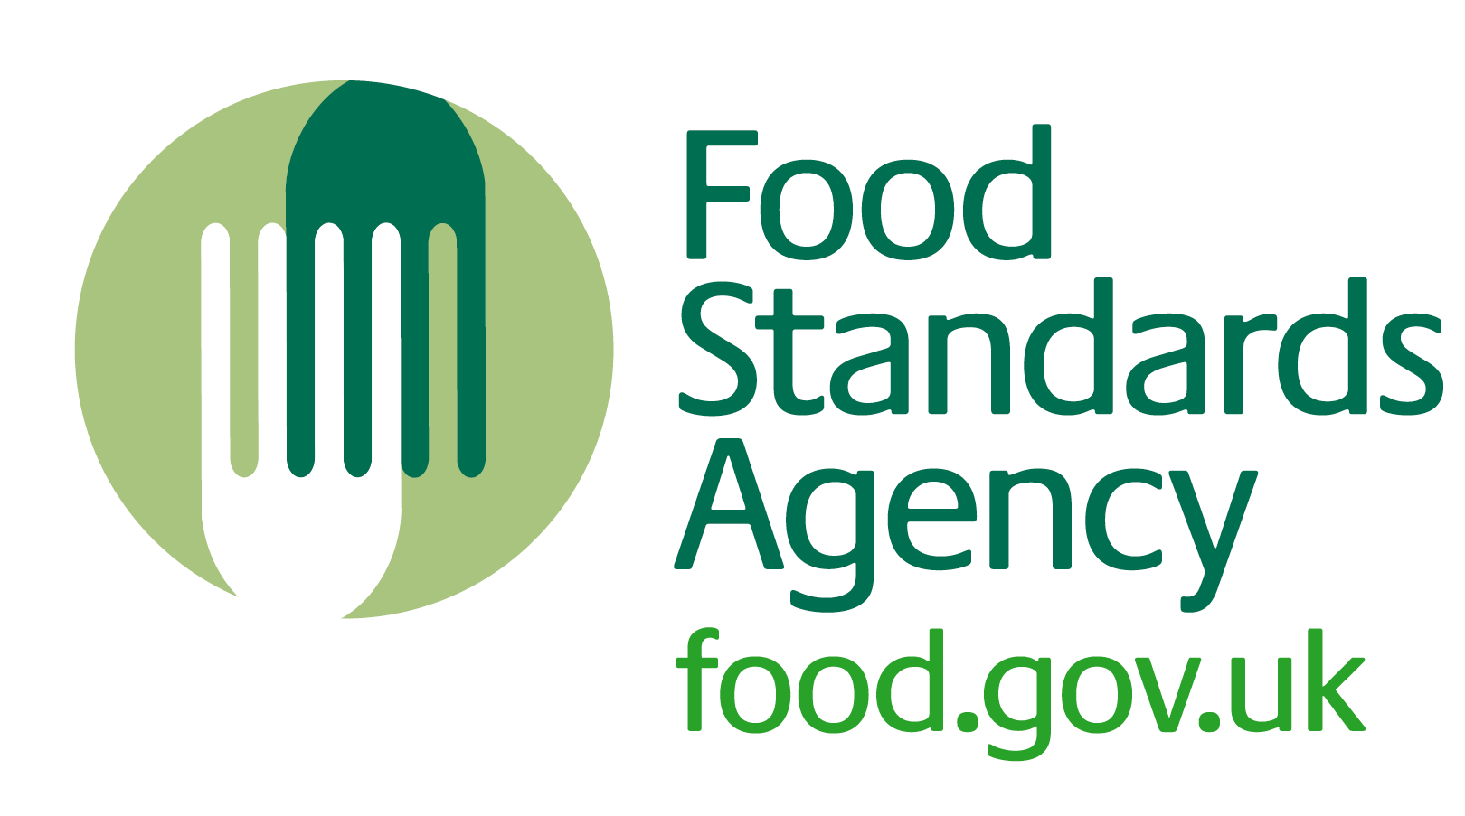
HO5

SFBB 4-weekly review
Attached is a sample 4-weekly review to show how it might look when it has been completed.
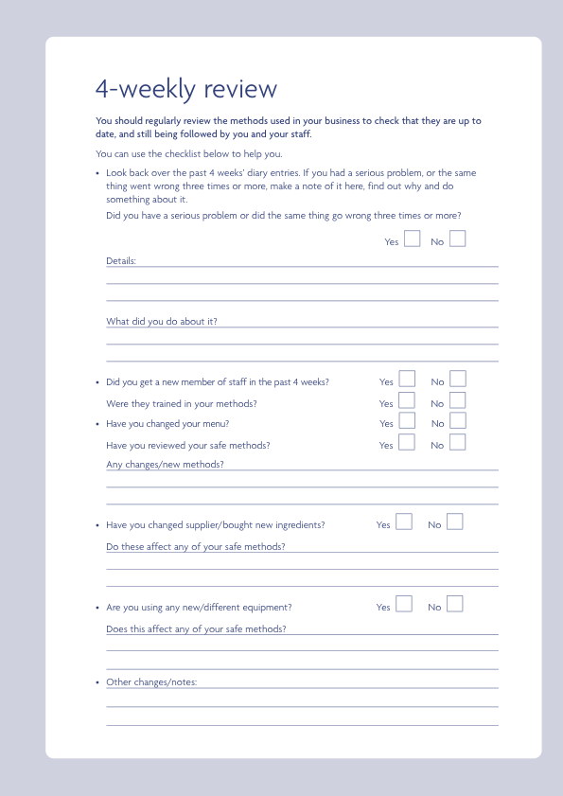
Hair found in a customer’s food
Mouse droppings and dead mouse found in dry store.
Re-trained Jo in the kitchen on the correct way of wearing her hairnet. Pest control, cleaning and re-training. We assessed the food and threw out contaminated food where necessary.
√

√

√

√

√

2 new specials.
Yes, new fish supplier ‘Fish4 Us’ – quality documents received.
New microwave – staff trained.
Must make sure Sophie Wells completes all her safe methods induction.
√

√

