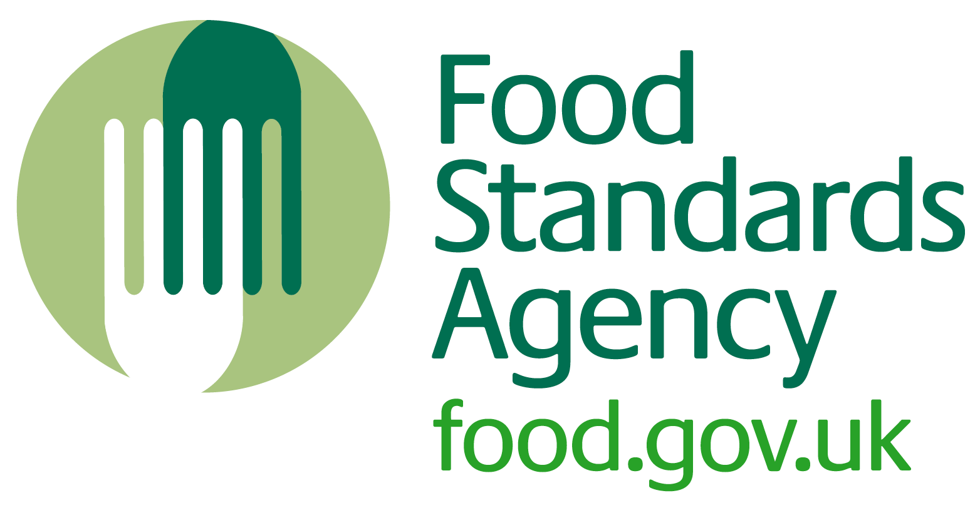

Training checklist for the delivery of SFBB to catering lecturers and support staff prior to the implementation of SFBB

Delivery:
This training is for the person who will be ultimately responsible for the SFBB system within a specific vocational area (for example, production, pastry, larder, restaurant, stores).

It is envisaged that this information will be communicated to the relevant staff either on a one-to-one basis or in small groups. This is to promote relevance within each training area. The method of delivery will very much be determined on the prior knowledge of the staff and their willingness to comply with these systems. On average, it is envisaged that this training will take two hours.

Topics:
For all staff, the following topics will need to be delivered:
- SFBB systems and legal compliance
- Working through all the safe methods relating to the relevant area and signing of the training record in the SFBB pack
- Preparing the opening and closing checks for the area
- Completing the SFBB diary
- Undertaking a 4-weekly review

Resources available
- SFBB packs
- Guidance available on the FSA website: Managing Food Safety
- Relevant PowerPoint presentation
- Handouts 1–5
- Any other suitable resources that you have prepared

