
Case study
The SFBB journey
Introduction
The purpose of this case study is to describe the steps we at Northampton College have taken to implement SFBB within all our catering facilities.
It will look at:
- a description of the size, scale and scope of the catering facilities at Northampton College
- the processes undertaken to implement SFBB within the department
Background
Northampton College is classified as a medium-sized, general-purpose further education college.
The catering department
The role of the catering department within the college is twofold.
The academic and training arm centres on the delivery of mainly NVQ/VRQ programmes at levels 1 to 3. Working with approximately 160 full-time and 300 part-time learners, much of the delivery takes place in practical sessions within realistic working environments.
Our second role is in the provision of a catering service across three sites. This includes the operation of various self-service operations providing a range of hot and cold food and drinks, and an internal hospitality service with products ranging from tea and coffee to a full hot and cold buffet service.
The catering staff
The catering department is jointly run by two programme managers, supported by a catering manager and an assistant manager. On the academic side, both programme managers are contracted to teach 574 hours a year, together with 10.6 full time and 12 hourly-paid staff.
The catering services team is run on a day-to-day basis by a manager, supported by an assistant manager, five supervisors, 20 catering assistants (working in cafeteria areas), 10 catering technicians (working in training kitchens and stores), a chef technician and a bakery technician (both of whom have a dual training and operational role).
The practical areas
Cafeteria areas are open 8am to 7pm Monday to Thursday and 8am to 3pm on Fridays and Saturdays. Although predominantly staffed by a cohort of catering assistants employed by the college, this area is also used for the delivery of part-time day release and full-time level 1 NVQ qualifications. Training is delivered by lecturing staff, supported by a chef/trainer.
Full-time learners undertake most of their practical work between Tuesday and Thursday. Monday and Friday have been set aside for theory delivery, testing and key skills.
Practical areas are as follows:
Larder – butchery  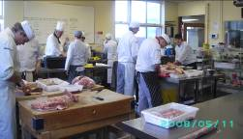 | This kitchen provides all meat and fish required for practical production and training classes. Lecturers place requisitions with the larder lecturer who is then responsible for the control and ordering of meat and fish.  It is then prepared for each class in line with menu requirements.
Larder – cold prep  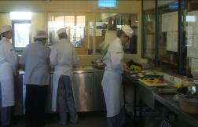 | Situated alongside the larder, this cold kitchen prepares salads for two salad bars, cold starters for the lunch-time restaurant and bistro and completes any internal hospitality orders.
Pastry  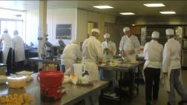 | This area operates for two sessions a day. The morning session is run by VRQ learners preparing hot and cold desserts for the restaurant and bistro.  The second session starts at 3pm and is run by level 3 learners preparing desserts for the evening restaurant.
Restaurant – production  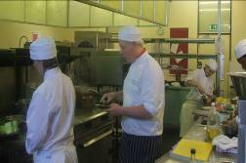 | This kitchen also runs two sessions a day. Lunch is a three-course table d’hôte menu for around 35–40 covers (see sample lunch menu).  Dinner production is undertaken by level 3 learners (see sample dinner menu).  All food is freshly prepared on a daily basis. Any food items that are not used are sent to the cafeteria to be used on the hot meal counter.
Bistro lunch – production  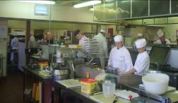 | The bistro lunch menu is more informal (see sample menu). Although only open for lunch-time service, it serves between 25 and 50 covers.  As above, any unsold food is transferred to the cafeteria.  In the evening, it is used by the pastry group for service.
Training kitchen 1  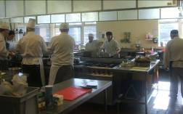 | This general-purpose kitchen is predominantly used by level 3 learners from Tuesday to Thursday. Mise-en-place for the evening production is undertaken by a daytime level 3 group.  It is also used for skills sessions, demonstrations and school link groups.
College restaurant  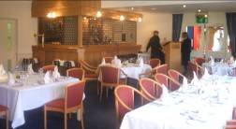  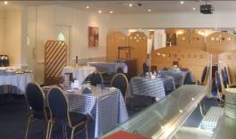 | This area is supervised by level 3 hospitality learners and run by level 2 food-service groups. At lunch time, screens divide the restaurant to create a bistro at one end. In the evening, the space allows us to accommodate functions of around 100 covers.  It is often used on Mondays and Fridays as a classroom. A data projector and screen are attached to the ceiling in the bistro.  As the largest space within the college, it is often used for college training events and meetings.
Cafeteria  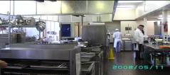  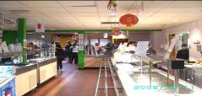 | This is the main eating facility within the college. With around 2,500 transactions a day, this busy unit aims to meet the needs and requirements of its diverse body of customers.  Main food items include soups, salads, jacket potatoes, fast food, hot meals and a range of confectionery items.
The bakery  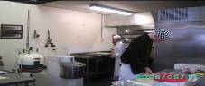  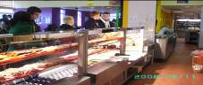 | The bakery is open Tuesday to Thursday, producing a range of items produced by learners.  All are sold in the bakery shop, which is situated alongside the cafeteria area.  Bread and bread rolls for the restaurants also come from this area.
Before SFBB
Food safety practices and procedures within the catering team have been consistently 'reasonably' robust. All learners receive level 2 food safety training during their induction and level 3 learners complete level 3 food safety training. All catering support staff and additional support assistants are also trained at level 2. Cleaning practices, maintenance programmes and frequent building checks have always been high-priority areas.
However, there has always existed within the catering team a limiting belief that due to the 'unique' nature of our business, a workable HACCP (hazard analysis critical control point) system did not exist. The range of products produced, the number of staff and learners involved in the processes, and the movement of food items and dishes around the department was considered to be untrackable.
Several IT-based tracking systems were investigated, but it was felt that most systems would need us to employ additional staff to implement, monitor and control their operation. This was not an option.
The result was that after an environmental health inspection, we received a 'Scores on the doors' rating of two stars. In another inspection, following the implementation of SFBB, we achieved a rating of four stars.
Implementation of SFBB
- We started by ensuring that all our catering supervisors undertook the L3 Supervising Food Safety Award.
- It was agreed that we would use SFBB in all areas. It could be argued that our operating systems are far too complex for this system. However, we felt it was important that our learners were familiar with a system they are likely to find in industry. The only way we felt this system could work effectively would be to treat each production area as an individual SFBB area.
- It was identified that the lecturer responsible for a class would be responsible for the HACCP system. Level 3 learners (in their role of head chef) may be responsible for opening and closing checks and signing the diary, but the lecturer would need to countersign.
- Rather than impose the system across all areas simultaneously, we decided to introduce SFBB to two production areas each half term. We started in September 2008 with the bistro kitchen and the training kitchen. Although chef lecturers work in many different areas, all are allocated a kitchen for which they are responsible. The kitchens selected to implement SFBB initially were chosen because they were run by lecturers who were respected across the team, had high standards, could influence others and could cope with change.
- In August, SFBB was explained to the two lecturers. Current practices and systems were audited and reviewed and, where appropriate, alterations were made. Opening and closing checks were written.
- In September, all new learners were introduced to SFBB as part of their level 2 food safety qualification. All were shown the 'staff section' of the DVD and signed the Training matrix to indicate they had received basic SFBB training.
- Within the first few weeks of term, all returning level 2 and level 3 learners received a two-hour training session on SFBB and signed the Training matrix. Level 3 and more able level 2 learners were also trained in conducting opening and closing checks and diary recording.
- During the first few weeks, both kitchens were audited to identify any further training needs. The 4-weekly review was completed and feedback given to improve diary writing and recording menu changes. Temperature monitoring systems were deemed to be erratic and so all catering technicians received further training.
- As our learners work in a new kitchen every two weeks, we needed to ensure that they were aware of the specific safe methods relevant to each kitchen. We also recognised that it was important to maintain the awareness of SFBB and the importance of safe methods. To promote this, the safe methods were uploaded onto Moodle (the virtual learning environment used within the college).
- To demonstrate competency and understanding, different levels of tests and quizzes were also uploaded onto Moodle. Completed tests are emailed to be marked and results recorded on the Training matrix.
- By spring 2009, SFBB had been implemented in lunch and dinner production sessions, all front-of-house training areas, pitstop, stores, larder and pastry kitchens, as well as the cafeteria and bakery. After an environmental health inspection in March 2009, we were awarded a 'Scores on the doors' rating of four stars.
Summary
Overall, the majority of staff have understood the importance of SFBB systems and have worked to implement them. A few (as to be expected) have not coped well with change. The key has been in ensuring clear and supportive communication. All practical areas continue to be audited every half term (in addition to the 4-weekly review) and as long as the report writing is fair with solutions identified, most staff perceive it as a positive initiative. Many unexpected areas for improvement have been identified and current practices challenged. Although at times this has led us to question why we even started this project, we are now at a stage where we believe the skills and knowledge our learners have gained can only help the catering industry of the future.

The College Restaurant
Lunch Menu
Hors d’oeuvres
Cream of tomato soup
Lentil and coriander soup
Poached egg florentine

Poached salmon with watercress sauce
Turkey escalope, asparagus and potato rosti
Braised lamb chop champvallon
Roast beef with Yorkshire pudding and
horseradish sauce
Mushroom omelette

Sauté potatoes
Marquis potatoes
Braised leeks
Glazed carrots

The College Restaurant
Dessert Menu
White chocolate orange pear condé
Profiteroles and chocolate sauce
Tropical trifle
Meringues with raspberry mousse
Lemon posset with shortbread
Chocolate roulade
Hot dessert
Jam roly-poly
Bread and butter pudding

Coffees Teas

The College Restaurant
Dinner Menu
Scallops and seared salmon, served
on a bed of creamed linguine
Chicken liver pâté served with red onion chutney
Smoked meats with butternut squash tartlet,
spiced plum and ginger glaze
Tian of cream cheese and avocado with orange salad

Cream of cauliflower and thyme soup

Poached lemon sole and pollock served with braised fennel, courgette ribbons and cocotte potatoes
Partridge with redcurrant and whisky jus,
berrichonne potatoes, parsnip crisps, sugar snap peas
and honey glazed carrots
Pan-fried guinea fowl with cranberries, garlic roast potatoes, braised red cabbage and salsify
Cassoulet of pork served with sweet potato mash
and green beans
Beef fillet with gratin of wild mushrooms, celeriac mash
and sprouting broccoli
Ravioli filled with spinach and mushroom served with
pea risotto and goats cheese fritter
The College Restaurant
Dessert Menu
Sticky toffee pudding with rum and raisin ice cream
Bread and butter pudding served with chocolate rice condé
Mandarin custard tart
Blueberry parfait savarin
Blackberry bavarois
Selection of British cheeses

Freshly brewed coffee or tea and petit fours

Four-corners Bistro
Leek and potato purée soup
Smoked mackerel mousse – from Larder
Roast beef, Yorkshire pudding, horseradish sauce
Roast gravy
Roast potatoes
Dauphinoise potatoes
Green beans with toasted almonds
Buttered macedoine swedes
Lasagne
Fresh linguine of seafood with a chive and
grain mustard sauce
Sweet potato and goats’ cheese rosti, couscous-stuffed pepper
Sweet and sour pork, egg fried brown rice
Chargrilled marinated pork cutlet, puy lentils and glazed apples with sage
Deep-fried fillet of haddock with hand-cut chips and mushy peas
Freshly baked ham and mushroom pizza
Tandoori lamb kebab, English curry sauce, timbale of pilaf rice, garlic naan, mint and cucumber raita

Northampton College
SFBB reward scheme
- Three different schemes exist across three main programme areas. In each scheme, groups compete against each other.
- The scheme is based around the audit system. When each area is audited, two points are awarded for examples of good practice and four deducted when an unsafe practice is observed.
- Audits are conducted for each group throughout the year. The most appropriate times have been identified as:
- beginning of October
- end of November
- end of January
- beginning of March
- beginning of May
- NVQ Level 1 programme has two groups of learners working in practical sessions. VRQ 1 (first years) and NVQ Level 2 (second years) combine to form eight practical groups. NVQ Level 3 has three groups.
- When auditing the groups, it is important to try to ensure consistency across the variety of operational areas. For example, it is recognised that there are more opportunities for observing an unsafe practice in a production kitchen than in the restaurant and this can affect the overall points score for that group.
- After each audit, the groups’ scores are recorded, together with the cumulative score, and displayed on a notice board. Recognition is given to groups doing well. The names of any learners who were observed following an unsafe practice are never disclosed publicly. Motivational encouragement is given to those groups who did not do well. Any training opportunities identified are discussed with the relevant lecturers.
- After the final audit, the group with the highest score will receive a certificate of achievement and gift vouchers.
- Other rewards can also be offered to the group with the most improved score. Any group not doing well can be set its own target and rewarded if it is met.

