Northern Ireland consumer perceptions of reformulation of food
Category report (Bakery – cake, morning goods, biscuits)

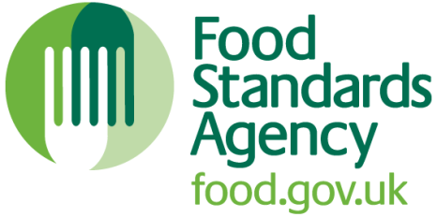

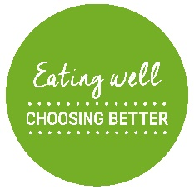
April 2019

Contents

1 Executive summary 4
2 Introduction 9
2.1 Background and context 9
2.2 Research objectives 9
2.3 Research methodology 10
2.4 Category reporting: purchasers of bakery products: cake, morning goods and biscuits 12
3 Main findings 13
3.1 Awareness and perceptions of reformulation 13
3.1.1 Existing concerns about eating more healthily 13
3.1.2 Awareness of efforts to reduce fat, sugar and salt content 15
3.1.3 Acceptance of reformulation 17
3.2 Acceptability of reformulation 23
3.2.1 Overall likelihood to purchase 23
3.3 Implications for engagement and communications 29
3.3.1 Communications: product information is important 29
3.3.2 Changes to retail environment 33
3.3.3 Wider public education and messaging 35
3.4 Final considerations 37
3.4.1 Changing eating behaviour is complex and takes time 37
3.4.2 Upsetting the treat landscape could have unintended consequences 37
Appendix 1: List of figures 39
Appendix 2: List of tables 39
Appendix 3: Qualitative sample overview 40
Appendix 4: “2CV Momento” 42

1 Executive summary

Background and methodology
In January 2018, the Food Standards Agency (FSA) commissioned 2CV and Community Research to conduct independent research exploring Northern Ireland (NI) consumers’ perceptions of food reformulation (to reduce levels of sugar, fat, salt) and reductions in portion size by the NI food industry. Research focused on seven higher priority food categories from the Eatwell Guide which are included in Public Health England’s (PHE) sugar reduction and wider reformulation programme: breakfast cereal, morning goods (e.g. croissants, scones, pancakes etc), ice cream, yoghurt, cake, pudding and biscuits. These have been identified to be among the categories which contribute most to children’s sugar intakes. A strong evidence base was required to inform the FSA’s engagement and partnerships with industry, as well as the FSA’s own consumer messaging and communications to support small and medium sized businesses (SMEs) in NI. This report focuses specifically on consumer attitudes to product reformulation of bakery goods; specifically, cake, morning goods and biscuits, while drawing in the broader findings from the rest of the research.

A multi-method and staged approach was used, combining traditional and experimental research techniques. Qualitative focus groups and digital diaries explored what informs consumer perceptions and the real-world context in which people make decisions about what food they eat and buy. This was followed by quantitative engagement with consumers to measure acceptance, purchase intent and the impact of framing on acceptance. The methodology drew on best-practice behavioural science thinking to get closer to consumers’ actual purchase behaviour.

Research methods used
While there are many different ways to conduct research, methodologies broadly fall into one of two categories: qualitative or quantitative. For this study we chose to employ both types to both quantify and measure people’s behaviours and attitudes, as well as explore and understand why they hold these attitudes and what motivates them.
Qualitative and quantitative approaches to research differ greatly, from the type of information they collect, to the way the research is conducted, and the nature of the evidence base they yield.
Qualitative sample sizes are generally much smaller than quantitative samples, as the emphasis is on depth of exploration rather than breadth. Where quantitative sample sizes tend to be several hundred people, qualitative sample sizes can range from as few as six people (e.g. for an in-depth ethnographic study) to 100 (e.g. for a citizen forum or deliberative study).
What does this mean for reading this report?
When we report on qualitative findings we are often reporting on the strength of feeling as expressed by both individuals and groups. In quantitative research, we are looking for majority and minority views, and statistically significant differences.
- Quantitative research – designed to measure and generalise behaviours and attitudes. The quantitative findings throughout this report are therefore primarily referenced in the form of numerical data e.g. numbers and percentages.

- Qualitative research – used to provide understanding of an audience or subject. It uncovers reasons, opinions and motivations underlying people’s decisions and behaviours. Emphasis is on exploration not measurement. The qualitative findings detailed in this report are therefore referenced using words, descriptions and quotes to describe meaning.

Research Findings: Bakery products (cake, morning goods and biscuits) focused summary
There were no major differences in consumer perceptions in the bakery category (cake, morning goods and biscuits) when compared with other priority food categories asked about in the research. There is a broad acceptance of the need for food reformulation which is at similar levels to other food categories.
Acceptance of reformulation for bakery products of cake, morning goods and biscuits, as for other products rested on three conditions, that product taste, value and health (perceived healthiness or allergy risks posed by replacement ingredients) must remain consistent. Health concerns were seen as less of an important issue for bakery products than for other categories such as ice cream or yoghurt.
In line with other high priority food categories, acceptance of reformulating morning goods and biscuits was greater than the proposal to resize such products.
While likelihood to purchase resized products was not significantly lower than reformulated products for biscuits and morning goods, it was directionally lower, reflecting a common trend across other food categories. Cake is the only food category where this is not the case and likelihood to buy remains similar across reformulated and resized products.
For any changes to bakery products, as for all food products, communication and engagement activities will be key to building consumer trust. A multi-pronged approach to communication was identified as necessary, encompassing changes to the retail environment, product information and public education and engagement. Participants of the research highlighted the importance of clear labelling to indicate food reformulation. Consumers most commonly stated that they would like to find out about changes through information shown on the front of pack. This was the case across all food product types.
Research Findings
There was broad acceptability of the reformulation initiative
NI consumers broadly accepted the need for food reformulation, seeing it as a move in keeping with current health trends and with potential benefits for themselves and their family. It aligned with their aspirations for healthy living. Resizing products was also accepted, in principle due to the perception of wider social benefits, even though individuals felt that they themselves would lose out.

Acceptance existed regardless of what consumers believed the rationale for it was
NI consumer acceptance of food reformulation existed no matter who the consumers believed was driving it. Acceptance was significantly lower when people were informed it was driven by industry, compared to when they were informed it was driven by government or when not told anything at all. Qualitative research confirmed that NI consumers are wary of industry motives surrounding health marketing and this led consumers to doubt the ultimate consumer benefit of reformulation.
Acceptance rested on three conditions: product taste, value and health
NI consumer acceptability of reformulation, both reformulated recipes and reduced sized products, rested on three conditions – that the new products matched old ones in terms of taste, value and the perceived healthiness or allergy risks posed by replacement ingredients. These consumer priorities are all well-evidenced through previous FSA research, namely FSA NI Food Labelling (2016), Our Food Future (2016) and FSA Strategy 2015-2016 (2014).
Acceptability was higher for reformulated products than resized ones
Across all food categories, NI consumers were more accepting of reformulated than resized products, both reduced overall size (e.g. fewer biscuits in pack) and reduced portions sizes (e.g. smaller biscuit size).
The likelihood to purchase was significantly lower for smaller sized biscuit packets, with directionally fewer participants stating they would buy biscuits with a smaller portion size compared to lower sugar or lower fat biscuits.

For morning goods, the likelihood to purchase was highest for lower sugar and lower fat products, with a directionally lower proportion of participants stating they would buy a smaller portion size. These results reflect the broader trend across the seven higher priority food categories of consumers being less likely to buy resized products than reformulated. This may be due to consumers expectations that reformulated products would not compromise the key condition of value. Whereas, acceptability of resized products was generally lower as people believed consumers were losing out at the manufacturers’ gain.

For cake there were no significant differences in likelihood to buy, although directionally, lower fat cake products were the least likely to be purchased.

The research demonstrated the acceptability of reducing product size was the least favoured of all options, as the consumer benefit was least clear. People did not see themselves eating any less (therefore the change would provide no health benefit), they foresaw difficulty with meal-planning (“[Product] size change is not a good option as this is a good size for a full meal”) and most importantly the value condition was forfeited as they felt they would get less value for their money.
Communication and engagement activities will be key to building consumer trust
While this research demonstrated there was broad acceptability of reformulated foods, NI consumer concerns surrounding the taste, value and health of products will need to be addressed at product launch and in longer-term communications to guarantee the initiative’s success. Qualitative research revealed that creating a “positive buzz” around the initiative will be important for providing this reassurance. It further highlighted the need for messages and engagement activities to come from a wider perspective, and numerous stakeholders, than just the food industry as this will help to allay concerns about questionable motives.
A multi-pronged approach to communication was identified as necessary, encompassing changes to the retail environment, product information, public education and engagement. Brand communications and marketing were considered important, but other actions will be needed to shape consumer behaviours, shift attitudes and confront public scepticism.
The research has shown that clear and noticeable information signalling product changes will be important for creating trust and for reassuring consumers that their three conditions – taste, value and health – are being met. Participants of the research also welcomed the fact that clear labelling created consumer choice, which is something they valued. Consumers most commonly stated they would like to find out about changes through information shown on the front of pack. However, as previous research also shows, consumer demand for product labelling can be contradictory; they say they want information but in reality they do not pay attention to the information provided. We also know that feeling ‘overwhelmed’ by health claims and marketing can have a negative effect on consumer trust and can lead to disengagement. It will therefore be important to consider the right balance between transparency and overload.

Participants of qualitative sessions viewed the retail environment as the logical place for engagement initiatives such as in-store demonstrations, taste tests and information stands. As consumers have questions and concerns surrounding food reformulation, engaging with new products prior to purchase could help allay doubts, create positivity and raise general awareness. In turn prompting word of mouth recommendations.

Wider public messaging and a proactive government voice are also valuable
This research clearly demonstrates the risk that consumers will reject food reformulation if they believe the initiative is being led by industry. A supporting public voice is therefore critical to build consumer trust in the initiative and to make the consumer benefits of reformulation clear.

Recent FSA Trust research supports this proactive government role and points to the value it has for building trust in the wider food sector, including brands. The public want to know that someone is looking out for consumers’ interests and holding industry to account (FSA Trust, 2018) .
FSA Trust findings, March 2018, research conducted for FSA by 2CV and Community Research
- While trust in the food system is generally higher than other sectors, it is still fragile and the ‘trust bond’ people have with food brands and the wider system can easily be shaken.
- People value a proactive government that is seen to hold industry to account and safeguard consumer interests.

2 Introduction

2.1 Background and context
In January 2018, the FSA commissioned 2CV and Community Research to conduct independent research to explore NI consumers’ perceptions of food reformulation (to reduce levels of salt, sugar, fat) and reduction in portion size by the food industry in NI among identified categories of food from the Eatwell Guide.

This was identified as a gap in the evidence base through the Eating Well Choosing Better steering group. The FSA Eating Well Choosing Better programme is a 4-5 year initiative which aims to make the healthier choice the easier choice for NI consumers. The Eating Well Choosing Better programme, which is included in the draft Programme for Government delivery plan, leads on a number of workstreams including those with SMEs and with the retail sector in NI to increase the availability of healthier foods. Research was needed to inform the FSA’s own consumer messaging as part of the Eating Well Choosing Better programme and to help the FSA provide support to SMEs around communication and information provision for their consumers.

The programme complements and aligns with the sugar reduction and wider reformulation programme overseen by Public Health England on behalf of the Department of Health and Social Care, and has been developed following publication of the Childhood Obesity Plan. The FSA needed a strong evidence base to inform future engagement with industry and support on-going conversations and potential partnerships.

2.2 Research objectives
To explore consumer perceptions and acceptability of food reformulation (reduction in sugar, fat, salt / decrease in portion size) by the food industry in NI.
The overall key objectives are shown below. For this report, the focus is on perceptions relating to bakery products: cake, morning goods and biscuits.
- Determine consumer perceptions of the reasons the food industry may choose to reformulate or reduce the portion size of their products (including consumer awareness of government initiatives on reducing sugar, saturated fat, salt and portion size, and how this features over the consumer perception of the food industry reducing portion sizes as a cost-saving measure).
- Determine how acceptable consumers find reductions in portion size and product reformulation (reduction in sugar, fat, salt), for the seven higher priority food categories.
- Identify what information, if any, consumers would like to see on packaging or labels or in the media about reformulated and resized food and drink that has been reformulated or portion size has been reduced.
- Explore shopping behaviour in relation to food products that have been reformulated/ where portion size has been reduced.

In particular, the research focused on seven higher priority food categories: breakfast cereal, morning goods (e.g. croissants, scones, pancakes etc), ice cream, yoghurt, cake, pudding and biscuits. These have been identified as the categories which contribute most to children’s sugar intakes, included in PHE’s sugar reduction and wider reformulation programme.
This report focuses specifically on consumer attitudes to product reformulation of bakery products: cake, morning goods and biscuits, while drawing in the broader findings from the rest of the research.

2.3 Research methodology
A multi-method and staged approach was chosen for this study, combining traditional and cutting-edge research techniques: qualitative focus groups, digital diaries and quantitative scenario-testing. The bespoke approach was designed specifically to meet FSA’s objectives of understanding actual, not just claimed behaviour.

Figure 1 Research methodology
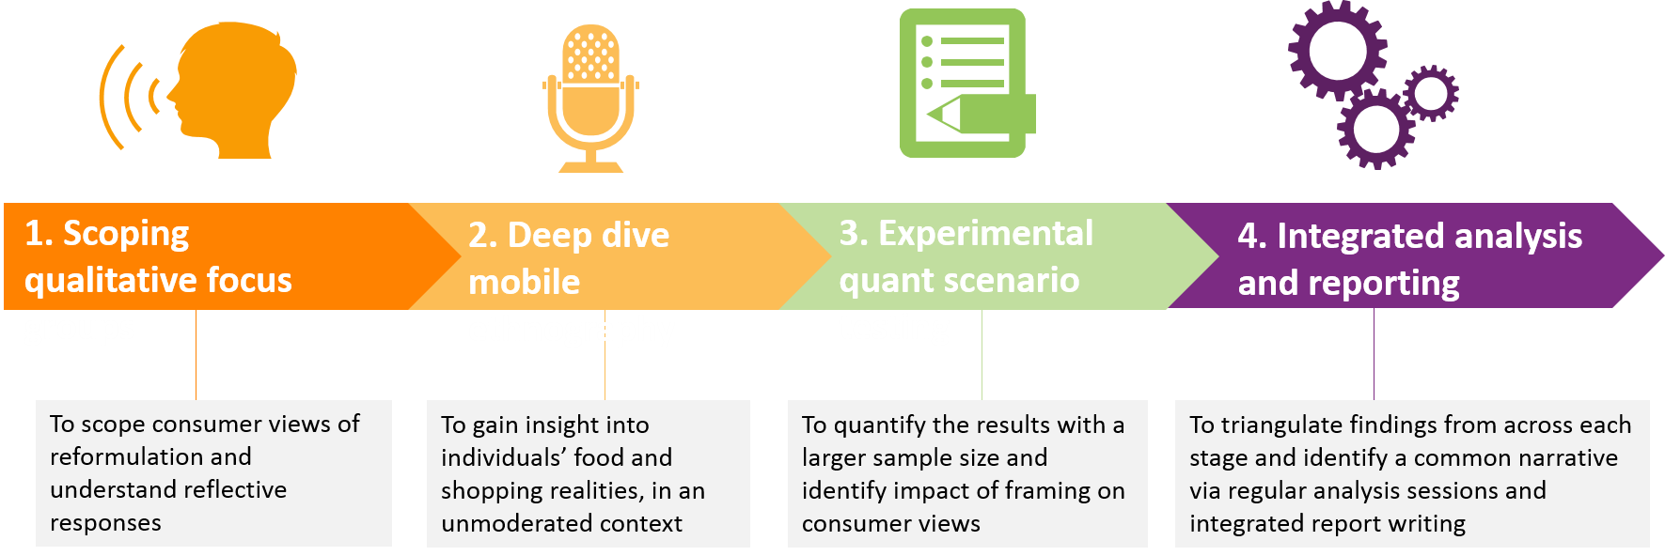

Stage 1: Qualitative scoping
The qualitative stage consisted of five focus groups with NI consumers (six to eight people per group, 35 participants in total) in Belfast and Portadown. Respondents were split by life-stage, gender (18 women and 17 men), socio-economic group and attitudes relating to food high in fat, sugar and salt, and healthy eating. These attitudes were asked in a pre-screener for all focus group participants.
The discussion flow was as follows: typical shopping habits; attitudes to nutrition and health; awareness of health issues and health in the news; spontaneous and prompted views of product reformulation and portion size reduction; reflective evaluation of product reformulation and portion size reduction (benefits and concerns); ideal future communications and engagement on product reformulation and portion size reduction.
Qualitative sessions informed the design of the quantitative survey and provided an initial insight on consumer perceptions, acceptance levels, conditions for acceptance and information needs.
Stage 2: Deep dive mobile
The mobile ethnography captured actual eating and shopping behaviour. 40 participants used 2CV’s bespoke digital research app “2CV Momento” to log their attitudes and behaviour across a two-week period. Participants were set a structured series of tasks designed to explore both claimed and actual behaviour, submitting a mix of photos, text, voice-notes and videos to demonstrate their behaviour.
Figure 2 Digital research tasks
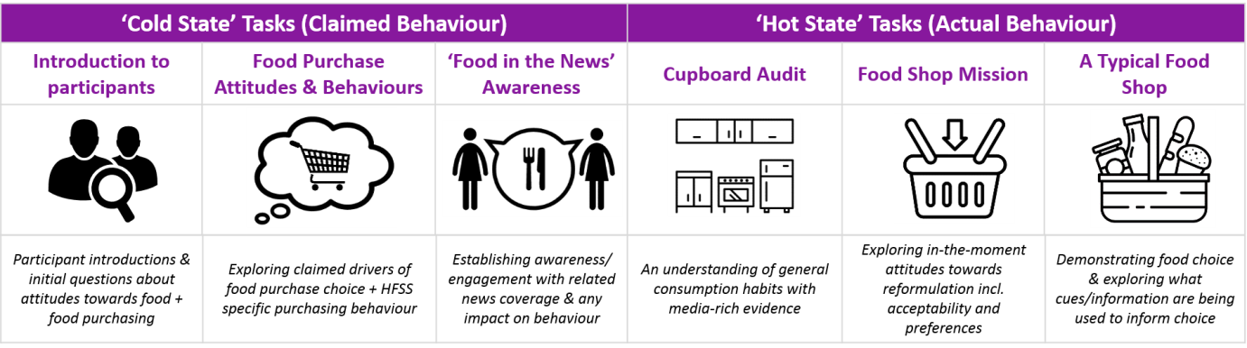
Stage 3: Quantitative survey and experimental scenario-testing
The quantitative element comprised a 15-minute online survey with 305 nationally representative consumers in NI. Within this, there were a number of elements:
- Current eating habits and importance, ease and barriers to buying healthier options in the seven priority categories (listed on Page 9).
- Spontaneous awareness of anything related to reducing the sugar, saturated fat, salt content in pre-packed or processed food.
- Quick response questions using behaviour science-inspired ‘swiping’ tool. This approach utilised a real-life shopping scenario as closely as possible to aid the understanding of how intuitive feelings impact a respondent’s likelihood to buy various reformulated foods (reduced sugar, reduced fat, reduced overall portion size and reduced individual portion sizes). Consumers also gave spontaneous and prompted concerns about reformulated food and perceived advantages.
- Scenario-testing to understand the impact of framing – how do consumers respond depending on who they think is driving food product improvements? With an experimental approach, consumers were prompted with one of three scenarios:
  - The government is asking food businesses to make their products healthier
  - Some food manufacturers and retailers are making their products healthier
  - No introduction to the idea
Consumers were then asked about spontaneous perceptions, positivity about changes to products bought, and on broader positive and negative perceptions about food changes.

Stage 4: Integrated analysis and reporting
Throughout the research process the project team met regularly to analyse the data, share emerging insights and identify key themes. Regular analysis sessions allowed the preliminary qualitative stages to closely inform the design of the quantitative questionnaire and ultimately ensured that findings from each stage were triangulated and a common narrative thread was identified.

This report details findings from the digital, qualitative and quantitative research phases. It draws these together, and where appropriate identifies which phase specific findings relate to. Whilst the report is an evidence base that recorded what the research found – the behaviours, attitudes and responses of research participants – there are also passages which reflect the interpretations and informed judgements of the research team who carried out the work.

2.4 Category reporting: purchasers of bakery products: cake, morning goods and biscuits

This report focuses specifically on the experiences and opinions of consumers who purchase bakery products: cake, morning goods and biscuits. This largely draws from the quantitative survey, including:
- Comparison of attitudes for those who purchased these categories, against ‘all consumers’ (any consumers who bought products in the seven higher priority food categories).
- Response to reformulation for those who purchase these categories. These questions were asked specifically about each category of food.
Consumers were asked to answer questions about three categories that they said they purchased regularly or occasionally. Where the report refers to e.g. ‘consumers who purchase cake’, this is defined as those who were allocated to answer about cake.
Within the quantitative survey, we surveyed 132 consumers who bought cake, 133 who bought morning goods and 131 who bought biscuits.
This report also includes overall findings drawing on the other elements of the research.

3 Main findings

3.1 Awareness and perceptions of reformulation

3.1.1 Existing concerns about eating more healthily

The research demonstrated there were existing concerns about healthy eating, with consumers stating healthier food options are important to them. Within the seven priority food categories (breakfast cereal, morning goods, ice cream, yoghurt, cake, pudding and biscuits), healthier options were seen to be the most important for breakfast cereal (85%) and yoghurt (77%), shown in Figure 3.

Consumers were less likely to say that healthier options were important to them when buying cake (31%), as shown in Figure 3. This was lower than the rest of the seven higher priority food categories.

Figure 3 Importance of healthier options
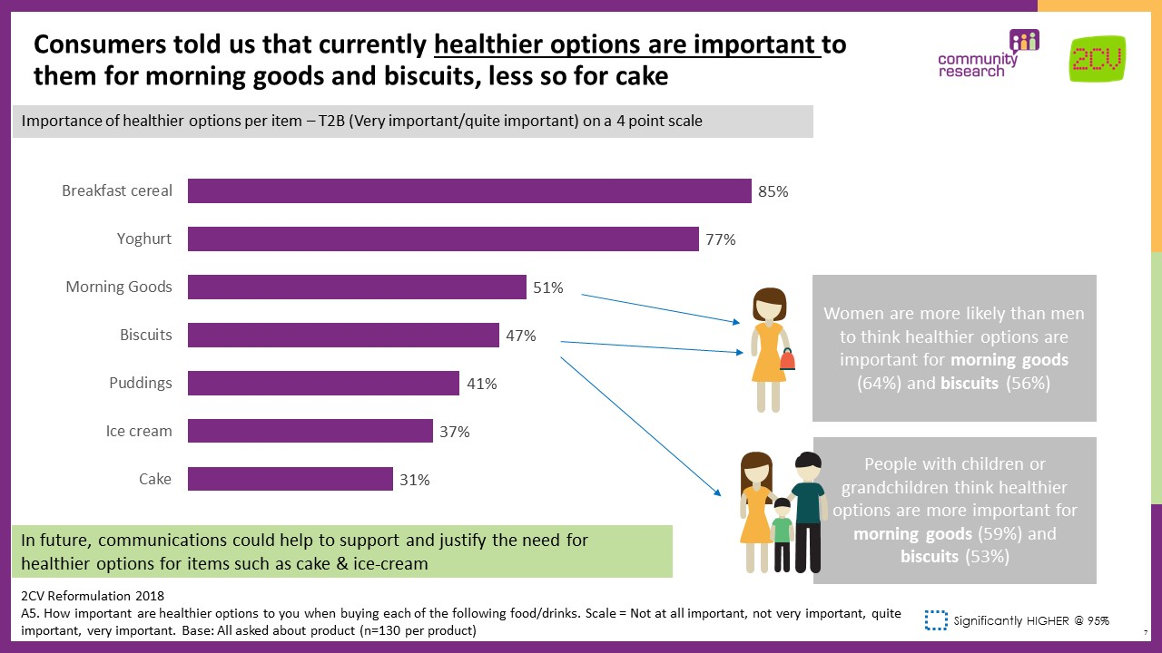

Women were more likely than men to think healthier options are important for morning goods (64%) and biscuits (56%).

The top reasons for not buying healthier options when purchasing cake were (as shown Table 1): healthier options not tasting as good, not looking for healthier options, the original options being more appealing and lack of healthier options available. Qualitatively, we found that for treat foods such as cake, the positive emotions people feel from having them are stronger, which can lead to a reluctance to try healthier alternatives.

‘Not looking for healthier options’ was less of a factor for morning goods (11%), with the top four reasons for not buying healthier options being: healthier options not tasting as good, the original options being more appealing, lack of healthier options available and they are too expensive. For biscuits, the top reasons were: healthier options not tasting as good, the original options being more appealing, healthier options being too expensive and not looking for healthier options.

Table 1 Reasons for not buying healthier options
Top reasons for not buying healthier options
Cake
The healthier options don’t taste as good | 31%
I’m not looking for healthier options | 27%
The original options are more appealing | 25%
There aren’t many healthier options available | 19%
Morning Goods
The healthier options don’t taste as good | 21%
The original options are more appealing | 20%
There aren’t many healthier options available | 19%
They are too expensive | 14%
Biscuits
The healthier options don’t taste as good | 28%
The original options are more appealing | 19%
They are too expensive | 18%
I’m not looking for healthier options | 17%

There were concerns that many foods aimed at children contained more of the ‘bad’ and so-called ‘unhealthy’ ingredients than they should; parents want to do something to help their children eat healthier but can feel helpless. Those with children or grandchildren were more likely to think that healthier options are important for morning goods (59%) and biscuits (53%) than those without children.
Health concerns about food purchasing were intensified in relation to children’s health, with consumers reporting changes of habit once they have children and many parents saying they pay close attention to what they feed their children. Participants who submitted “digital diaries” further told us that health news stories can often have a bigger impact on purchasing food for their children than for themselves.

3.1.2 Awareness of efforts to reduce fat, sugar and salt content

Many NI consumers had an existing awareness of efforts to reduce the fat, sugar and salt content in pre-packaged or processed food. Overall, 60% of consumers had heard about efforts to reduce fat, sugar and salt content in foods. This was at a comparable level (56%-62%) for those who purchased cake, morning goods or biscuits.
Figure 4 Awareness of efforts to reduce the fat, sugar or salt content in pre-packaged and processed food
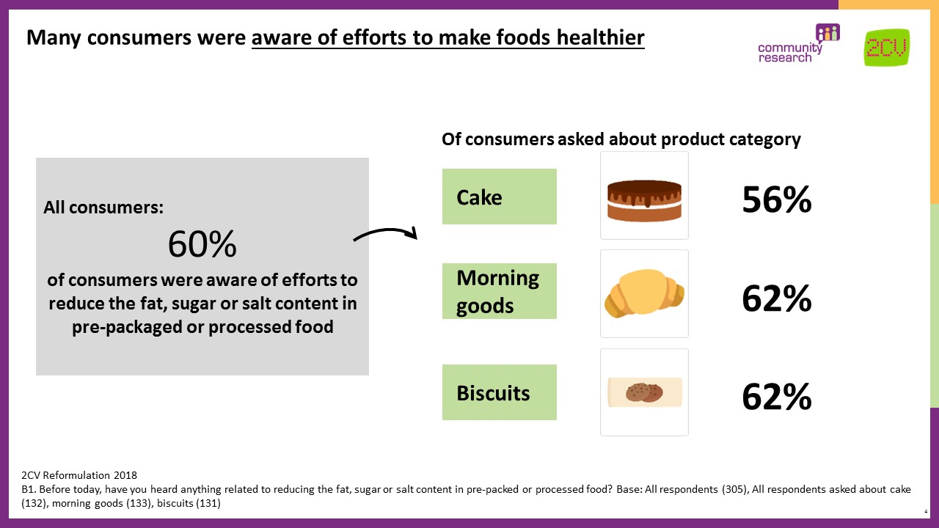
Among those who had already heard about these efforts, the most common intervention mentioned was initiatives (49% of those who purchased biscuits, 52% for morning goods and 52% for cake), as shown in Figure 5. The most commonly mentioned initiatives were the soft drinks industry levy (17% for cake, 14% for morning goods and 18% for biscuits) and more broadly ‘government initiatives’ (18% for cake, 20% for morning goods and 15% for biscuits).

(Note: The research was conducted prior to the introduction of the soft drinks industry levy in April 2018 and associated news coverage including references to reformulation. However, the research was conducted after the initial announcement in April 2017). However, in qualitative sessions we found that awareness of reformulation as an initiative was not well known or something that was not a priority for people.

Figure 5 Sources of efforts to reduce the fat, sugar or salt content in pre-packaged and processed food
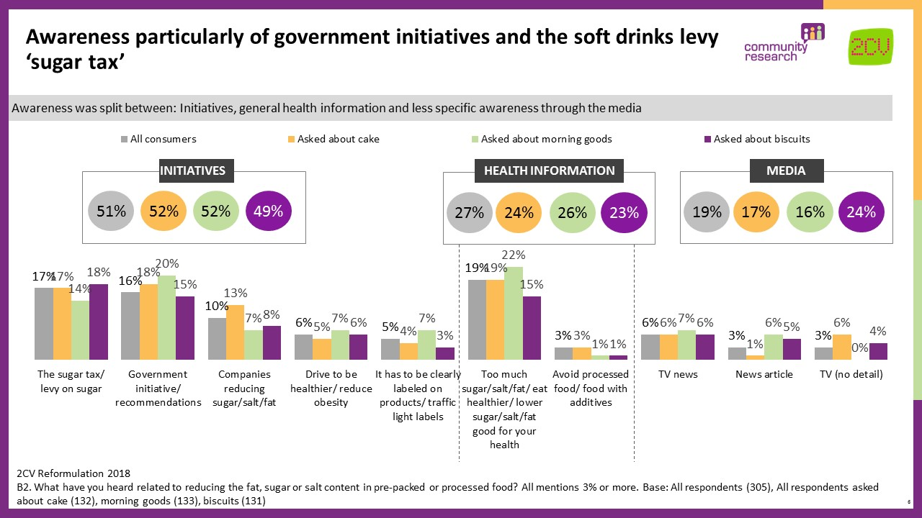

Consumers are becoming increasingly aware of how an unhealthy diet can lead to long term health implications, through news stories, health campaigns and media coverage including documentaries. However, this research demonstrates that awareness of high fat, sugar and salt foods is less salient among consumers in NI, with consumers more aware of diet related messaging such as cancer risks and eating 5 a day.

Among those who had heard about efforts to reduce the fat, sugar or salt content in pre-packaged or processed foods, the majority of them believed that the government was responsible. When asked who they believe is driving these efforts, 40% of all respondents named the Food Standard Agency specifically and 66% saying the ‘government’ more generally (Figure 6). Those who bought morning goods were more likely to think that supermarkets were behind changes (20% compared with 11% of all consumers) and less likely to attribute this to the government (57% compare with 66% of all consumers).

Figure 6 Who is driving food changes?
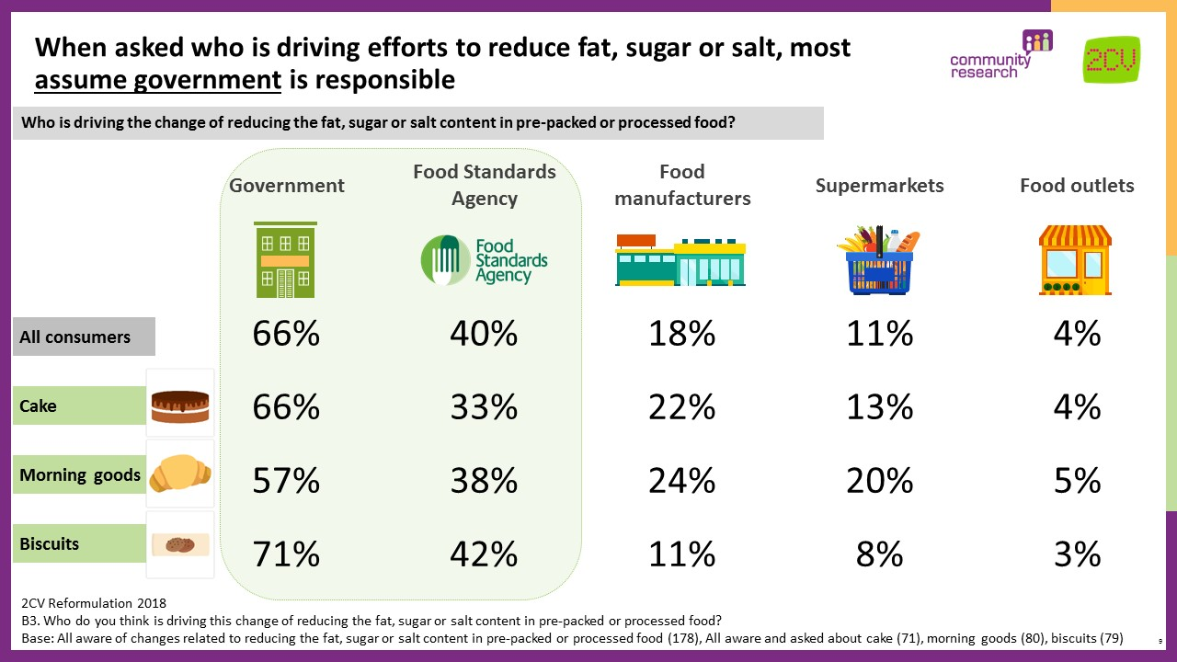

3.1.3 Acceptance of reformulation

Consumers were introduced to the idea of reformulation via three scenarios. In an experimental approach, the quantitative sample was split so that consumers saw one scenario: that the government is asking food businesses to make some of their products healthier; that some food manufacturers and retailers are making their products healthier; or no introduction to reformulation.

Figure 7 Reformulation scenario testing
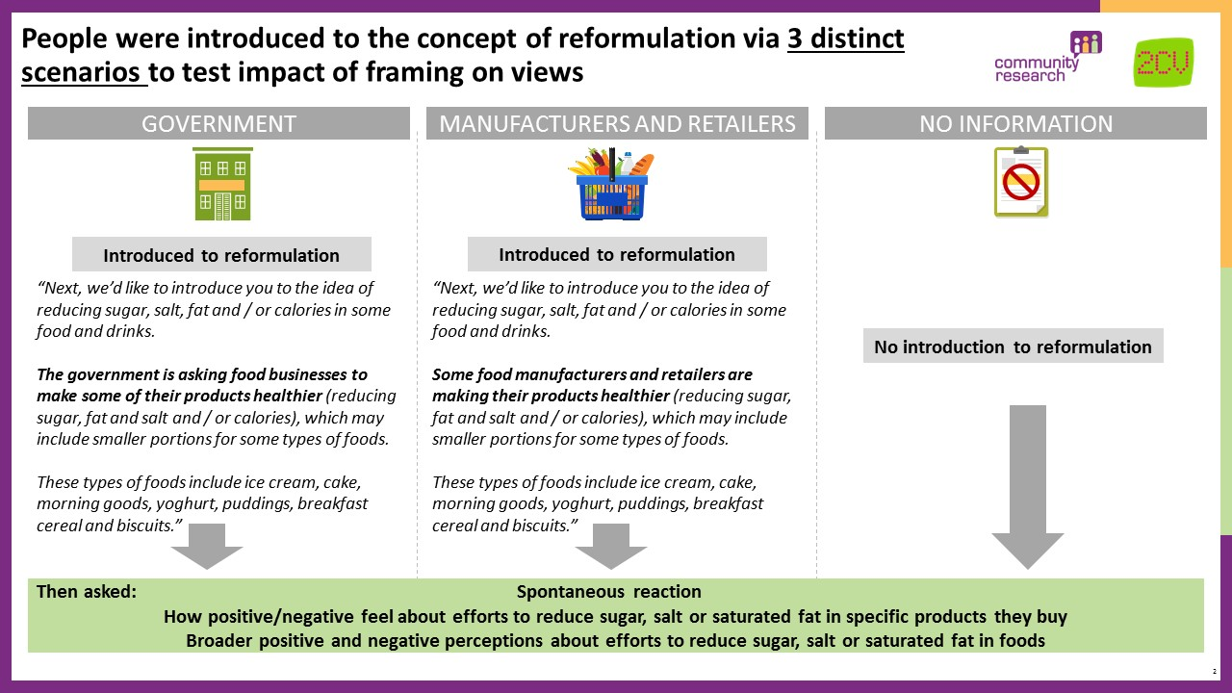

The research showed that NI consumers broadly accept reformulation, seeing it as building on current health trends and with potential benefits in terms of buying for both themselves and their family. It aligns with aspirations for healthy living, although this is not always a reality.

Acceptance for food reformulation exists regardless of what people believe the rationale for it is, or who they think is driving it. However, agreement that ‘It’s good that the government/manufacturers and retailers are trying to make products more healthy’ was significantly lower when people are told that it is driven by industry (65%) than when told that it is driven by government (72%) or when not told anything at all (79%).

Consumers buying bakery products had similar levels of agreement with the potential positive impacts (shown in Figure 8), as all consumers buying any of the seven priority food categories. Due to low base sizes, it is not possible to see how responses differed by reformulation scenario for individual food category purchasing.

Figure 8 Positive perceptions of reformulation
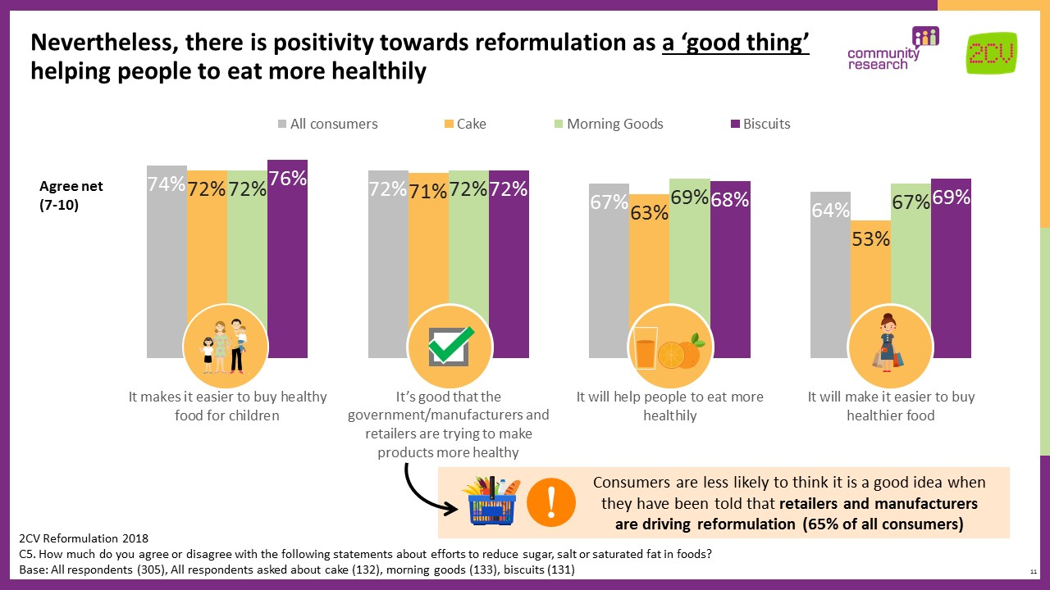

Regardless of what people were told about the rationale for reformulation, most were positive about efforts to make the products they buy healthier. Thinking specifically about the products they buy, 60% said that they were positive about efforts to reduce sugar, salt and saturated fat in their cake products, 65% for morning goods and 57% for biscuits, as shown in Figure 9.

Figure 9 Positivity about concept of reformulation
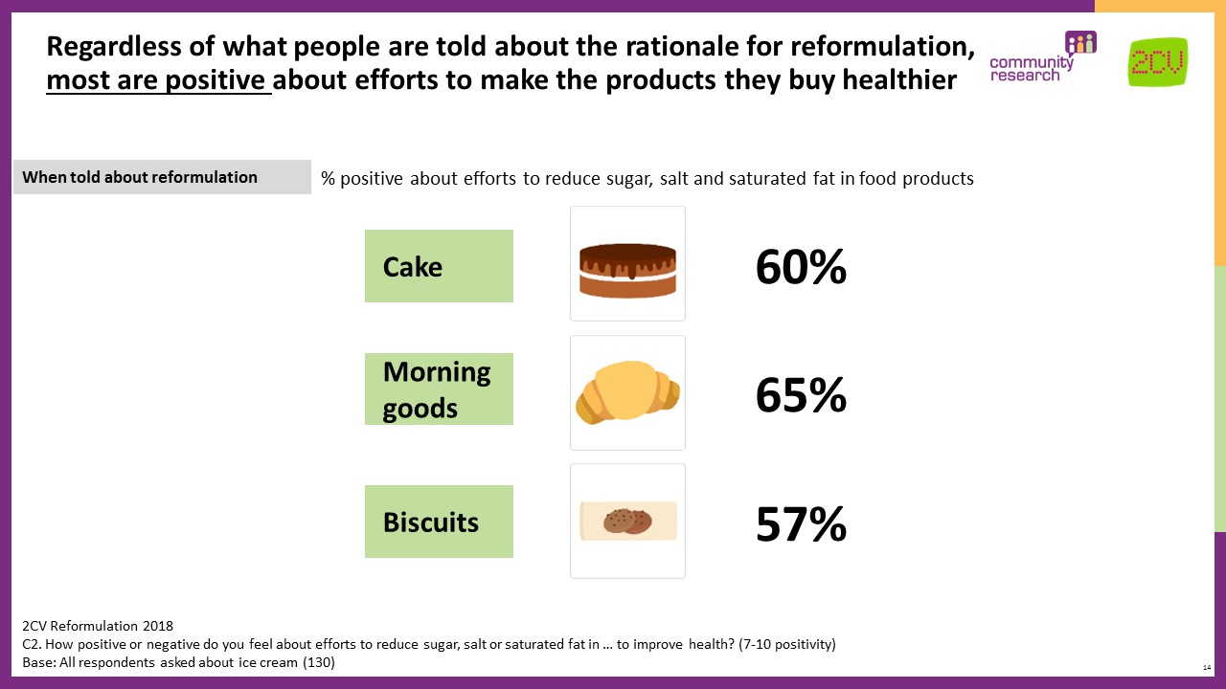

There were some concerns that reformulation could be used to benefit industry. When told that manufacturers and retailers are the driving force behind the initiative, 10% of consumers had concerns about price and 12% thought that companies could use this to make more profit by offering smaller products. However, these concerns were significantly lower when told that the initiative is driven by the government, with only 3% mentioning concerns about price and 2% concerned about companies making profit (Figure 10). Due to low base sizes it is not possible to see how response differed by reformulation scenario for individual food category purchasing.

Figure 10 Spontaneous response to government/ manufacturers and retailers making products healthier
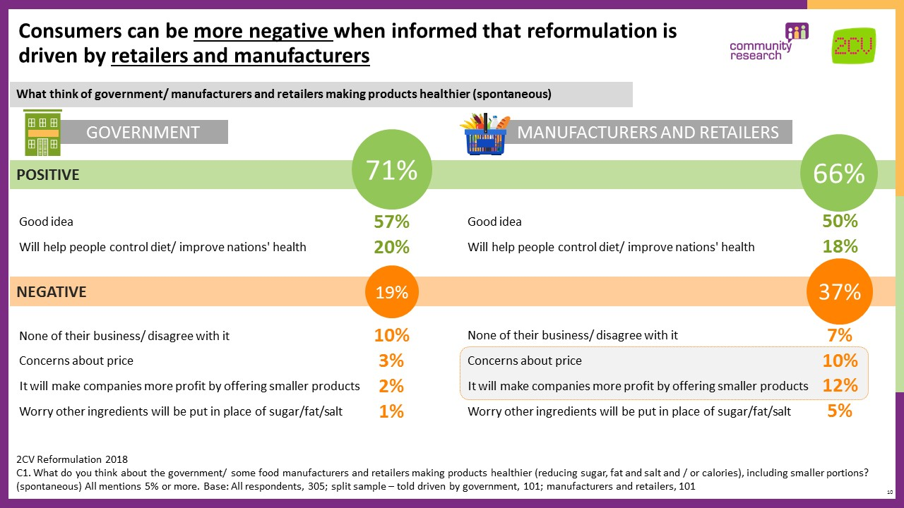

Agreement that ‘food manufacturers could use this to make more money’ was significantly higher when consumers were told that the initiative is driven by manufacturers and retailers (70%), than when told that it is driven by government (62%) or when not told anything at all (56%). Similar levels were seen among those who purchased bakery products (shown in Figure 11).

Figure 11 Consumer concerns about reformulation
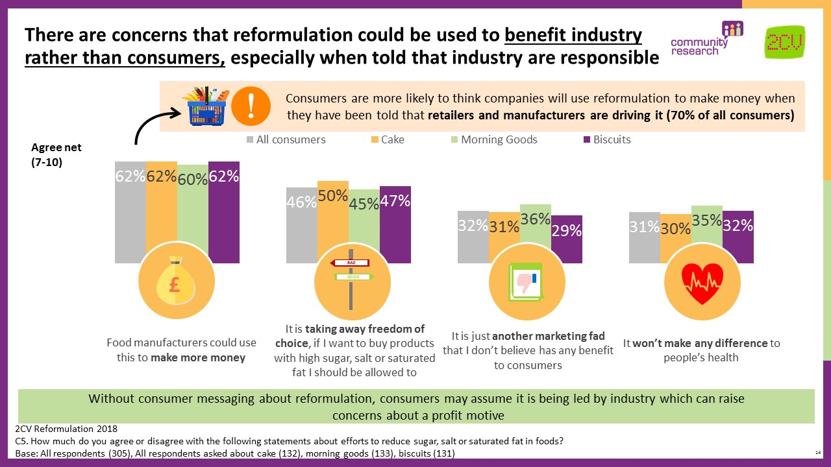

Qualitative research confirmed that consumers are wary of industry motives surrounding health marketing and that this can lead to doubt about the ultimate consumer benefit of the initiative.

In qualitative sessions and digital diaries, there were spontaneous concerns that reformulation may be anti-consumer choice, with 46% in the quantitative research agreeing that ‘it is taking away freedom of choice’. Qualitatively, some also perceived it as being related to the ‘nanny state’ and could reject the concept on these grounds.

People are averse to losing the qualities they deem to be important in the food they eat, so there was also some resistance to the idea of favoured products changing: consumers expressed a wish to have a choice between the original and reformulated food. This sentiment tended to be more pronounced for treat-like food, as the pleasurable experience and positive emotions related to these foods were stronger. There was some concern about feeling ‘robbed’ of these treats and that they would not get the same pleasure from reformulated food.

3.2 Acceptability of reformulation

3.2.1 Overall likelihood to purchase

Many consumers welcomed the increase in affordable healthier options when shopping, as healthier options can be associated with being premium. This leads consumers to accept both reformulated food and healthy alternatives. Reformulated food holds appeal because consumers like the idea of being able to buy old favourites without guilt or the need to switch to something different and thereby take a risk.

Consumers were asked how likely they would buy reformulated or resized products for each of the seven priority food categories that they purchase (breakfast cereal, morning goods, ice cream, yoghurt, cake, pudding and biscuits). Consumers were also asked about scenarios where they visit a shop to purchase the product and notice that their usual product has been changed. There were four scenarios of how each product could have changed:
- Lower sugar
- Lower fat
- Smaller overall size (e.g. fewer biscuits in pack)
- Smaller portion size (e.g. smaller biscuit size)

Overall, likelihood to purchase reformulated or resized products (smaller overall size or smaller portion size) was high, with an average of 73% across the seven higher priority food categories who said they would still purchase the product. The average for bakery products was broadly consistent with this, at 75% for cake, 73% for mornings goods and 70% for biscuits.

Likelihood to purchase was significantly lower for smaller overall sized biscuit packets, with 62% saying they would purchase this (fewer biscuits in pack). Smaller portion size (smaller individual biscuits) was less rejected, although still directionally lower with 68% saying they would buy this compared to lower sugar (74%) or lower fat (75%) biscuits.

For morning goods, 77% said they would purchase lower sugar products, 75% lower fat, and a directionally lower proportion of 68% for smaller portion size, reflecting the broader trend across the seven higher priority food categories of consumers being less likely to buy resized products than reformulated. For cake there were no significant differences in likelihood to buy, although directionally, lower fat cake products were the least likely to be purchased (71%), as shown in Figure 12.

Figure 12 Likelihood to buy reformulated and resized products
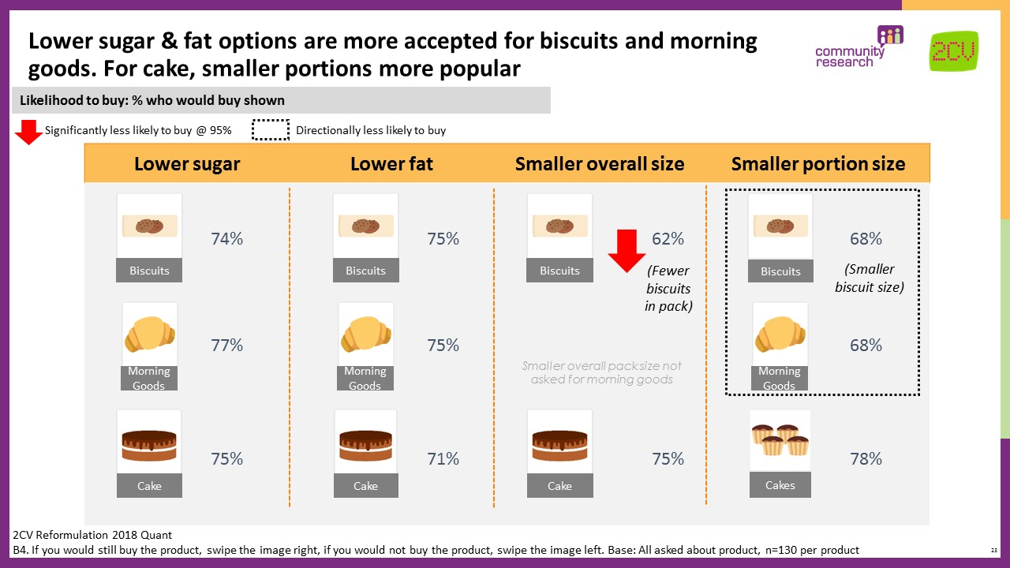

Across all seven priority food categories, acceptability of reformulation (both reformulated and resized products) rested on three conditions – that the new products matched old ones in terms of the taste, value and perceived healthiness of replacement ingredients (i.e. that the health impacts are not worse for people than the original product). These consumer priorities are all well-evidenced through previous FSA research, namely FSA NI Food Labelling (2016), Our Food Future (2016) and FSA Strategy 2015-2016 (2014).

The key to acceptance of reformulated products is to ensure that the taste and health properties are safeguarded. There are some consumer concerns that both of these could be affected when food is reformulated.

For resized products (smaller overall size or smaller portion size), value was a key concern. Consumers who said they would not buy a resized product spontaneously gave this as their top reason for not purchasing, as people expect to pay a cheaper price for less product. The second concern for resized products was about portions being too small and they preferred the product size before reformulation. This was consistent across food categories. Responses for cake, morning goods and biscuits are shown in Figure 13 and 14.
Figure 13 Reasons why consumers would not buy resized cake, morning goods and biscuits products: Value
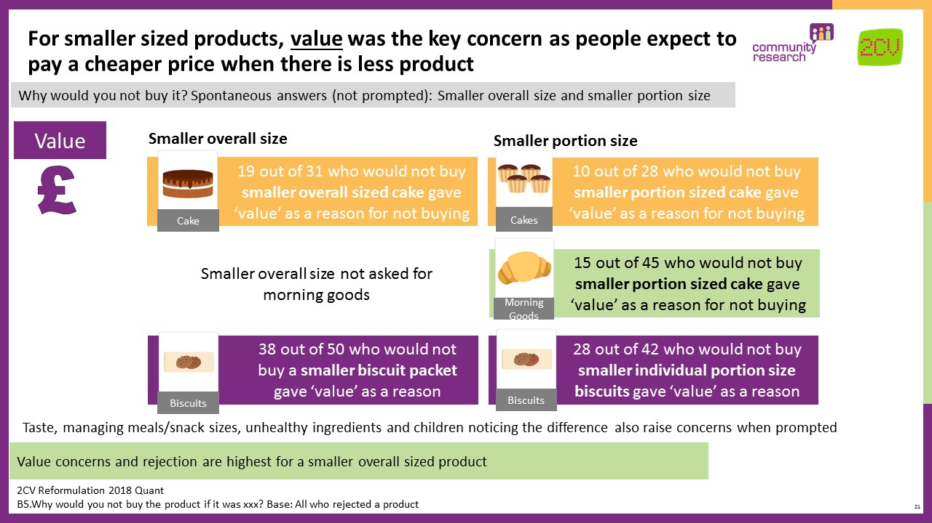

Figure 14 Reasons why consumers would not buy resized cake, morning goods and biscuits products: Wanting/ liking the same size
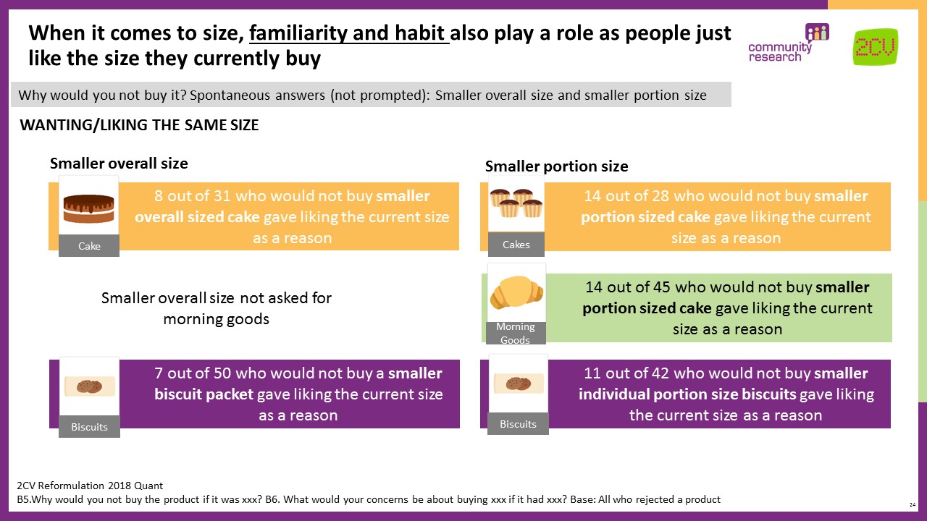

For reformulated products (lower sugar or fat), the primary concern was taste. This was consistent across food categories. Figure 15 shows that concerns about taste were the key concern for those who would not buy reformulated cake, morning goods and biscuits.

Figure 15 Reasons why consumers would not buy reformulated cake, morning goods and biscuits products: Taste
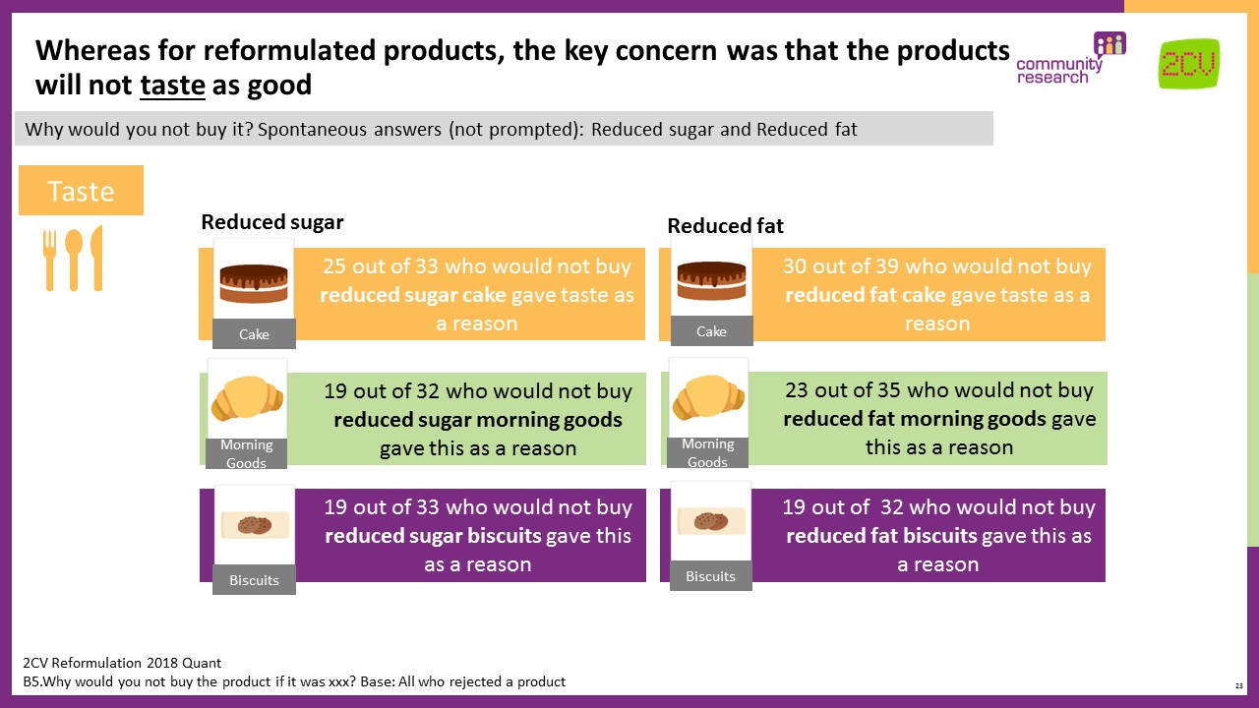

Taste was a particular concern when buying for children, as children might reject the reformulated products if there is a detectable difference in taste. Concerns also existed around the ingredients and healthiness of reformulated products, particularly in terms of sugar and fat substitutes, although this was less of a concern for cake, morning goods and biscuits than for other products such as ice cream and yoghurt. Figure 16 shows the low levels of concern about health of reformulated products.

Figure 16 Reasons why consumers would not buy reformulated ice cream products: Health
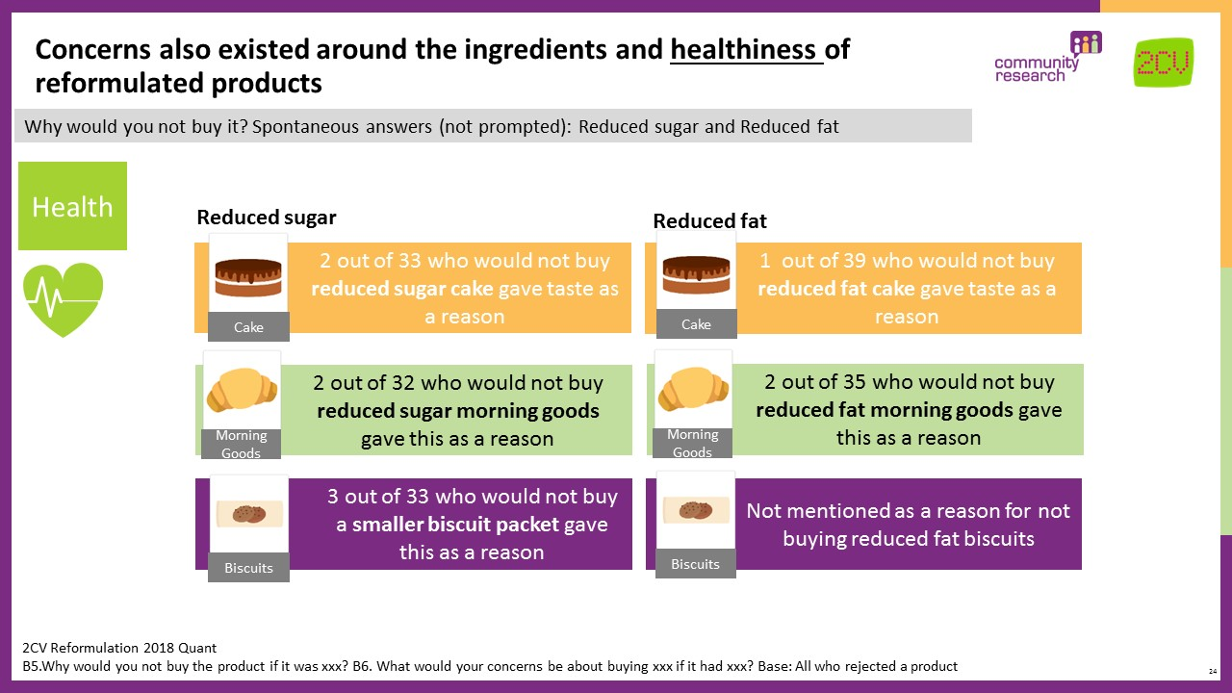

While value was less of a concern for reformulated products, there was still some concern that reduced fat or sugar products could be more expensive.

Note: qualitative research showed that the associated costs of reformulation / resizing products carried by industry were not a priority for people and the associated consumer benefits were not sufficiently valued to be worth paying for.

3.3 Implications for engagement and communications

Both quantitative and qualitative phases showed that consumers broadly accepted reformulation and were open to purchasing low sugar, fat and salt alternatives. However, qualitative sessions demonstrated that successful uptake and long-term engagement will depend on how well concerns surrounding taste, value and health properties are addressed. This research has therefore shown that consumers need to see and feel the benefits of reformulation or they will reject it.

As with any behaviour change process, there is no perfect solution. The success of reformulation will take time and commitment from multiple stakeholders. Consumers explicitly reported this during qualitative sessions; they expected action across both industry and government. Furthermore, they recognised that their personal decisions were only part of the story and that individual change can and should be prompted by wider social change. They believed that influential public and private sector organisations carried a degree of moral responsibility for consumer healthy-eating behaviours.

“I think this is really important. They should be doing this. To be honest though when I’m in the shop I just want to be in and out….I’m not really thinking. Especially if my son’s with me…You look for things to help you decide.”
Focus Group, Belfast

The research shows that therefore a multi-pronged approach to behaviour change is key. Communications, education and environment changes are all important for encouraging acceptance of reformulated products and informing purchase decisions. To address consumer concerns surrounding the taste, value and perceived healthiness of reformulated foods, it is important to generate a positive ‘buzz’ around the initiative and highlight the consumer benefits.

Messages and engagement activities will also need to come from a wider group of stakeholders than solely industry (i.e. manufacturers and retailers) given the level of doubt consumers in the research voiced about profit motives and industry safeguarding its interests over consumers.

3.3.1 Communications: product information is important

The research shows that clear and open brand communications and product information will be important for creating trust in reformulated and resized alternatives. Across the research, from the initial qualitative sessions through to the digital research and ultimately in quantitative testing, consumers clearly stated their appetite for noticeable changes to product labels. In particular, front of pack labels as these were most likely to catch consumers’ attention and inform their decisions.

Minor changes to product labels signalling what has been changed is considered important by the respondents that took part in this research for three reasons:

- Consumer trust and transparency. By highlighting changes, brands demonstrate that they are treating consumers with openness and respect, which helps build consumer trust and avoids the risk that people feel misled if they find out recipe or size changes have been made by stealth.

- Reassurance around taste, value and the health of food. Consumers want to know a new product will deliver in terms of taste, value and health, and that they are not compromised. Clear information about what has changed helps provide reassurance and allay consumer doubts that could otherwise lead to rejection.

- Consumer choice. The perception of being in control and having freedom of choice is prized by consumers. Food choices can be emotional and highly personal (FSA Trust 2018); people value the decisions they make and do not like to think they are being influenced or ‘nannied’ over food. This is unsurprising – rarely will people admit to wanting less choice – but the important issue to consider is, that even the perception of choice can be a driver of acceptance. Therefore, flagging that there has been a change makes people feel informed and that they are making an active choice, which is empowering.

“The best way would be additional information on the labelling. ‘Now with 20% less salt with same great flavour’ written clearly on the packaging, then it will be obvious that it has been changed and if it tasted the same it wouldn’t affect me buying it as I’d be expecting the same product.”
Auto-ethnography

The quantitative research showed that the desire to be informed and the stated need for simple and clear notifications on product labels are consistent across product categories. It does not matter whether people are buying ice cream, yoghurt or a pack of biscuits, it is clear from this research consumers value the ability make an informed choice. When asked for a list of options on how they would prefer to find out about changes to the products they buy, 48% of people wanted to see a label on the front of the product telling them what has changed in the recipe or portion size (shown in Figure 17). This was consistent across products purchased.

Figure 17 Product Information
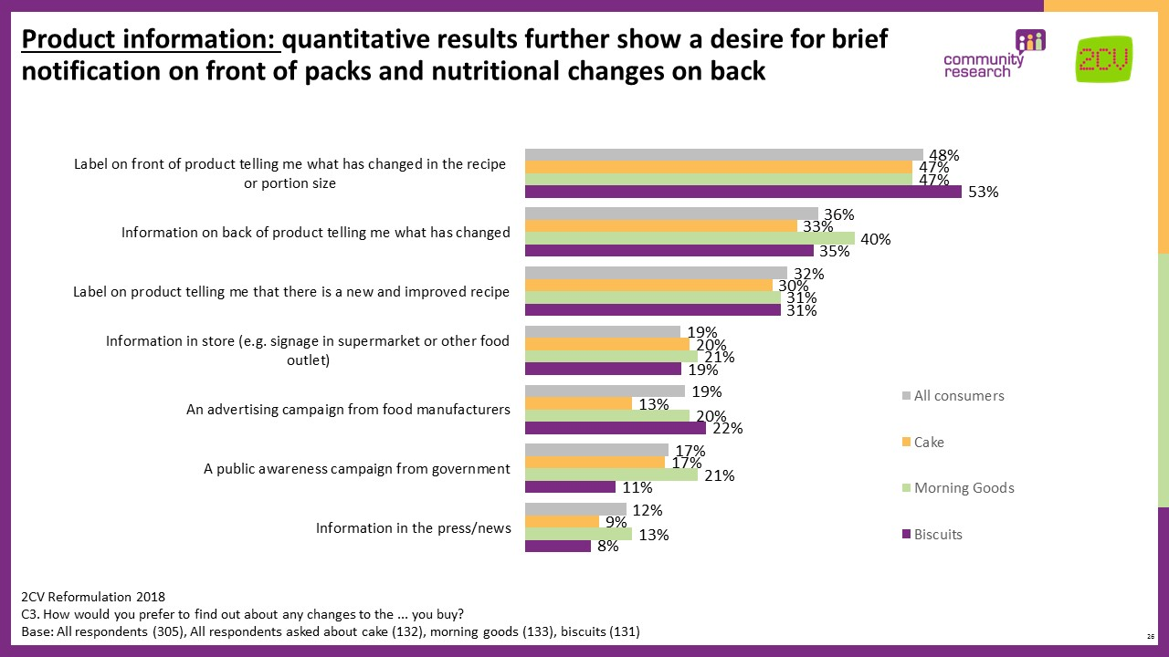

The fact that there is appetite for explicit communication of changes that may be obvious to the eye, such as a reduced portion size, indicates how much people value brands being honest and transparent about the changes they are making.

There was also notable support from this research for information on the back of products telling people what has changed (36%) and for a label on the product telling people that there is a new and improved recipe (32% of all consumers). This was consistent across food products, with no significant difference among those who purchased bakery products.

The qualitative research confirmed that feeling informed is not just something consumers would prefer but can actively prompt purchase decisions and make reformulation more acceptable. Particularly for health-conscious shoppers who tended to be more motivated by information signalling a reduction in sugar, salt or fat.

“If it had good communication on the box stating it had reduced its sugar level then I would definitely try it.”
Auto-ethnography

When shopping, consumers operate at a low-conscious level. They reportedly rely on mental shortcuts and habit for efficiency of decision-making. A short and simple message, clearly visible on the front of product pack is therefore important to signal whether a product is healthy and prompt quick purchase decisions. Consumers told us they use convenient shortcuts to quickly assess a product’s healthiness. For example, labelling that includes words like ‘balanced diet’, ‘free range’ or ‘organic’ are used by consumers as shorthand for ‘healthy’ or ‘healthier’. This is even true in the cases where a product contains significant levels of sugar, like organic cake, but is perceived to be healthier because of the word ‘organic’. Green traffic lights also signal a healthy choice and there is much positivity towards the introduction of traffic light labels on product packs.

However, we know from this and previous FSA research that consumer demands for product labelling can be contradictory. People say they want information but in reality, generally they do not pay close attention. We also know that consumers can feel overwhelmed by health claims and constant marketing can have a negative effect on consumer trust and lead to disengagement. Previous FSA research including ‘Consumer needs around food labelling (2016)’ and ‘FSA Trust (2018)’ confirm this finding.

Getting the message and nutrition and health claim right will be fundamental as consumers need to trust brands to make genuine nutrition and health claims. Currently, nutrition claims like ‘Low in X’ or ‘No X’ are met with scepticism. From this research, consumers believe they are too good to be true and assume a ‘one in one out’ rule for ingredients, making the claim disingenuous. In this research, consumers were not aware that there is legislation governing health claims.

“If it’s low in X it’s high in something else.”
Auto-ethnography
“If they take out the sugar, what are they replacing it with?”
Focus group, Belfast

It will therefore be important to consider the right balance between transparency and overload when communicating changes to the consumer. Brands should consider consumers’ core information needs – what is essential and what is supplementary. For example, are there existing elements on front of pack labels that could be de-prioritised to make space for messages about reformulation without compromising information that consumers currently find useful (e.g. traffic lights).

While parents and grandparents see helping their children and grandchildren to be healthier as an advantage of buying reformulated or resized products, a subtler approach to communications may be required when it comes to children.

Despite the attraction to parents of healthier foods for children, and a common belief that many children’s foods currently on the market are unhealthier than they should be, parents with young children ultimately just want them to eat. Parents told us in the qualitative sessions that ‘healthy’ branding can sometimes put kids off certain products. Therefore, getting the look and feel of the message right on product labels that kids are likely to see will be important. Parents want to be alerted to a change, but without their children necessarily seeing or knowing about any changes.

“For me not advertising would be best as my son might notice the ad and refuse to eat it. Perhaps email or literature on it would be best.”
Auto-ethnography
“If it says ‘low sugar’ there’s no way he’ll eat it though!”
Focus group, Belfast

Through this research we have identified a set of best practice communication principles to inform FSA messaging and business guidance. These principles are intended to complement, not supplement, the formal legislative requirements that reformulation communications must comply with.
- Point to the fact reformulation is part of a wider initiative e.g. a recognisable stamp – this raises awareness that it is not industry-led and may help to counter public scepticism.
- Be clear and concise – consider the need to balance transparency about the new product with the risk of information overload and potentially prioritise signalling the new recipe/new size over other information.
- Give reassurance about taste, value and the health of food to counter concerns and underline the consumer benefit of the new product.
- Don’t overstate the ‘healthy’ message as consumers are wary and pragmatic (“How healthy can chocolate be?!” Auto-ethnography).
- Consider a subtle/different approach for products aimed at/popular with children given parents are attracted to healthier options but also wary of ‘putting children off’.

3.3.2 Changes to retail environment

People shop quickly and make on-the-spot decisions often guided by habit. Changes to shop environments, eye-catching aisle and at-shelf signage can all influence consumer choices that are made instinctively and mindlessly. Past evidence shows, for example, that end of aisle displays increase sales by up to 50% (Sugar Reduction: The evidence for action, PHE,2015).

“Best way to advertise for me would be on the shelf or on the actual package.”
Auto-ethnography

“I always notice the special offer things they put at the end of the aisle – they could do more with that to catch your attention.”
Focus group, Belfast

Consumers expected government to work in partnership with retailers and manufacturers to roll-out these kinds of initiatives. Research participants wanted to see government-industry partnerships help make their individual decisions easier and create the right conditions for them to change their own behaviours. Participants in the qualitative phase cited multiple examples of how changes to the retail environment have previously impacted their behaviour and in-store routine, suggesting opportunities for similar disruption to habits may exist.

“It’s like the way the fresh stuff is at the front – that makes a difference the minute I walk into the shop I want to pick it up!”
Focus group, Belfast

“I just think you shop so quickly and if I have my kid with me I’m barely paying attention so I need something to guide me!”
Focus group, Belfast

Consumer suggestions for environment changes gathered through qualitative engagement include:
- At-shelf and aisle signage that clearly signpost people to healthier and reformulated food
- Aisle / shop layouts that clearly segregate unhealthy and healthy options
- End of aisle stands showcasing new products

The retail environment was also seen by consumers as the logical place for engagement initiatives such as in-store demonstrations, taste tests and information stands – given the questions people have surrounding reformulation, being able to engage with new products prior to purchase can help allay doubts, create positivity and raise general awareness in turn prompting word of mouth. Practical activities in stores show people that the reformulation initiative is trustworthy and that there is a genuine consumer benefit behind it, reducing risk of rejection.

Engagement activities are also important because they help address consumers’ key conditions.
- They prove to people that reformulated products taste good – letting people try for themselves;
- They allay concerns about the potential healthiness of new products through explanations and expert guidance;
- They demonstrate openness and willingness to answer consumer questions, showing people that industry cares and that there is a consumer benefit.
Consumer suggestions for engagement activities gathered through qualitative engagement include:
- In-store tastings showcasing reformulated products
- Cooking demonstrations
- Information stands with leaflets
- Recipe ideas for new and existing products

3.3.3 Wider public education and messaging

Finally, there is an important role for public education and a proactive government voice to build public trust in the initiative and make the consumer benefits of reformulation clear. The quantitative research clearly showed the risk that consumers will reject reformulated food if they believe the initiative is being led by industry, so this supporting public voice is critical. People need to know that consumer benefit is driving the cause and want wider public education and engagement as confirmation.
Recent FSA Trust research supports this proactive government role and points to the value it has for building trust in the wider food sector, including brands. The public want to know that someone is looking out for consumers’ interests and holding industry to account (FSA Trust 2018).

How the reformulation initiative is framed clearly impacts consumer perceptions, how positive or negative they feel towards it and ultimately how acceptable they find it. As the following table shows, framing reformulation as a partnership involving different players in the food industry has potential to prompt greater acceptance and motivation to act (i.e. purchase new products).

Table 2 Framing of reformulation initiative
Framed as a partnership: | Framed as from industry:
- Public health interest  - Helping me be healthier without compromising my favourite foods  - Supported more widely than just the big brands | - Profit interest  - A marketing fad/trick to make me think I’m eating healthier  - Another thing to overwhelm me and make it harder to eat healthily  - Making healthy something premium

Boosting wider trust in the food system will be important for ensuring reformulation is well-received and gathers public support. Recent FSA work exploring drivers of trust in the food system (FSA Trust 2018) revealed the importance of ‘trust bonds’ – a social contract between consumers and organisations operating in this space.

FSA Trust findings, March 2018
- Trust relies on a social assessment of intention: does an organisation intend to do me well?
- People need to feel that their interests are being looked out for (hence why taste, value and health claims are key).
- While trust in the food system is generally higher than other sectors, it is still fragile and the ‘trust bond’ people have with food brands and the wider system can easily be shaken.
- People value a proactive government that is seen to hold industry to account and safeguard consumer interests.
Consumers want to know that ’someone’ is working behind the scenes to prevent:
- “Manipulative” marketing, which makes consumers question motivations in the food sector - “Is it all profiteering?”
- Information overload, as this leads to concerns about transparency and good intentions – “deliberate complexity”
- Contradictory health messages, as this leads to scepticism - “everything either cures or causes cancer!”
- Over-claim from brands, which are seen as disingenuous and potentially harmful – “It’s like if [brand name] says “it’s healthy”!”
- Brands and retailers acting unethically, as this shakes trust in their intentions – “there’s way too much packaging now”

3.4 Final considerations

3.4.1 Changing eating behaviour is complex and takes time
As with any behaviour change objective, understanding the barriers to change is important. Whilst a full exploration of this was beyond the scope of this project, it is worth lingering on them as the FSA consider the implications of this research and next steps.
Table 3 Barriers to behaviour change
Barriers to behaviour change
Public distrust | Too much ‘noise’ and inconsistent information: “Everything either causes cancer or is a cure for cancer!” (Auto-ethnography)
Lived experience | Some simply don’t believe tasty food can be healthy food: “appealing food often isn’t healthy” (Auto-ethnography)
Aspirations not reality | “We all know what’s healthy and unhealthy but doing something about it is a different thing” (Auto-ethnography)
Distance from issue | Being overweight happens to other people (and in the extreme): “I saw a TV documentary about rising obesity.” (Auto-ethnography)
Optimism bias | People can feel they have diet under control so no need to change: “Treats at weekends”, “Cook fresh if possible” (Focus group, Belfast)

While reformulation is not a silver bullet and is not intended to address all of these barriers to behaviour change, managed and communicated effectively it can help shape consumer attitudes and encourage trust in healthier options.

3.4.2 Upsetting the treat landscape could have unintended consequences

People have well-established habits and routines around food – when they “treat” themselves versus when they are “good”. With the appeal of reformulated products comes the potential that products may no longer be seen as a treat. Consumers may see reformulated food as healthier and this could prompt some consumers to eat more. The ability to eat more of a favourite food was a stated advantage in both the qualitative and quantitative research. Across types of reformulation or resizing, on average 12% said an advantage would be that they can buy it more frequently if the product is healthier (11% for cakes, 16% for morning goods and 9% for biscuits).
Upsetting the balanced diet people believe they have could have unintended negative consequences as people start to eat more treat products. This will be an important consideration for anyone working to ensure that reformulation leads to better public health outcomes.
“We only eat this at weekends as a treat. If they changed the recipe to make it healthier that would be great! It would encourage me to buy it more.”
Auto-ethnography

“This would ease the guilt of eating these and I know they aren’t that healthy, it would also encourage me to buy these for throughout the week whilst I am dieting rather than just having them as a treat on a Saturday night!”
Auto-ethnography
Communications should make it clear that reformulated food may still be high in sugar, fat and/or salt and therefore should still be regarded as a treat, even though the food is now less unhealthy than the original product. It will also be important to make consumers aware of how to achieve a healthy and well-balanced diet by using the Eatwell Guide - https://www.food.gov.uk/business-guidance/the-eatwell-guide.

Appendix 1: List of figures

Figure 1 Research methodology 9
Figure 2 Digital research tasks 10
Figure 3 Importance of healthier options 12
Figure 4 Awareness of efforts to reduce the fat, sugar or salt content in pre-packaged and processed food 14
Figure 5 Sources of efforts to reduce the fat, sugar or salt content in pre-packaged and processed food 15
Figure 6 Who is driving food changes? 16
Figure 7 Reformulation scenario testing 17
Figure 8 Positive perceptions of reformulation 18
Figure 9 Positivity about concept of reformulation 19
Figure 10 Spontaneous response to government/ manufacturers and retailers making products healthier 20
Figure 11 Consumer concerns about reformulation 21
Figure 12 Likelihood to buy reformulated and resized products 23
Figure 13 Reasons why consumers would not buy resized cake, morning goods and biscuits products: Value 24
Figure 14 Reasons why consumers would not buy resized cake, morning goods and biscuits products: Wanting/ liking the same size 25
Figure 15 Reasons why consumers would not buy reformulated cake, morning goods and biscuits products: Taste 26
Figure 16 Reasons why consumers would not buy reformulated ice cream products: Health 27
Figure 17 Product Information 30

Appendix 2: List of tables
Table 1 Reasons for not buying healthier options 13
Table 2 Framing of reformulation initiative 34
Table 3 Barriers to behaviour change 36

Appendix 3: Qualitative sample overview

Stage 1: Qualitative scoping focus groups
Five 90 minute focus groups with six to eight participants per group.
- Participants were split into two cohorts based on attitudes to nutrition and food labelling: ’Unsupported and Confused’ and ‘Engaged and Knowledgeable’. Attitudinal questions were used to identify which cohort individuals belonged to.
- All participants were recruited to either be the main shopper or jointly responsible for household shopping.
Breakdown of sample by group:
 | Segment | Gender | SEG | Lifestage | Location
1 | “Unsupported and Confused” | Female | To fall out | Family (at least one child under 11) | Urban - Belfast
2 | “Engaged and Knowledgeable” | Female | To fall out | Family (at least one child under 11) | Rural - Portadown
3 | “Unsupported & Confused” | Male | To fall out | Family (at least one child under 11) | Rural - Portadown
4 | “Engaged and Knowledgeable” | Male | To fall out | Family (at least one child under 11) | Urban - Belfast
5 | “Unsupported & Confused” | Mixed | To fall out | Pre-family | Urban - Belfast

Stage 2: Deep dive mobile ‘Digital diaries’
40 fresh participants took part in a 2-week mobile ethnography exercise, logging their food and shopping attitudes and behaviours via 2CV’s bespoke digital research app “2CV Momento” (see Appendix 3 for more detail).
- Participants were recruited to reflect a good mix of attitudes, use and knowledge of nutritional labelling information. Soft quotas were set on the following characteristics:
  - Importance of high fat, salt, sugar & calories to inform shopping decisions (<5 who say it is not important; <15 who say it is very important)
  - Frequency of looking at nutritional label information (mix of frequencies)
  - Understanding of food labelling around HFSS and calories (mix of confidence levels)

Breakdown of sample:
Lifestage | Gender | SEG | Location
15 x Younger Family (at least one child <11) | 60% female, 40% male across the sample | BC1/C2DE weighted 15/25 in favour C2DE across the sample | At least 7 x Urban  At least 7 x Rural
15 x Older Family (at least one child 11+) |  |  | At least 7 x Urban  At least 7 x Rural
5 x Empty Nesters |  |  | At least 2 x Urban  At least 2 x Rural
5 x No kids (Pre Family) |  |  | At least 2 x Urban  At least 2 x Rural

Appendix 4: “2CV Momento”

2CV Momento is 2CV’s bespoke digital research app. It is an intuitive, engaging and non-invasive mobile research app that allows us to go in-depth and study people’s thoughts and feelings at specific moments in time. “Momento” ensures that we collect in-the-moment responses without disrupting natural behaviours or placing participants in an unnatural research setting. The result is a very rich and pure qualitative dataset.
How does it work?
Similar to any research methodology, the research team designs a structured series of tasks and questions, in this case, to explore claimed and actual behaviours relating to food and nutrition. Participants download the Momento app to their mobile phones and are subsequently sent messages and notifications reminding them to complete tasks and take part. Participants are able to upload a range of audio-visual material, including voicenotes, photos and videos as well as written text responses, documenting their experiences, thoughts and behaviours.

Once the fieldwork period is complete, the research team listens back to and downloads the uploaded data and conducts analysis using qualitative analysis techniques.

Tasks can be completed in participants’ own space and time over the course of a two-week period on either a mobile phone or computer. Participants are incentivised and, where necessary, supported to undertake tasks.

Try it for yourself!

‘Understanding Northern Ireland Consumer Needs Around Food Labelling’, FSA research report prepared for FSA by TNS BMRB (July 2016) https://www.food.gov.uk/research/research-projects/understanding-northern-ireland-consumer-needs-around-food-labelling
‘Our Food Future’, FSA research report prepared in partnership with TNS BMRB (February 2016) https://www.food.gov.uk/sites/default/files/media/document/our-food-future-full-report.pdf
‘FSA Strategy 2015-16’, research report prepared for FSA by TNS BMRB (March 2014) https://acss.food.gov.uk/sites/default/files/fsa-strategy-research-report.pdf
‘Trust in a changing world’, FSA research report prepared for FSA by 2CV and Community Research (September 2018) https://www.food.gov.uk/research/research-projects/trust-in-a-changing-world
‘Childhood obesity: a plan for action’. The government’s plan for action to significantly reduce childhood obesity in England by supporting healthier choices (published August 2016). https://www.gov.uk/government/publications/childhood-obesity-a-plan-for-action
‘Understanding Northern Ireland Consumer Needs Around Food Labelling’, FSA research report prepared for FSA by TNS BMRB (July 2016) https://www.food.gov.uk/research/research-projects/understanding-northern-ireland-consumer-needs-around-food-labelling
‘Our Food Future’, FSA research report prepared in partnership with TNS BMRB (February 2016) https://www.food.gov.uk/sites/default/files/media/document/our-food-future-full-report.pdf
‘FSA Strategy 2015-16’, research report prepared for FSA by TNS BMRB (March 2014) https://acss.food.gov.uk/sites/default/files/fsa-strategy-research-report.pdf
‘Understanding Northern Ireland Consumer Needs Around Food Labelling’, FSA research report prepared for FSA by TNS BMRB (July 2016) https://www.food.gov.uk/research/research-projects/understanding-northern-ireland-consumer-needs-around-food-labelling
‘Trust in a changing world’, FSA research report prepared for FSA by 2CV and Community Research (September 2018) https://www.food.gov.uk/research/research-projects/trust-in-a-changing-world
Sugar Reduction, report prepared by Public Health England (2015) https://assets.publishing.service.gov.uk/government/uploads/system/uploads/attachment_data/file/470174/Annexe_3._Marketing_evidence_review.pdf

