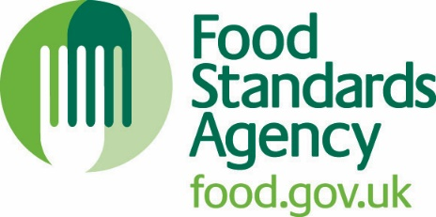

Please be aware this is a second draft and that your contribution will be expected. This document will be under annual review.

Supply of Wild Game for Human Consumption
Guidance for hunters and retailers on the safe handling, preparation and supply of wild game and wild game meat
Publication Date: DD Month Year

Last Reviewed: DD Month Year

Summary
Intended audience: | - Those who shoot and/or supply wild game.  - Enforcement officers.  - Retailers and Processors.
Which UK nations does this cover? | This guidance covers England, Wales and Northern Ireland. However, indication is always given where there are specific issues or legal requirements concerning England, Wales and Northern Ireland.
Purpose: | To provide food businesses and people who hunt wild game and supply it in-fur or in-feather or as small quantities of wild game meat within England, Wales and Northern Ireland with clear guidance to the requirements of the relevant parts of the EU food hygiene and domestic legislation.
Legal status: | This Regulatory guidance clearly explains the legal requirements of the EU food hygiene and relevant domestic legislation with which food businesses and people that hunt wild game and supply it in-fur or in-feather or as small quantities of wild game meat have to comply. The guide also provides advice on Food Standards Agency’s (FSA) interpretation of the legislative requirements, particularly in the light of practical experience.
Key words | Food law, monitoring and controls.  Hygiene and food safety.  Meat and livestock.
Review date | August 2021

Revision history
This guidance follows the Government Code of Practice on Guidance. If you believe this guidance breaches the Code for any reason, please let us know by emailing betterregulation@foodstandards.gsi.gov.uk.
Revision  No. | Revision date | Purpose of revision and paragraph number | Revised by
0 | 2007 | Draft Guidance | Jane Gibson
1 | July 2008 | Draft Guidance | Vanessa Charles
2 | October 2008 | Final Version | Abi Abdul
3 | June 2009 | Update | Abi Abdul
4 | April 2010 | Update | Abi Abdul
5 | March 2011 | Update | Abi Abdul
6 | June 2014 | Complete Revision | Simon Tudor
7 | November 2015 | Update | Paul Stubbington
8 | July 2020 | Update | Mary McGlinchey

Contents
Supply of Wild Game for Human Consumption 1
Contents 4
Introduction 5
Approved game handling establishment (AGHE) 7
Trained hunter’s examination 9
Exemptions 13
Processing and sale of game meat by hunters 14
Processing and supply of game meat by retailers 18
Table for the supply of wild game/wild game meat 19
Transport 22
Traceability 24
Testing/examination 26
Definitions 31
References 35
Review 35
Contacts 35
Annexe A: Specimen forms 36
Large wild game declaration 36
Small wild game information 37
Annex B - Bibliography 40

Introduction
This guidance aims to explain the legal requirements that apply in the different circumstances in which wild game is supplied for human consumption either in-fur/in-feather or as wild game meat.
Individuals and food businesses involved in hunting wild game with the intention of placing it on the market are food business operators (FBOs) and the food they produce will need to meet food safety requirements. This will be achieved by ensuring compliance with relevant requirements of the legislation.
This guide is not intended to provide enforcement advice for local authority enforcement officers though the information provided may prove useful.

Intended audience
This guidance is intended primarily for industry who hunt and sell wild game for human consumption, however enforcement officers responsible for the supervision, monitoring and enforcement in Approved Game Handling Establishments (AGHEs) and registered game premises may also find the information helpful.
Industry includes:
- Hunters of wild game and supplied in-fur or in-feather or as wild game meat for human consumption, and
- Food businesses that accept in-fur or in-feather wild game carcases, dressed carcases or cut or process game meat. This includes retail establishments such as butchers' shops, restaurants and AGHEs. Retail establishments is defined in Regulation (EC) 178/2002 Article 3 states:
‘retail’ means the handling and/or processing of food and its storage at the point of sale or delivery to the final consumer, and includes distribution terminals, catering operations, factory canteens, institutional catering, restaurants and other similar food service operations, shops, supermarket distribution centres and wholesale outlets;

Purpose of guidance
This guidance aims to explain the legal requirements that apply in the different circumstances in which wild game is supplied for human consumption with either in-fur/in-feather or as wild game meat.

Legal status of guidance
This guidance aims to explain the legal requirements of supplying wild game for human consumption either in-fur/in-feather or as wild game meat, in adherence with the following Regulations:
- Regulation (EC) 178/2002 - General Food Law
- Regulation (EC) 852/2004 - Hygiene of Foodstuffs
- Regulation (EC) 853/2004 - Hygiene Rules for Food of Animal Origin
- Regulation (EC) 999/2001 - Rules for the Prevention, Control and Eradication of Certain Transmissible Spongiform Encephalopathies.
- Regulation (EC) 2017/625 – Official Controls Regulations
If followed the guidance will help you comply with the law. Businesses with specific queries may wish to seek the advice of a local food safety team, depending on the arrangements, this will usually be the Environmental Health or Trading Standards department of the local authority.

Approved game handling establishment (AGHE)
A ‘Game-handling establishment’ is defined in Annex I of Regulation (EC) No 853/2004 as ‘any establishment in which game and game meat obtained after hunting are prepared for placing on the market’.
You cannot start trading before receiving an approval. You must not commence any business activity which requires approval unless you have received conditional or full approval for your proposed activity from the FSA. If you start trading without approval, it is an offence which may lead to prosecution.

Obtaining AGHE approval
Approval application information for England, Wales and Northern Ireland are available.

Processing and supply of meat – AGHE
If you intend to process wild game and supply wild game meat and you are not a retailer, or a hunter supplying small quantities of game meat directly to the final consumer or to local retail establishments that supply this game meat directly to the final consumer, you are required to become an AGHE.
An AGHE:
- Must be approved by the Food Standards Agency (FSA) (if located in England, Wales or Northern Ireland).
- Must comply with both Regulation 852/2004 and Regulation 853/2004;
- Must ensure that animal by-products (ABPs) are handled and disposed of in accordance with Regulation (EC) No.1069/2009;
- Is subject to official controls (by the FSA in England and Wales, and DAERA in NI), including audit of structural and operational hygiene requirements, post-mortem inspection and health marking of carcases.
- May process only wild game that has either been examined initially by a trained hunter and, for large wild game, is accompanied by a trained hunter’s declaration or, in the case of large wild game, if no trained hunter was available, is accompanied by the head (except for antlers or horns) and all the viscera except the stomach and intestines;
- Is not restricted in terms of the quantity of game meat it may produce or how local its suppliers or customers may be. Both the EU and world export markets may be supplied as long as the receiving country standards and requirements are met.
- Has to keep the traceability records to identify from whom they have received in-fur and in-feather wild game, including verification of the hunter’s status as a trained person, for a suitable period of time.
An AGHE may sell unprocessed game that has not been subject to post-mortem inspection but only to another AGHE in the UK or EU. If you process and supply wild game meat and you are not within the exempt routes of supply (refer to table on page 16 and 17) and are not an AGHE, you are acting illegally and may be subject to prosecution.
AGHEs can only accept wild game carcasses from trained hunters. You will need to comply with the requirements below to supply.

Trained hunter’s examination
A trained hunter must carry out an examination of the body and, in the case of large wild game, of any viscera removed to identify any characteristics which may indicate that the meat presents a health risk. The examination must take place as soon as possible after killing.
It is a legal requirement that all the wild game (small and large) intended to be sent to an AGHE must be inspected by a trained hunter.

Trained hunter’s declaration: large wild game
Following the examination referred to above, large wild game carcases eviscerated in the field require a declaration from a trained hunter. It is a legal requirement stated in 853/2004 that the declaration must bear the date, time and place of killing and carry a declaration that, based on an examination of the carcase and viscera:
- there is no suspicion of environmental contamination.
- no abnormal behaviour was observed before killing.
- no abnormal characteristics were found during the examination.
The declaration must be numbered and should be attached to the carcase, unless it covers more than one animal body. The declaration may cover more than one animal body, provided that a clear link between the animal bodies and the declaration is established and guaranteed. In these circumstances, the declaration would make reference to a group of numbered carcases and each carcase would be clearly identified with numbered tags or firmly attached labels.
Note: If abnormal characteristics are found during the examination, abnormal behaviour was observed before killing, or environmental contamination is suspected, the trained hunter must inform the competent authority.

Head and viscera
Where the trained hunter’s declaration is provided stating that no abnormalities were found, the head and the viscera need not accompany the body, except in the case of species susceptible to trichinosis (wild boar), whose head (except for tusks) and diaphragm must accompany the body. The exception to this is that if the head is required for further use as a trophy, it may be sent to an ABP processing plant that has been approved for the production of trophies. In these circumstances, the head may be dispatched pending a satisfactory trichinella test, provided that the identification of the head is maintained throughout the process.

Acceptance at AGHE
Large wild game carcases not accompanied by the head and viscera must be the subject of a declaration signed by the trained hunter.
If there is no signed declaration, such carcases will not be accepted in AGHEs, and are not eligible for human consumption.
If any of the information required to be included in the hunter’s declaration in the sub-topic above is missing, the carcases will not be accepted in the AGHE and the carcase is not eligible for human consumption unless the missing information is provided by the Food Business Operator (FBO).
The FBO of the AGHE should keep a copy of the hunter’s training certificate for verification purposes or other suitable method that can verify that the hunter is trained.
Unskinned large wild game may be received by an AGHE from another Member State only if it is accompanied by a certificate issued and signed by an Official Veterinarian (OV).

Trained person (hunter) unexpectedly delayed
If the trained person (hunter) is unexpectedly delayed, carcases accompanied by the head and all the viscera (with the exception of the stomach and intestines) may be accepted into an AGHE without the declaration from a trained person.

Offal
In the case of large wild game carcases and offal presented without the trained hunter’s declaration (as in the circumstances detailed above), they cannot be accepted unless clear identification and correlation marks between carcase and offal are present.
In most cases the offal will not be present where the carcase has a hunters’ declaration. In the event that the offal is present, it must be clearly correlated to the carcase; if it is not, then the offal cannot be used for human consumption.
Where the carcase has a hunter’s declaration stating that abnormalities were found, then the offal must accompany the carcase and must be correlated to it.
(As an example of correlation, the hunter’s declaration is often made on a tie-on label attached to the hock of the carcase; a duplicate label can be tied to the offal where present.)

Small wild game
In the case of small wild game, a trained hunter’s declaration is not a legal requirement, but the carcases must be still inspected by a trained hunter.
However, if abnormal characteristics are found during the examination, abnormal behaviour was observed before killing, or environmental contamination is suspected, the trained person must inform the competent authority. The declaration may be attached to trays or cartons to inform the competent authority of any abnormal characteristics, behaviour or environmental contamination.
In general, if small game exhibits abnormal behaviour, they should not be considered to be fit for human consumption.

Contamination on carcases and belly shots
The inspection of large game by a Meat Hygiene Inspector (MHI) or OV at the AGHE, pays particular attention to contamination associated with gralloching (green offal removal), around the pelvis sternum and cut flanks. In carcases that have not been head shot, contamination may be extensive and may result in rejection of the whole carcase – although pre-inspection checks by the FBO should normally identify such carcases.
Carcases that are so contaminated that entry in an AGHE would jeopardise operational hygiene or that show evidence of advanced or generalised decomposition will be rejected and disposed of as animal by product (ABP).

Exemptions

Primary production for private domestic use
If you, either as an individual or as a member of a hunting party or shooting estate, hunt wild game solely for your own private domestic consumption, the game is regarded as primary production for private domestic use. In this situation the game is not subject to any of the requirements of EU food safety legislation (see for reference Regulations (EC) 852/2004, 853/2004 and 178/2002). The key point is that the game is not for sale or supply to anyone else as part of a food business operation.

Primary production for direct or local sale by a hunter (in- fur/in-feather)
Registration/approval
As a hunter, if you are supplying and/or selling wild game outside your immediate household you are a food business, whether for profit or not, and you must register as a food business with your Local Authority. This applies whether you supply directly to local consumers, local retailers (butchers, restaurants, etc) or an AGHE. Registration is free and can be completed online.
The hunters supply of in-fur in-feather wild game into a food business must be checked by a trained hunter and traceability information must be provided by the hunter. In addition, each person/business must supply information with each batch to the next person/business in the supply chain in compliance with Regulation (EC) 178/2002.
The supply of wild game by a hunter can either be:
- To an AHGE on an unlimited quantity basis;
- Direct to local consumers or retailers. This supply must be restricted under the “small quantities” definition.

Processing and sale of game meat by hunters
It is expected that hunters will normally supply their in-fur/in-feather wild game to an AGHE. However, if the hunter has registered as a food business with their local authority, they can supply small quantities of wild game meat they hunted, directly to the final consumer or to local consumers and local retailers (the definition of small quantities can be found on page 32 of this guide). If a hunter chooses to supply in these routes (supplying small quantities to final consumers, local consumers and local retailers) they are exempt from Regulation (EC) 853/2004 (please see Article 1 paragraph 3 c and e). However, they are not exempt from the requirements listed in Regulation (EC) 852/2004 or Regulation (EC) 178/2002 which must include the below:
- Notification to the appropriate competent authority, i.e. local authority, of the relevant food business establishment under their control with a view to the registration of this establishment.
- Compliance with the traceability obligations of Regulation (EC) No 178/2002, which includes both the maintenance of records relating to suppliers and businesses they supply, and the ability to make such information available rapidly to the competent authority on request.
- The responsibility for producing safe food and ensuring that all stages of the production, processing and distribution of food under their control complies with the relevant hygiene requirements of Regulation (EC) No 852/2004.
- Having a food safety management system based on HACCP (Hazard Analysis and Critical Control Point) Principles.
- Having adequate structures and operations in place for the processing of wild game.
- Having adequate facilities in place for the appropriate storage-including the ability to maintain the cold-chain of wild game bodies and wild game meat.
- Having hygienic facilities to transport the wild game or wild game meat to the final consumer or local retailer.
- The hunter having completed training to the satisfaction of the competent authorities in order to be deemed a ‘trained person’ within the meaning of Regulation (EC) No 853/2004 (see page 16 for further details on hunter training).

Summary
- Hunters of wild game can supply small quantities of their wild game meat online directly to the final consumer.
- Hunters of wild game can supply small quantities of their wild game meat locally to the final consumer where the game was hunted.
- Hunters of wild game can supply small quantities of their wild game meat directly to a local retailer, e.g. butcher, restaurant, pub, hotel, shop.
- Retailers, e.g. butcher, restaurant, pub etc who have received wild game meat from a registered hunter, cannot supply this meat to another retailer, only a hunter is permitted to supply a retailer. Retailers can only supply the final consumer, not another retailer.

Examples
- Hunters of wild game can supply small quantities of their wild game meat directly to a butcher; however, the butcher cannot supply this meat to a supermarket.
- Hunters of wild game can supply small quantities of their wild game meat directly to a caterer; however, the caterer cannot supply this meat to a hotel.
- Hunters of wild game can supply small quantities of their wild game meat directly to a farm shop; however, the farm shop cannot supply this meat to a restaurant.
- Hunters of wild game can supply small quantities of their wild game meat directly to a wholesaler; however, the wholesaler cannot supply this meat to a caterer.
- Hunters of wild game can supply small quantities of their wild game meat directly to a shop; however, the shop cannot supply this meat to a butcher.

Exemptions explained
- Retail exemption: A retailer can receive wild game meat from an AGHE or a local hunter but can only sell to the final consumer.
- Hunter exemption: A hunter can supply small quantities of wild game meat to the final consumer or a retailer.
The key point is unless wild game and wild game meat is supplied from an AGHE and you are a retailer, you cannot supply wild game meat to another retailer, you can only receive wild game meat from a registered hunter and supply to the final consumer. Only a hunter can supply wild game meat to a retailer, and a retailer cannot supply another retailer.
The exemption described in this guidance document merely for completeness and
to raise awareness of its existence and would be expected to be a very minor route by which wild game meat would be placed on the market. It is expected that the vast majority of wild game processing will be conducted at approved game handling establishments.
Hunters using the exemption to supply wild game or meat to consumers or local businesses are expected to comply with Regulation EC 852/2004 and Regulation EC 178/2002. This includes:
All food handlers must have relevant training in the processing and handling of meat. Please see page 29 for information concerning training.

Separate area for de-feathering or de-skinning.
This should be a separate room or facility from the area or room where meat is processed, in order to prevent cross contamination.

Separate processing area from the game larder.
The processing area must be completely pest proofed, easy to clean, have hot and cold-water supply to a dedicated wash hand basin, have equipment washing facilities, and a means of disinfecting knives and other cutting equipment used to prepare the wild game meat.

Temperature control
Wild game meat should be stored below 7⁰C for large game and 4⁰C for small game.

Food safety management documentation
Records for temperature control of chiller, cleaning procedures and traceability, pest control, training records and water supply information must be maintained.

Waste
Waste from shooting and processing of wild game and meat by food business and AGHE’s must be handled and disposed of in accordance with Animal By-Product (ABP) regulations.

Processing and supply of game meat by retailers
Any retailer who receives wild game (in-fur/feather) or wild game meat must only supply the final consumer, (i.e. walk in customers to restaurant, butchers, hotel, pub, farm shop).
However, retailers can only supply the final consumer using small quantities exemption from local hunters.
Retailers using this exemption are expected to comply with Regulation EC 852/2004 and Regulation EC 178/2002. This includes:

Separate area for de-feathering or de-skinning
Ideally this should be a separate room or facility from the area or room where meat is processed, in order to prevent cross contamination.

Temperature control
Wild game meat should be stored below 7⁰C for large game and 4⁰C for small game.

Food safety management documentation
Records for temperature control of chiller, cleaning procedures and traceability information must be maintained.

Waste
Waste from shooting and processing of wild game and meat by food business and AGHE’s must be handled and disposed of in accordance with Animal By-Product (ABP) regulations 1069/2009.

Labelling
Any products sold to the final consumer must be correctly labelled if pre-packaged.

Table for the supply of wild game/wild game meat
Note: This table has been produced to help you identify which requirements apply in your particular situation.

Hunting for private domestic consumption

If you shoot wild game only for your own private consumption within your household and hunting party. |  | You are not a food business operator, so you do not need to register as a food business with local authority.

Direct supply of small quantities of in-fur/in-feather game carcases to the final consumer or local retailers
If you are a hunter, estate or shoot organiser that supplies all of your in-fur/in-feather wild game carcases directly to the final consumer or to local retailers that directly supply the final consumer and not to Approved Game Handling Establishments (AGHEs). |  | You are responsible for supplying safe food under Regulation (EC) 852/2004.  You are required to register with your Local Authority as a food business under Regulation (EC) No. 852/2004 and are required to comply with the general hygiene requirements;

Supply of in-fur/in-feather game carcases to approved game handling establishments
If you are a hunter shooting alone or a hunting party, or a shoot organiser, and supply all or part of your in fur /feather game to an AGHE.  In addition, if you buy in primary product not shot by yourself or your shooting party you can only supply that to an AGHE [this is to cover the game dealer requirements]. |  | You are required to register as a food business with your Local Authority and comply with general hygiene requirements for primary producers. This includes any vehicle you use when supplying an AGHE and your game larder, if you use it before it goes to an AGHE. These are specific provisions of Regulation 853/2004 that apply to the initial handling of wild game intended for subsequent supply to an AGHE.  The relevant completed Trained Person documentation at the shoot must accompany the carcases when collecting from the shoot and delivering to any AGHE, with the documentation submitted to the AGHE for official inspection.

Direct supply of wild game meat by the hunter to the final consumer or local retailers
If you hunt or shoot, process and supply small quantities of game meat direct to the final consumer and/or to local retailers that directly supply game meat to the final consumer, and/or process game meat for sale from your own retail outlet. Note: You may not supply game meat from another shooter or shooting party under this exemption. |  | You are required to register with your Local Authority as a food business under Regulation (EC) No. 852/2004.  - You are required to comply with the general hygiene requirements;  - You must have in place a food safety management procedure based on HACCP principles.  Please note – the requirements are adapted where private dwelling houses or temporary/moveable premises are being used. Advice can be sought from your Local Authority during registration.

Supply of unlimited quantities of game meat to processors, retailers and wholesalers

If your main business is processing unlimited quantities of game meat from bought-in in fur/in feather carcases and supplying it to retail and wholesale customers. If you have a business which buys in primary product not shot by you or your shooting party and then processes that into game meat and supplies it to retail and wholesale customers | You are a food business operator under Regulation (EC) No. 853/2004 and you are required to:  - be an AGHE and subject to official veterinary controls;  - comply with general and specific hygiene requirements of Regulation (EC) No. 853/2004 and have in place a food safety management procedure based on HACCP principles;

Transport
When transporting wild game from the shoot to a larder or to an AGHE, it is essential to ensure good hygiene. In particular, wild game must be stored away from people and animals and to allow good airflow between carcasses.
For large wild game, chilling must begin within a reasonable period of time after killing and achieve a temperature throughout the meat of not more than 7°C. Food law states that “Where climatic conditions so permit, active chilling is not necessary”. There may be occasions or times of the year when active chilling may not be required to reduce the temperature of large wild game to below 7°C. For small wild game, the required temperature is not more than 4°C.
However, it is likely that active chilling of the wild game bodies will be required to meet this temperature objective, for example, if:
- Game are not transported to an approved game handling establishment as soon as possible after killing and are intended to be stored at the site of primary production or elsewhere for a period of time.
- Transportation from the place of primary production or place of storage of the primary product is prolonged.

Good examples of transportation
Clean hygienic transportation, preventing contamination and allowing good air flow between carcases.
Figure 1: Good examples of transportation
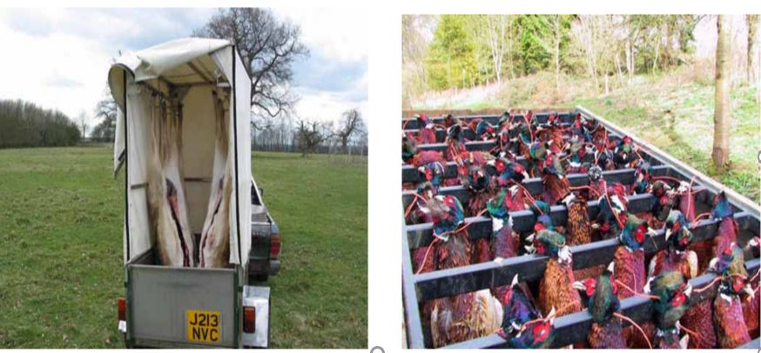

Bad examples of transportation
Heaping and cross contamination should be avoided.
Figure 2: Bad examples of transportation
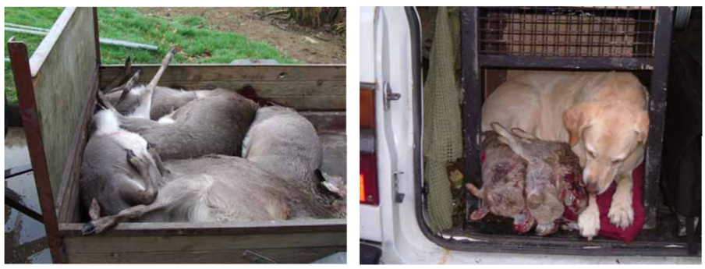
Further pictures of good and bad examples of transportation are available.

Traceability
Traceability is defined in Article 3 (15) of Regulation (EC) 178/2002 as:
“the ability to trace and follow a food, feed, food-producing animal or substance intended to be, or expected to be incorporated into a food or feed, through all stages of production, processing and distribution”.
- Primary producers (e.g. trained hunters) are expected to maintain full traceability records of all small and large wild game. The requirements of traceability are taken from Article 18 Regulation 178/2002. Please refer to these regulations for further information on traceability.
The information required to accompany wild game meat to be supplied to an AGHE is as follows, as seen in 931/2011:
- Accurate description of the animal (date, time and location where animal is shot, species, approximate age, sex).
- Volume/quantity; number of animals with approximate size/weight (large game) or volume (small game).
- Name and address of person/food business dispatching.
- Name and address of carrier / transporter / person responsible for moving wild game.
- Name and address of the food business receiving the food.
- Reference identifying lot, batch or consignment.
- Date of dispatch.
The Regulations do not specify an amount of time traceability records should be kept for, other than “until it can be reasonably assumed that the food has been consumed”.
The following has been taken from Regulation (EU) 931/2011 (on the traceability requirements set by Regulation (EC) No 178/2002)
Article 3(3):
‘The information referred to in paragraph 1 (Article 3 (1) 931/2011) shall be updated on a daily basis and kept at least available until it can be reasonably assumed that the food has been consumed.
When requested by the competent authority, the food business operator shall provide the information without undue delay. The appropriate form in which the information must be made available is up to the choice of the supplier of the food, as long as the information requested in paragraph 1 is clearly and unequivocally available to and retrievable by the business operator to whom the food is supplied.’

Testing/examination

Trichinella testing of wild boar
Regulation (EU) 2015/1375 requires that animals susceptible to Trichinellosis, such as all wild boar, whether feral or farmed, should be tested for the presence of Trichinella. Samples taken are tested within 48 hours of arrival at the laboratory with results sent out on the same day. It is therefore necessary to carry out surveillance for Trichinella in all wild boar in order to help determine the UK’s Trichinella status. For outside of personal consumption, this must be done by law.

Wild boar for personal consumption
For your own protection and to assist in collecting data, the FSA has introduced mandatory Trichinella testing of all wild boar as part of its UK monitoring scheme. This involves hunters sampling any wild boar that has been shot and sending the sample to an appropriate laboratory for testing. The FSA will pay for the sampling kit, the cost of posting the sample, together with the cost of the testing (contact details below).

Sample preparation – the steps
- The muscle sample should ideally be taken from the pillar of the diaphragm (see Figure 3), cutting along the thick meaty part close to the ribs. If this is not possible, muscle should be taken from the foreleg and/or the tongue.

Figure 3: Arrow showing sample of the diaphragm
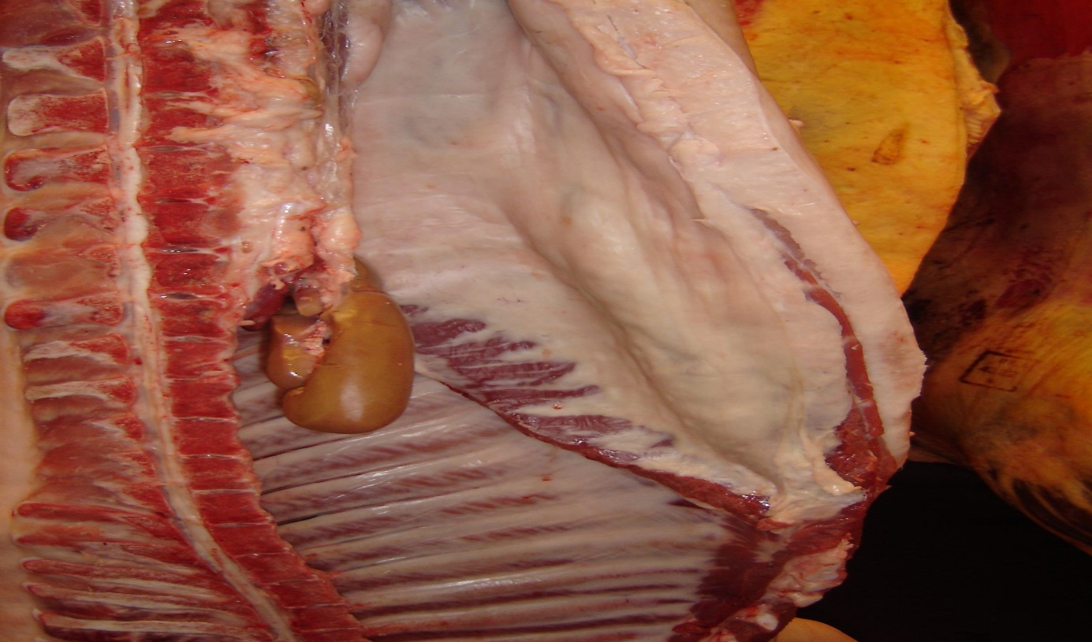
- A muscle sample of at least 60–100g should be cut from the pillar of the diaphragm of each animal as soon as possible after death. The sample should be free of fat and other tissue.
- If required, samples can be stored in the refrigerator at approximately 4ºC for a few days and sent by next day delivery at room temperature. The sample must not be frozen as this can interfere with the execution of the diagnostic assay.
- Once the muscle sample has been taken from the carcass it should be double-bagged, placed in a padded envelope and sent for testing as soon as possible.

Sample storage and transport
Sampling kits and freepost, self-addressed envelopes can be ordered free of charge from the Testing Laboratory at the Animal and Plant Health Agency (APHA), National Reference Laboratory for Trichinella and Echinococcus, Sand Hutton, York, YO41 1LZ. Email: NRL.Parasitology@apha.gov.uk; Tel: 07584 111971

Waste
Waste from shooting and processing of wild game and meat by food business and at AGHE’s must be in accordance with Animal By-Product (ABP) rules. No animal by-products are allowed to enter the food chain.
If a hunter believes an animal is infected with a disease communicable to humans or animals, then it should be disposed of in line with Article 12 of Regulation (EC) 1069/2009 (this would usually be by incineration or rendering).
If the animal was thought to be infected with a notifiable disease, then it would need to be notified to APHA prior to disposal.
Exemptions from the ABP waste rules:
- Green offal (“Grollach”), red offal and excess shot animals.

Animal by-products (ABP)
Animal by-products (ABPs) are defined in Article 3 of Regulation (EC) 1069/2009 as ‘entire bodies or parts of animals, products of animal origin or other products obtained from animals that are not intended for human consumption’. This includes catering waste, used cooking oil, former foodstuffs, butcher and slaughterhouse waste, blood, feathers, wool, hides and skins, fallen stock, pet animals, zoo and circus animals, hunt trophies, manure, ova, embryos and semen not intended for breeding purposes.
More information on the various categories of waste and regulations is available.

Export of unskinned deer carcases to Europe (current requirements):
All unskinned deer carcases intended to be sold in the European market need to be accompanied by a health certificate signed by an Official Veterinarian (registered with APHA).
You need to apply for a health certificate via TRACES. In doing this you need to complete information about the consignment, when and where it is going and container details etc.
For further information you can contact APHA on their Helpline Telephone Number 03000 200 301 or Email: product.exports@apha.gov.uk.

Hunter training
It is the responsibility of the AGHE operator (or FBO) to satisfy themselves that those supplying wild game are suitably trained. Any person who hunts wild game with a view to supplying into the food chain must have sufficient knowledge of the pathology of wild game, and the production and handling of wild game and wild game meat after hunting, to undertake an initial examination of the game on the spot, unless they are part of a hunting team of which at least one “trained person” is a member. The “trained person”, having undertaken the initial examination, must make a declaration in the approved form (this is only a legal requirement for large game but considered best practice for small game).
Under Regulation (EC) 853/2004 at least one member of each hunting party should have received training in the following areas:
(a) the normal anatomy, physiology and behaviour of wild game;
(b) abnormal behaviour and pathological changes in wild game due to diseases, environmental contamination or other factors which may affect human health after consumption;
(c) the hygiene rules and proper techniques for the handling, transportation, evisceration etc. of wild game animals after killing; and
(d) legislation and administrative provisions on the animal and public health and hygiene conditions governing the placing on the market of wild game.
You can receive training from the following organisations:
- Deer Management Qualifications (DMQ) has information on deer and wild boar training.
- The National Gamekeepers Organisation has information for large and small game.
- In Northern Ireland, Country Sports Ireland also provide appropriate training for hunters and the handling of large wild game (deer).

Definitions

Wild game
‘Wild game’ is defined in Annex l of Regulation (EC) 853/2004 as:
‘wild ungulates and lagomorphs, as well as other land mammals that are hunted for human consumption and are considered to be wild under the applicable law in the United Kingdom. These include mammals living in enclosed territory under conditions of freedom similar to those of wild game and
‘wild birds that are hunted for human consumption’.
‘Wild ungulates’ are hooved animals such as wild deer and feral wild boar but can also include certain feral populations of sheep and goats. ‘Lagomorphs’ are rabbits and hares. ‘Other land mammals’ are e.g. squirrels.

"Farmed" game
Farmed game is defined in Regulation 853/2004 as farmed ratites and farmed land mammals other than domestic bovine, porcine, caprine and ovine animals and domestic solipeds. Farmed game includes deer and boar produced by farming. All meat from farmed game placed on the market must be produced in approved slaughterhouses. Further details can be found in the Guide to the Food Hygiene and Other Regulations for the UK Meat Industry.

Primary producers
There is no specific legal definition of a primary producer of wild game, however it is considered that a reasonable definition includes those involved in the production of primary products of wild game. These include hunters who shoot alone or in a hunting party, and any person who has the right to take the game on estate land, all are considered as primary producers.
Article 2 (1) (b) Regulation (EC) 852/2004 states:
‘primary products’ means products of primary production including products of the soil, of stock farming, of hunting and fishing.
Primary products in the wild game sector include:
- ‘In-fur’ large wild game
- ‘In-fur’ small wild game
- ‘In-feather’ wild game birds
These primary products may be supplied into the food chain either eviscerated or non-eviscerated. However, once the fur or feathers are removed, or any further preparation goes beyond normal hunting practice, then these products are no longer regarded as primary products.
This has important implications as it indicates the point where hunting (primary production) activities end, and where processing wild game into meat begins.
Any individual who processes game with the intention of placing the game on the market beyond the point at which they are considered primary products, has additional food safety legislative obligations and responsibilities, above that demanded of a primary producer, which must be complied with in order to operate legitimately.

Hunter/hunting party
For the purposes of food law, a hunter is a person who hunts wild game with a view of placing the meat on the market for human consumption. A hunting party comprises more than one hunter. At least one person within the hunting party must have received accredited training (see section on training) regarding:
- the detection of pathology or any other abnormality in wild game.
- the hygienic production and handling of wild game meat.
- the wild game meat legal requirements.
Accredited training is essential in order to be able to undertake an initial examination of the carcass and offal on the spot immediately after shooting. In each hunting party the trained person can be the gamekeeper or game manager, but he or she must be present on the hunt (Regulation (EC) 853/2004).
Under Regulation (EC) 853/2004 all bodies and viscera of hunted wild game intended for the community market should be presented for official post-mortem inspection at an approved game handling establishment. Only in circumstances where the hunter is trained is it not necessary to deliver all of the hunted viscera to an AGHE for post-mortem examination, as he/she are able to undertake any initial examination on the spot to identify any anomalies or hazards. In these circumstances the trained hunter should keep a declaration document for the large game to confirm that they were satisfied that no abnormalities were identified.

Small quantities
Small quantities are regarded as self-defining because demand for in-fur or in- feather carcases from final consumers and local retailers is limited.
The supply of small quantities by the producer must also be local and direct to where the hunter is food registered. For the purpose of this guide ‘local’ means within the hunter’s own county plus the greater of either the neighbouring county or counties or 30 miles/50km from the supplying county boundary.

Final consumer
(EC) 178/2002 defines it as:
“final consumer” means the ultimate consumer of a foodstuff who will not use the food as part of any food business operation or activity.

Retailer
Regulation EC 178/2002 defines retail as:
“the handling and/or processing of food and its storage at the point of sale or delivery to the final consumer, and includes distribution terminals, catering operations, factory canteens, institutional catering, restaurants and other similar food service operations, shops, supermarket distribution centres and wholesale outlets”.

Roadkill
Roadkill cannot be sold under any circumstances as such activity would likely be in contravention of Article 14 of 178/2002 and Regulation (EC) 853/2004. Therefore, any roadkill must be treated as waste under the ABP rules.

Game larder
Game larders are usually registered individually as food businesses and normally consist of a room or area within a food business used for the storage of in-fur/in- feather wild game. Game larders should be capable of chilling foods to below 7°C for large game and 4°C for small game. They must be made of impervious material that are easy to clean, pest proofed and sufficient in size for the quantities being stored. Cleaning of larders must be carried out using potable water and a suitable disinfectant. Where appropriate, wild game should be stored in a separate chiller unless it can be demonstrated that there is no risk of cross-contamination.

References
- Trichinella Guidance – Wild Boar
- Regulation (EC) 852/2004, Regulation (EC) 853/2004, and Regulation (EC) 178/2002, Regulation (EC) 999/2001, Regulation (EC) 931/2011
- FSA Manual of Official Controls

Review
- The FSA aims to keep all guidance material up to date and undertakes regular reviews of guidance material to ensure that material is still relevant. The next scheduled review date for this guidance is August 2021.
- The FSA welcomes user feedback on guidance, including reports of any broken links to reference material or other content that may require updating. Please use the contact details below.

Contacts
Meat Hygiene Policy: wildgameguidance@food.gov.uk

Annexe A: Specimen forms

A - Suggested format for large wild game declaration
Front

Large wild game declaration
Tag Number: ……………………………… Species: Roe fallow red muntjac
Date/Time of Kill: ……………../…..…..…. Sika Chinese
Location/Estate:....……………………….. Other……………………….……………….
Sex: M F Weight: ……….. (KGs)

I declare in accordance with EU Regulation 853/2004 that no abnormal behaviour was observed before killing and there is no indication of environmental contamination. I have inspected the head, pluck and viscera without observing abnormalities*.
Notes:………………………………………………………………………………………..
Trained person qualification:……………..……………………………………………..
Contact details …………………………………………………………………………….
Name:………………………………………………………………………………………..
Signature:…..……………………………………………………………………………….

B – Suggested format for submitting information on small wild game
Front

Small wild game information
Date/Time of Kill: …………..….…/…..……..….Location/Estate:.……………….…….…….
Number in batch:………….
Species: Pheasant Partridge Pigeon Hare Other………….…..........................................
Observations:………………………………….………………………………………..…………
………………………………………………………………………………………………………..
Trained person qualification:……………..…………………………………………………….
Contact details ……………………………………………………………………………………
Name:………………………………………………………………………………………………..
Signature:……………………………………………………..…………………………………….

C – Suggested format for information on several large wild game sent to a single game handling establishment
Front
Large wild game information
Tag Number………………………………………………………Species: Roe fallow red
Date/Time of kill:…………………………………………………Muntjac Sika Chinese
Location/Estate:……………………………Other…………………………………………..
Number in batch:………………………………………………………………………………
Back
I declare in accordance with EU Regulation 853/2004 that no abnormal behaviour was observed before killing and there is no indication of environmental contamination. I have inspected the heads, pluck and viscera without observing abnormalities or trichinella infestation*.
In the case of game trophies, heads of animals including species susceptible to trichinella infestation may be sent to a plant registered in accordance with Regulation (EC) 1069/2009 for the production of a game trophy:
Name & address of approved technical plant:……………………………………………………
Notes:…………………………………………………………………………………………………
Trained Person qualification:……………………………………………………………………….
Contact details:………………………………………………………………………………………
Name:…………………………………………………………………………………………………
Signature:……………………………………………………………………………………………..
*Where heads are of animals susceptible to Trichinosis infestation, the trained person should make sure that details of the Approved Technical Plant for producing the trophy are entered on the form and a copy of the form is sent to the plant.

Annex B - Bibliography
For further information you may wish to look at the following sites:
- British Association for Shooting and Conservation
- Countryside Alliance
- Deer Management Qualifications
- Federation of Associations for Country Sports in Europe (FACE-UK): conor.ogorman@basc.org.uk
- National Gamekeepers’ Organisation
- National Game Dealers’ Association c/o Pollard Farm, Clanville, Andover, Hampshire SP11 9JE
- Royal College of Veterinary Surgeons
- The British Deer Society – The Deer Initiative

