Safe Methods training resource summary

Activities to aid the delivery of safe methods
Number | Title | Description | Linked to other resources | Time needed
SM1 | The Calamity Café | Individually or in small groups.  For a list of potential hazards, identify the cross-contamination threats and suggest how they can be prevented. | Levels 1, 2 and 3 | 20–30 minutes
SM2 | Cross-contamination – The journey | Practical exercise demonstrating transfer of bacteria around different areas. | Levels 1 and 2 | 15 minutes – 1.5 hours
SM3 | Safe methods – Cross contamination | Small group presentation.  To prepare a poster identifying key safety points. | Levels 1 and 2 | 30 minutes – 2 hours
SM4 | Safe methods – Cleaning schedule | Either individually or in small groups. Prepare a cleaning schedule for items of equipment. More complex equipment for higher-level learners. | Levels 1, 2 and 3 | 30 minutes
SM5 | Safe methods – Fridge cleaning checklist | Either individually or in small groups, prepare a cleaning checklist for a single item of equipment. | Levels 1 and 2 | 20 minutes
SM6 | Safe methods – Cooking checks | Individually or in pairs, for a given list of menu items, describe how you would check they had been cooked safely. | Levels 1 and 2 | 15 minutes
SM7 | Safe methods – Temperature checks | Exercise on calibrating and taking temperatures in refrigerated equipment. | Levels 1, 2 and 3 | 30 minutes –1.5 hours
SM12 | The head chef - Part 2 | Case study, small group. For a forthcoming event, identify potential hazards and produce an action plan to control them. | SM11 | 30 minutes – 1.5 hours
SM8 | Safe methods – Checking your menu | Pairs or small groups, from a list of menu items, complete the ‘Checking your menu’ sheet from the SFBB pack. | Level 2 and 3 | 40 minutes – 1 hour
SM9 | Safe methods – Kitchen cleaning audit | Prepare a cleaning checklist for a specific kitchen. Conduct an audit and give feedback. | Level 3 | 45 minutes – 1 hour
SM10 | Brave new world | Case study, small group. Reasons for introduction of SFBB and barriers to implementation. | Level 3 | 1–1.5 hours
SM11 | The head chef – part 1 | Case study, small group. Identify kitchen hazards and present short- and long-term solutions. | Level 3 | 30 minutes – 2 hours
SM12 | The head chef – part 2 | Case study, small group.  For a forthcoming event, identify potential hazards and produce an action plan to control them. | Level 3 | 30 minutes – 1.5 hours
SM13 | Preparing for a new job | Identify knowledge a learner would need to know on their first day at work. | Level 1 | 15 minutes
SM14 | Preparing an induction training programme | Case study – to prepare a list of topics to be included in an induction together with suggested delivery methods. | Level 2 and 3 | 20–30 minutes  30–45 minutes

Activities to aid the delivery of SFBB recording systems
Number | Title | Description | Linked to other resources | Time needed
REC1 | Opening and closing checklists | Using existing checklists, discuss the tasks that must be completed at the start and end of a shift. | Level 1 | 25 minutes
REC2 | Diary writing | Using blank diary pages, prepare examples of what should be recorded in a diary. | Levels 2 and 3 | 10 minutes
REC3 | 4-weekly review | Using an example of four weeks’ worth of diary pages, complete a 4-weekly review. | Levels 2 and 3 | 30 minutes
REC4 | Preparing checklists | Working in twos or threes, prepare an opening and closing checklist for a specified area. | Levels 2 and 3 | 25 minutes
REC5 | Auditing practice | Design/use an audit form to conduct an audit . | Levels 2 and 3 | 30–45 minutes

Activities to aid the delivery of SFBB recording systems
Number | Title | Description | Linked to other resources | Time needed
Q1 | SFBB Quiz 1 | 10 question test. | Level 1 | 20 minutes
Q2 | SFBB Quiz 2 | 10 question test. | Level 1 | 20 minutes
Q3 | SFBB safe methods quiz | 10 question test. | Level 2 | 20 minutes
Q4 | Card game | Using laminated cards, match questions and answers based on SFBB pack. | Levels 1 and 2 | 20 minutes
Q5 | Consolidation of safe methods | From a list of hazards, identify the relevant safe method. Answers summarised in a word search. | Levels 2 and 3 | Part 1 – 20 minutes  Part 2 – 15 minutes
Q6 | SFBB crossword | Individually or in pairs, a method of testing SFBB knowledge. | Levels 2 and 3 | 20 minutes
Q7 | SFBB recording quiz | Short answer quiz testing learning on SFBB recording systems. | Level 3 | 30 minutes

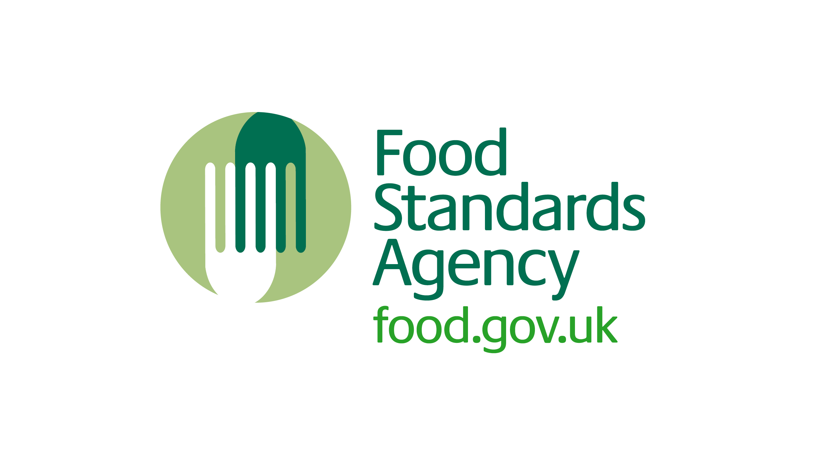
Additional handouts
Number | Title
HO1 | Opening and closing checklists – kitchen
HO2 | Opening and closing checklists – stores
HO3 | Opening and closing checklists – front of house
HO4 | 4 weeks of diary entries
HO5 | Completed 4-weekly review
HO6 | Audit form

